Implement Content Manager on Linux Server

## Purpose:

Install the Library and the Resource manager, DB2 Enterprise Database, IBM HTTP Server (with WAS plugins), IBM Websphere Application Server on a single Linux workstation.

Set up central administration of client property files for ease of system management.

Install Tivoli® Storage Manager Client to provide access to long-term storage. Set up hierarchical storage architecture with local storage system and TSM storage system.

Set up pClient environment. The Client for Windows enables the agents to query, view, and update data stored on the DB2 Content Manager system from their own workstation desktops. Because it is a dedicated client, the Client for Windows has rich functionality and responds rapidly.

The Client for Windows requires cataloging the library server database on the client workstation. The DB2® Run-Time Client is required to catalog the database on the client workstation.

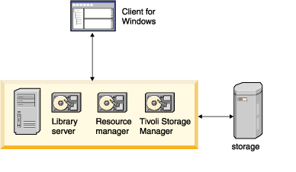

Figure 1: Single workstation configuration

## Installation Summary:

***Table 1.The software required for this content management configuration includes***

| **Client workstation** | **Linux Server system** |
| --- | --- |
| DB2 Run-Time Client  DB2 Content Manager for Windows® - pClient | DB2 Universal Database™ V9.5  IBM HTTP Server V7  WebSphere® Application Server V8  Tivoli Storage Manager Server  Tivoli Storage Manager Client  DB2 Content Manager library server  DB2 Content Manager resource manager application  DB2 Content Manager resource manager database  DB2 Content Manager System Administration Client |

|  |  |  |
| --- | --- | --- |
| *Table 2. Administration and connection IDs* | | |
| Administration or connection ID | **Default name** | **Actual value here** |
| DB2 Content Manager administration ID | ibmcmadm | ibmcmadm |
| DB2 Content Manager administration ID password |  | ibmcmadm |
| DB2 Content Manager administrator group | icmadmgrp | icmadmgrp |
| Library server database administration ID | icmadmin | icmadmin |
| Library server database administration ID password |  | icmadmin |
| Database connection ID | icmconct | icmconct |
| Database connection ID password |  | icmconct |
| Resource manager database administration ID | rmadmin | rmadmin |
| Resource manager database administration ID password |  | rmadmin |
| DB2 Universal Database™ instance ID | db2inst1 | db2inst1 |
| Primary group of the DB2 Universal Database instance ID | db2admin | db2admin |

|  |  |  |  |
| --- | --- | --- | --- |
| *Table 3. Working directory authentication information* | | | |
| Field name | **Description** | **Default name / option** | **Actual value here** |
| Administration user name | The name of the DB2 Content Manager administration user. | ibmcmadm | ibmcmadm |
| Password | If the administration user name exists, the password must match the existing password for the administration user name. |  | ibmcmadm |
| Administration user group | The name of the primary group to which the DB2 Content Manager administration user belongs. | ibmcmgrp | ibmcmgrp |

|  |  |  |  |  |
| --- | --- | --- | --- | --- |
| *Table 4. Creating the library server* | | | | |
| Field name | **Description** | **Field applies to custom installations only** | **Default name / option** | **Actual value here** |
| Library server database name | The name of the library server database |  | icmnlsdb | icmnlsdb |
| Library server schema name | Identifier used to group tables and database objects | yes | icmadmin | icmadmin |
| Library server database administration ID | Administration ID for the library server1 |  | icmadmin | icmadmin |
| Password  Confirm password | Password for the library server administration ID2 |  | password | icmadmin |
| Notes:  If the administration ID already exists on your operating system, type that value in this field and type the corresponding password in the Password field. If it does not exist, the installation program creates it.  You *must* type the password directly in these fields. You cannot copy a password from another area and paste it in the fields. | | | | |

|  |  |  |  |
| --- | --- | --- | --- |
| *Table 5. Library server database connection ID* | | | |
| Field name | **Description** | **Default name / option** | **Actual value here** |
| Library Server connection ID | The database connection ID that is authorized to connect to the library server | icmconct | icmconct |
| Password  Confirm password | Password for the library server connection ID | password | icmconct |

|  |  |  |  |
| --- | --- | --- | --- |
| *Table 6. Library server configuration options* | | | |
| Field name | **Description** | **Default name / option** | **Actual value here** |
| Name of library server ID | The ID used to identify the library server (Range = 1 to 99) | 1 | 1 |
| Library server transaction ID duration (seconds) | The number of seconds DB2® Content Manager transactions, such as users creating item types, last. This field is similar to a token duration and is used for security purposes. | 180 | 180 |
| Enable Unicode | Select this check box to save characters as Unicode characters. A unicode database is better at handling translated data. You must enable unicode to effectively set up multiple language support through your system administration client. When Unicode is enabled, you then designate code page 1208, which enables UTF-8 Unicode. | selected | yes |
| Enable text search | Select this check box to enable text search so that users can search the text of stored objects like documents.1 | cleared | yes |
| Enable LDAP | Select this check box to manage user IDs and passwords on an enterprise level.2 | cleared | yes |

|  |  |  |  |  |
| --- | --- | --- | --- | --- |
| *Table 7. Creating the resource manager database* | | | | |
| Field name | **Description** | **Field applies to custom installation only** | **Default name / option** | **Actual value here** |
| Resource manager database name | The name of the resource manager database |  | rmdb | rmdb |
| Resource manager database administration ID | Administration ID for the resource manager1 |  | rmadmin | rmadmin |
| Password  Confirm password | Password for the resource manager administration ID2 |  | password | rmadmin |
| Resource manager volume mount point | The default storage location of objects that are imported into the resource manager. | yes | C:\ | Resource Manager Database Volume mount point: /home  Resource Manager Database staging directory: /home/staging |
| Notes:  If the administration ID already exists on your operating system, type that value in this field and type the corresponding password in the Password field. If it does not exist, the installation program creates it.  You must type the password directly in these fields. You cannot copy a password from another area and paste it in the fields. | | | | |

|  |  |  |  |
| --- | --- | --- | --- |
| *Table 8. Resource manager options* | | | |
| Field name | **Description** | **Default name / option** | **Actual value here** |
| Resource manager volume mount point | The default storage location of objects that are imported into the resource manager. | C:\ | /home |
| Resource manager staging area directory | The path where you want to cache objects that are retrieved from the resource manager. | C:\staging | /home/staging |

|  |  |  |  |  |
| --- | --- | --- | --- | --- |
| *Table 9. Configuring the resource manager application* | | | | |
| Field name | **Description** | **Field applies to custom installations only** | **Default name / option** | **Actual value here** |
| Application server node name | The node name of your application server, which is typically the short name of this machine. 1 This value is case-sensitive. |  | Typically, the short name of the machine. | ibmserver |
| Application server security enabled | Select this check box to indicate that you have previously enabled security for your application server. |  | cleared | yes |
| Resource manager Web application name | The name of the Web application that is deployed within your application server | yes | icmrm | icmrm |
| Resource manager Web application context root | The context root of the resource manager application that is used to construct the Web address to the resource manager Web application. | yes | /icmrm | /icmrm |
| Token duration | The amount of time in seconds that a token generated by the library server for an action on the resource manager remains active before it is discarded by the system | yes | 172800(2 days) | 172800 |
| Starting port for resource manager services | Type a starting port number (the first of five consecutive numbers) to be used for resource manager components (migrator, purger, stager, replicator, and asynchronous recovery)2 | yes | 7500 | 7500 |
| Enable LDAP | Select this check box to manage user IDs and passwords on an enterprise level.3 | yes | cleared | yes |
| Notes:  If you are using WebSphere Application Server Version 6.0, the default value is still the short name of the machine, but with Node01 appended to it.  You can type a port number other than the recommended default number. However, it must be the first number of five available contiguous port numbers. | | | | |

|  |  |  |  |
| --- | --- | --- | --- |
| *Table 10. Configuring the resource manager application ports* | | | |
| Field name | **Description** | **Default name / option** | **Actual value here** |
| HTTP port | The port number for the Web server that is configured for use with your application server | 80 | 80 |
| HTTPS port | The secure Web application port number that the system administration client uses to communicate with the resource manager application | 443 | 443 |
| Application server security enabled | Select this check box to indicate that you have previously enabled security for your application server. | cleared | yes |
| Secure Sockets Layer Option | Click **Use and configure IBM® HTTP Server SSL** for the install program to configure SSL for you.  Click Use pre-configured settings for IBM HTTP Server SSL if you have already manually configured SSL and you want the resource manager Web application to use your settings.  Click Do not use IBM HTTP Server SSL if you want WebSphere to be used as the SSL type. Type values for your ports that were assigned by WebSphere during deployment. | Use and configure IBM HTTP Server SSL | No |

|  |  |  |  |
| --- | --- | --- | --- |
| *Table 11. Configuring Secure Sockets Layer* | | | |
| Field name | **Description** | **Default name / option** | **Actual value here** |
| Common name | The fully qualified name of the Web server where the resource manager application resides | Detected host name of the system | No |
| Organization | Your company name | IBM | No |
| Organizational Unit | Your organization section or department | DB2® Content Manager | No |
| Locality | Your city | SVL | No |
| State or province | Abbreviated name (2 characters) | CA | No |
| Country | Abbreviated name (2 characters) | US | No |

|  |  |  |  |
| --- | --- | --- | --- |
| *Table 12. Defining location of system configuration files* | | | |
| Field name | **Description** | **Default name / option** | **Actual value here** |
| Select Local or Remote | Specify **Local** to install the system configuration files locally.  Specify **Remote** to open another window where you specify the location of the system configuration files on a remote mapped drive, HTTP server, or LDAP server. | Local | /home/ibmcmadm/cmgmt/connectors |

|  |  |  |  |  |
| --- | --- | --- | --- | --- |
| *Table 13. Connecting system administration client to library server* | | | | |
| Field name | **Description** | **Field applies only if the library server was not selected along with the system administration client when you selected installation components** | **Default name / option** | **Actual value here** |
| Database server type | Specify DB2 or Oracle as the database type for the library server. | yes | DB2 | DB2 |
| Library server database name | The name of your library server. |  | icmnlsdb | icmnlsdb |
| Library server schema name | Type the existing schema name for your library server. |  | icmadmin | icmadmin |
| Authentication type | Related to DB2 database authentication. Choose **Client** or **Server** to match the settings on your DB2 server. |  | Server | Server |
| Enable single sign-on for client authentication | Allows users to authenticate through their operating system |  |  |  |
| Configure connection to remote library server database | Select to configure the system administration client to connect to a remote library server. | yes | cleared | yes |
| Enable LDAP for importing users | Select this check box to manage user IDs and passwords on an enterprise level. |  | cleared | yes |

|  |  |  |  |
| --- | --- | --- | --- |
| *Table 14. System administration client connection to library server* | | | |
| Field name | **Description** | **Default name / option** | **Actual value here** |
| Library server connection ID | The shared database connection ID that is authorized to connect to the library server | icmconct | icmconct |
| Password  Confirm password | Type the password for the library server connection ID (do not copy and paste the password). |  | icmconct |

|  |  |  |  |
| --- | --- | --- | --- |
| *Table 15. Remote connection to the library server database* | | | |
| Field name | **Description** | **Default name / option** | **Actual value here** |
| Library server operating system | The operating system where the library server is installed |  | Linux |
| Library server host name | The fully qualified host name of the machine where the library server resides. | Detected host name on your local machine (change it to the host name of the machine where the remote library server resides) | ibmserver |
| Library server database name | The name of the library server on the remote machine | icmnlsdb | icmnlsdb |
| Database port | The port number the system administration client uses to access the library server | 50000 | 50000 |
| Node name | The name of the machine where the library server resides | Detected short name of the local machine (change it to the short name of the machine where the remote library server resides) | ibmserver |

|  |  |  |  |
| --- | --- | --- | --- |
| *Table 16. Library server connection to remote resource manager database* | | | |
| Field name | **Description** | **Default name / option** | **Actual value here** |
| Resource manager database server host name | The fully qualified host name of the machine where the resource manager database resides. | Detected host name on your local machine (change it to the host name of the machine where the remote resource manager database resides) | ibmserver |
| Resource manager operating system | The operating system where you installed the remote resource manager database |  | Linux |
| Resource manager database name | The name of the resource manager database that exists on the remote machine | rmdb | rmdb |
| Resource manager administration ID | The administration ID for the resource manager database on the remote machine. | rmadmin | rmadmin |
| Password  Confirm password | Type the password for the resource manager administration ID (do not copy and paste the password). | Password must match the password associated with the resource manager administration ID | rmadmin |

|  |  |  |  |
| --- | --- | --- | --- |
| *Table 17. Library server connection to remote resource manager application* | | | |
| Field name | **Description** | **Default name / option** | **Actual value here** |
| Resource manager application host name | The fully qualified host name of the machine where the resource manager Web application resides. | detected host name on your local machine (change it to the host name of the machine where the remote resource manager application resides) | ibmserver |
| Web application name | The name of the Web application that is deployed on your application server. | icmrm | icmrm |
| Resource manager Web application context root | The context root of the resource manager application that is used to construct the Web address of the resource manager Web application. | /icmrm | /icmrm |
| Resource manager Web application port | The port number used to access the resource manager application. | 80 | 80 |
| Resource manager secure Web application port | The port number that the system administration client uses to communicate with the resource manager application | 443 | 443 |

**Important:** If you are using DB2 UDB, you must catalog the library server database on the machine where the resource manager application resides for a remote library server and resource manager application to communicate. If you are using Oracle, you must add the library server database entry in tnsnames.ora on the machine where the resource manager application resides.

|  |  |  |  |
| --- | --- | --- | --- |
| *Table 18. Resource manager database connection to remote library server database* | | | |
| Field name | **Description** | **Default name / option** | **Actual value here** |
| Library server host name | The fully qualified host name of the machine where the library server database resides. | Detected host name on your local machine (change it to the host name of the machine where the remote library server database resides) | ibmserver |
| Library server operating system | The operating system where you installed the remote library server database |  | Linux |
| Library server database name | The name of the library server database that exists on the remote machine | icmnlsdb | icmnlsdb |
| Library server schema name | The schema name of the library server database on the remote machine that is used to group tables and other objects. | icmadmin | icmadmin |
| Library server administration ID | The administration ID for the library server database on the remote machine. | icmadmin | icmadmin |
| Password  Confirm password | Type the password for the library server administration ID (do not copy and paste the password). | Password must match the password associated with the library server administration ID | icmadmin |

|  |  |  |  |  |
| --- | --- | --- | --- | --- |
| *Table 19. Resource manager database connection to remote resource manager application* | | | | |
| Field name | **Description** | **Default name / option** | **Actual value here** |
| Resource manager application host name | Type the fully qualified host name of the machine where the resource manager application is located. |  | ibmserver |
| Resource manager Web application name | The name of the Web application that is deployed on your application server. | icmrm | icmrm |
| Resource manager Web application context root | The context root that is used to construct the Web address of the resource manager Web application. | /icmrm | /icmrm |
| Resource manager Web application port | The port number used to access the resource manager application. | 80 | 80 |
| Resource manager secure Web application port | The port number that the system administration client uses to communicate with the resource manager application. | 443 | 443 |
| Token duration (seconds) | The amount of time in seconds that a token generated by the library server for a particular operation on the resource manager is active before it is discarded by the system. | 172800 | 172800 |

|  |  |  |  |
| --- | --- | --- | --- |
| *Table 20. Resource manager application connection to remote resource manager database* | | | |
| Field name | **Description** | **Default name / option** | **Actual value here** |
| Resource manager database server host name | The fully qualified host name of the machine where the resource manager database resides. | Detected host name on your local machine (change it to the host name of the machine where the remote resource manager database resides). | ibmserver |
| Resource manager operating system | The operating system where you installed the remote resource manager database. |  | Linux |
| Resource manager database server type | The server type for the resource manager database. |  | DB2 |
| Resource manager database name | The name of the resource manager database that exists on the remote machine. | rmdb | rmdb |

**Important:** If you are using DB2 UDB, you must catalog the resource manager database on the machine where the resource manager application resides.

|  |  |  |  |
| --- | --- | --- | --- |
| *Table 21. Resource manager database authentication information* | | | |
| Field name | **Description** | **Default name / option** | **Actual value here** |
| Resource manager administration ID | The administration ID for the resource manager database on the remote machine. | rmadmin | rmadmin |
| Password  Confirm password | Type the password for the resource manager administration ID (do not copy and paste the password). | Password must match the password associated with the resource manager administration ID | rmadmin |

|  |  |  |  |
| --- | --- | --- | --- |
| *Table 22. Defining the LDAP server* | | | |
| Field name | **Description** | **Default name / option** | **Actual value here** |
| LDAP server type | Select either **Standard LDAP**1 or **Active Directory** from the list. | Standard LDAP | No |
| LDAP server address (URL) | The address for your LDAP server | ldap://  ldapserver.ibm.com | No |
| Port | The port number of the LDAP server | 389 | No |
| LDAP server administration ID | The administration ID that already exists for your LDAP server |  | No |
| Password | Type the existing password for the LDAP server administration ID2 |  | No |
| Notes:  Select Standard LDAP if you are using a supported version of IBM® Directory Server, Tivoli® Directory server, or Lotus® Domino® Directory, or Sun Java™ System Directory Server.  Type the password. Do not copy and paste it. | | | |

|  |  |  |  |
| --- | --- | --- | --- |
| *Table 23. Configure the LDAP server* | | | |
| Field name | **Description** | **Default name / option** | **Actual value here** |
| Base distinguished name | The Base DN which exists at the top level of the LDAP tree. It is used to define searches for user IDs and groups. | o=ibm, c=US | No |
| User authentication attribute | The existing user attribute that determines the method for authenticating users. | cn | No |
| LDAP Search scope | Click**OneLevel** to search for users directly under the Base DN or click **Subtree** to search for users in all branches under the Base DN. | Subtree | No |
| LDAP Referral | Click **Ignore** to import users only from the LDAP server that you identified or click **Follow** to forward the request to import users to other LDAP servers. | Ignore | NO |

## Linux Server Installation and configuration

Preparation and prerequisites to install VMWare Workstation V10.

1. setup network environment.

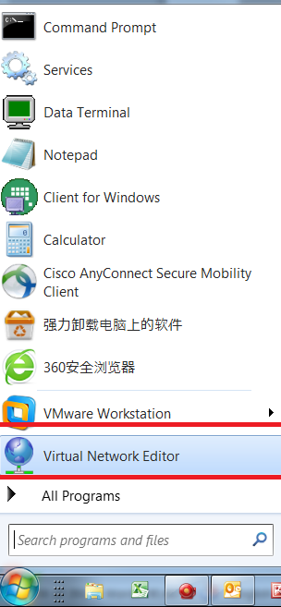

1. VMWare Workstation network VMnet1, VMnet8

network VMnet8 is used to connect virtual hosts to outside world(NAT type), subnet address 192.168.88.0, Gatewat IP: 192.168.88.2

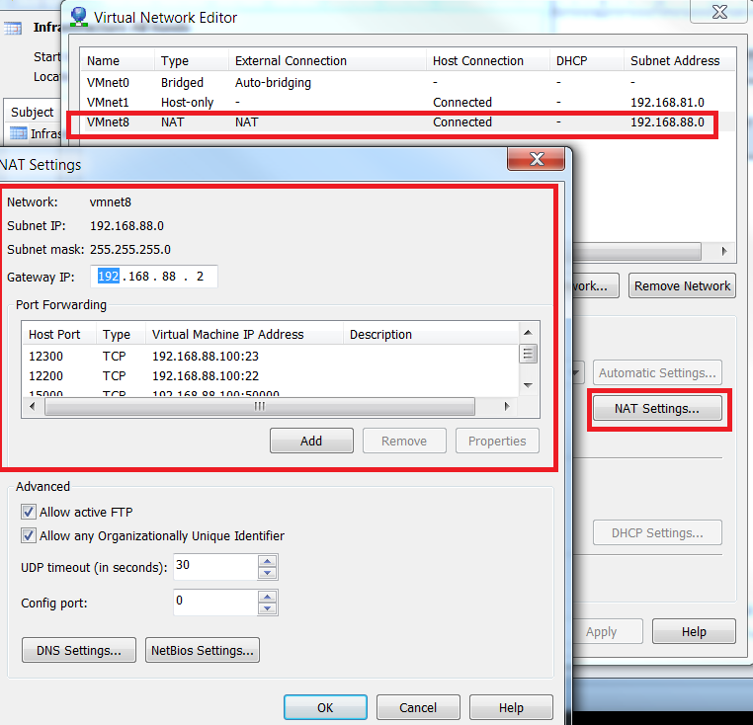

(option: port forwarding settings are for serices on virtual hosts provided to outside world)

network VMnet1 is used for inter-connection of virtual hosts(host-only), subnet address 192.168.81.0

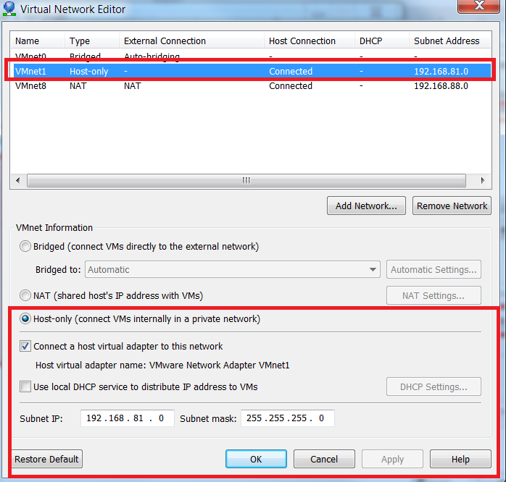

1. VMWare Network Adapter setup

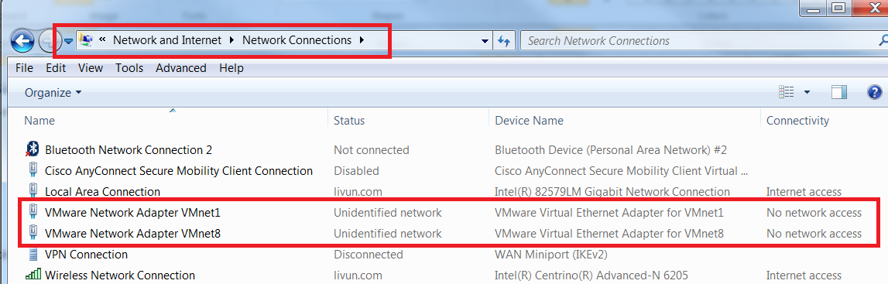

add static IP : 192.168.88.254 to VMnet8,default gateway: 192.168.88.2; add IP 192.168.81.254 to VMnet1

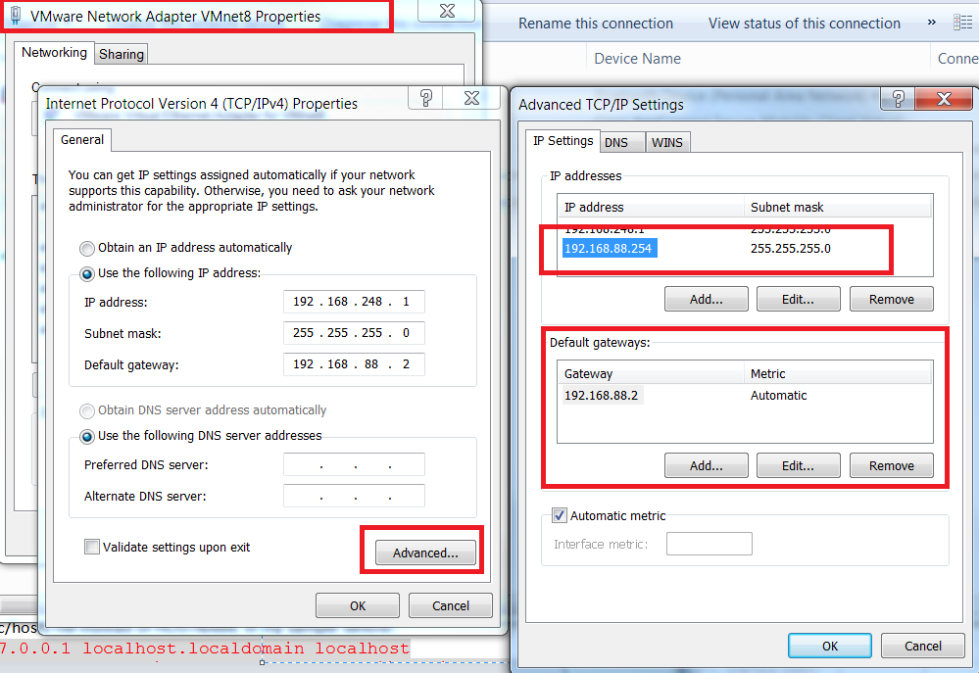

Preparation and prerequisites to install IBM CM on Linux

Hostname: ibmserver

IP:192.168.88.100

1. In /etc/hosts file there must be hostname.

# env | grep HOSTNAME

/etc/hosts file instead of HOSTNAME in my sample bellow:

127.0.0.1 localhost.localdomain localhost

192.168.253.110 ibmserver ibmserver.lii01.livun.com

For a Server, you need static IP address to provide services(Not DHCP). Also, sendmail need FQDN (fully qualified domain name) which would be something like ‘ibmserver.lii01.livun.com’, otherwise sendmail will start very slow with error in log /var/log/maillog

1. It’s always a good idea to disable Linux system’s firewall and SElinux when you implement new applications and software.

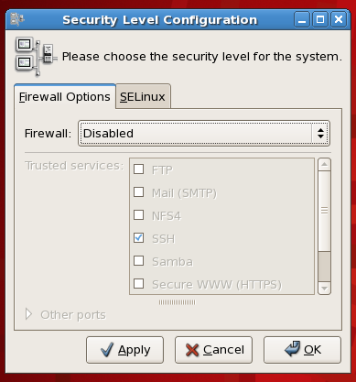

Please reset your system firewall policy and root access according to your company’s security policy after the implementation.

**Disabling SELinux:**  
  
edit file "/etc/selinux/config" and find line;  
  
SELINUX=enforcing  
  
Now replace it with,  
  
SELINUX=disabled  
  
***Now if you save & reboot your machine, it'll be disabled but if you don't want to reboot it now then, you can use following command;***  
  
#setenforce 0  
  
This will put SELinux in to the "Permissive mode", means it will run & log your whole session till next reboot, but will not control the permission

1. Pre-required OS level software(Library packages) must be installed before you can implement Content Manager Software (applications).

It’s recommended to use Linux GUI tools “ Add/Remove Software” to install specific packages.

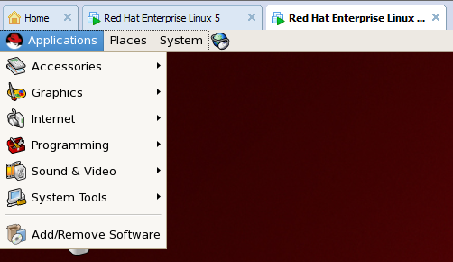

Tips: Repository Setting of Package Manager. You need to configure the repository setting if you want to install the software packages from the Linux5.8 installation DVD, Mount DVD device( /dev/sr0, /dev/hdc):

# mkdir –p /mnt

# mount /dev/hdc /mnt

Configure the Package Manager’ Repository

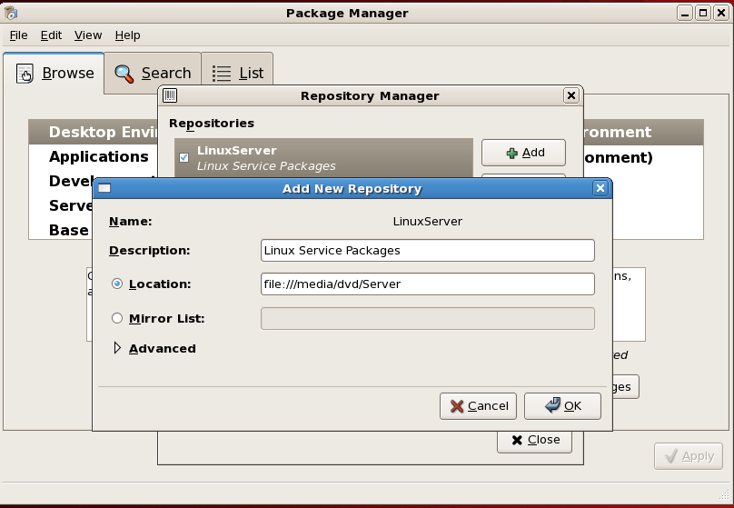

Location: file:///mnt/Server

For Example: If you are advised that libstdc++.so.5 missed, please use Package Manager to install all libstdc++ packages on Linux installation DVD:

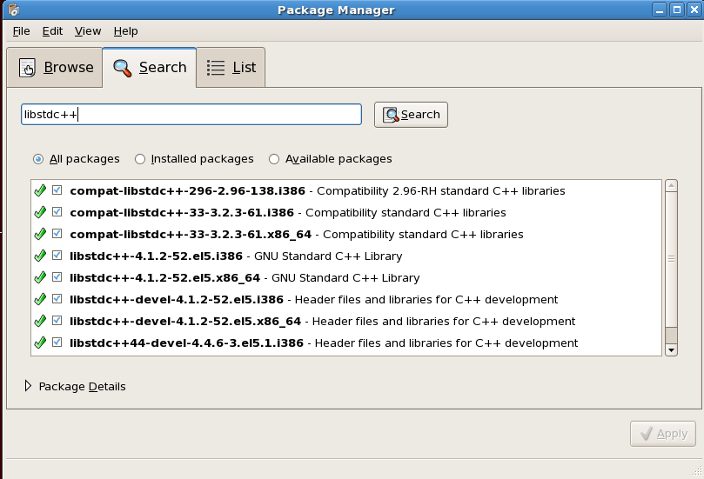

The Linux kernel (the core of the linux operating system), kernel-2.6.18-308.el5.x86_64,should be installed if you need VMware-Tools,

then, you have TWO kernel installed, choose first kernel ( /vmlinuz-2.6.18-308.el5) by setting /boot/grub/menu.lst:

default=0

then, restart Linux

1. Download IBM CM softwares to laptop windown system, and share download directory to Linux

The Content Manager Software packages are download on my laptop downloads directory:

* IBM DB2 V9.5
* IBM WebSphere Application Server8
* IBM DB2CM8
* IBM IHS7

If you need these software, please send email to [chenliru@yahoo.com](mailto:chenliru@yahoo.com), I will email them to you.

**Creating the Share on Windows**

Install Samba Server on Linux system is a best practice to share a directory between Windows & Linux systems, so you can copy the download software packages from Windows to Linux very conveniently.

To set up a shared folder on Windows for Linux to access, start by making sure your network settings are configured to allow the connection from the other computer by opening the Network and Sharing Center.

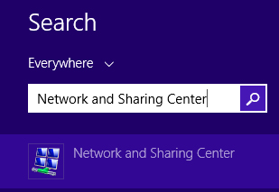

In the Network and Sharing Center window, click on “Change advanced sharing settings.”

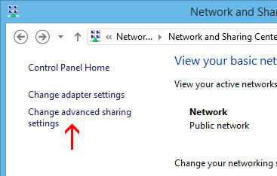

For your current profile, adjust the following two settings:

* Turn on network discovery
* Turn on file and printer sharing

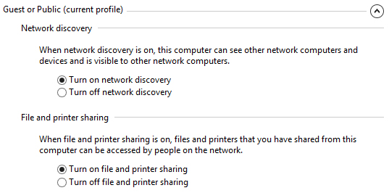

Click on “Save Changes” after those settings are configured. Now we can create a place on the Windows computer for the Linux machine to see files and copy contents to. There are no limitations to what you can share out (you could theoretically share your entire hard drive), but we will just be sharing out a folder called “Share” located on our Desktop.

Right click on the folder you’d like to share out over the network, and click Properties. Go to the Sharing tab and click Advanced Sharing.

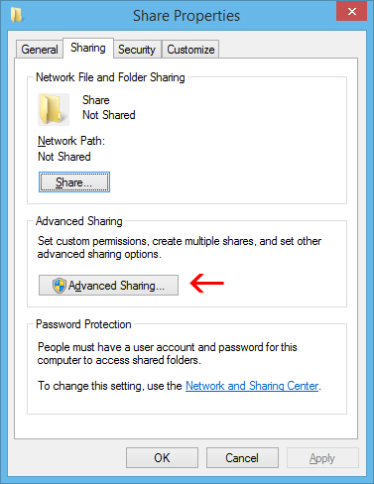

Check the “Share this folder” box and click on “Permissions” toward the bottom.

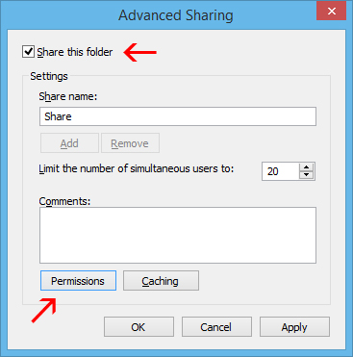

In the Permissions window, you can restrict access to the folder for certain accounts. To let any user have access to your folder, just give Full Control to the Everyone user. This will allow anyone to read and write changes to the shared folder. If you would rather restrict access to certain accounts, just remove the Everyone user and add the users you’d like to grant access to. Note: These user accounts are on the Windows computer, not Linux.

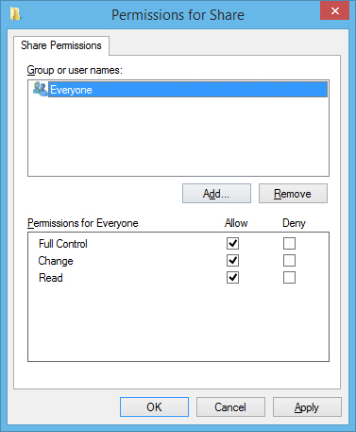

Click OK on the Permissions and Advanced Sharing windows once you’ve made your changes. While still in the Properties menu, click on the Security tab.

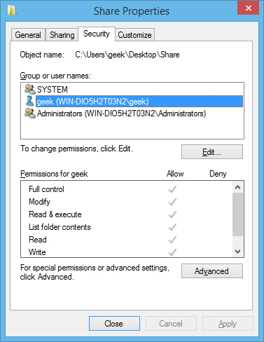

For the Linux user to have access to the shared folder, the same permissions need to be configured in this tab as what we configured in the sharing settings. If the two settings don’t match, the most restrictive settings are the ones that will take effect. If your desired user already has their security permissions set up (such as the geek user in our example) then you’re good to go and can click Close.

If you need to add a user, such as Everyone, click on Edit.

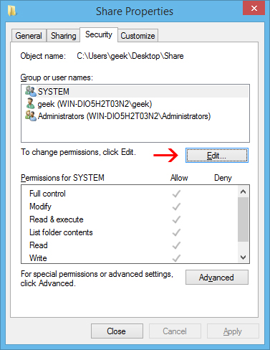

Click on Add in the next menu, enter the username, and click OK.

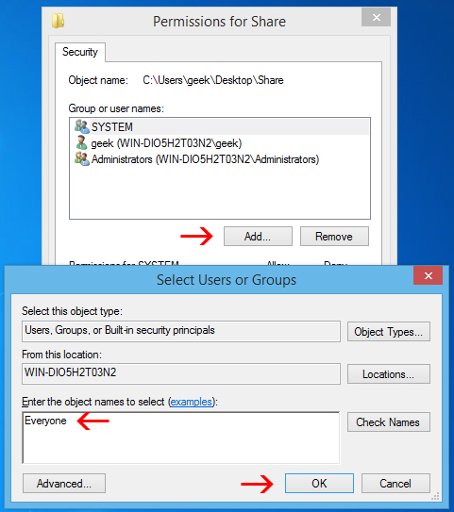

Click OK on all the open windows, and your folder should now be shared out and accessible on your Linux computer.

Accessing the Windows Share from Linux

You should be able to mount the shared folder by using the GUI in Linux, but it’s also very easy to do with the command line, and it’s easier to show a terminal example because it will work across many different distributions.

You’ll need the cifs-utils package in order to mount SMB shares:

# sudo apt-get install cifs-utils

After that, just make a directory and mount the share to it. In this example, we will mount the folder to our Desktop for easy access.

mkdir ~/Desktop/Windows-Share

# sudo mount.cifs //WindowsPC/Share /home/geek/Desktop/Windows-Share -o user=geek

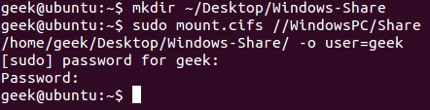

As you can see in the screenshot, we were prompted for the root password of the Linux machine, and then the password for the ‘geek’ account on Windows. After running that command, we are now able to see the contents of the Windows share and add data to it.

In case you need help understanding the mount command, here’s a breakdown:

sudo mount.cifs – This is just the mount command, set to mount a CIFS (SMB) share.

WindowsPC – This is the name of the Windows computer. Type “This PC” into the Start menu on Windows, right click it, and go to Properties to see your computer name.

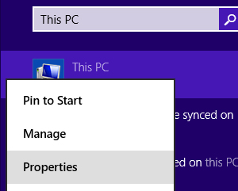

* //Windows-PC/Share – This is the full path to the shared folder.
* /home/geek/Desktop/Windows-Share – This is where we’d like the share to be mounted.
* -o user=geek – This is the Windows username that we are using to access the shared folder.

**Creating the Share on Linux**

To set up a shared folder on Linux for Windows to access, start with installing Samba.

# sudo apt-get install samba

After Samba installs, configure a username and password that will be used to access the share.

# smbpasswd -a geek

Note: In this example, we are using ‘geek’ since we already have a Linux user with that name – but you can choose any name you’d like.

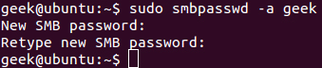

Create the directory that you’d like to share out to your Windows computer. We’re just going to put a folder on our Desktop.

mkdir ~/Desktop/Share

Now, use your favorite editor to configure the smb.conf file.

# sudo vi /etc/samba/smb.conf

Scroll down to the end of the file and add these lines:

[<folder_name>]  
path = /home/<user_name>/<folder_name>  
available = yes  
valid users = <user_name>  
read only = no  
browsable = yes  
public = yes  
writable = yes

Obviously, you’ll need to replace some of the values with your personal settings. It should look something like this:

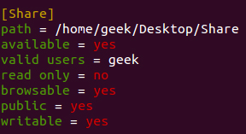

Save the file and close your editor. Now, restart the SMB service for the changes to take effect.

sudo service smbd restart

Your shared folder should now be accessible from a Windows PC.

Accessing the Linux Share from Windows

Now, let’s add the Linux share to our Windows Desktop. Right-click somewhere on your Desktop and go to New > Shortcut.

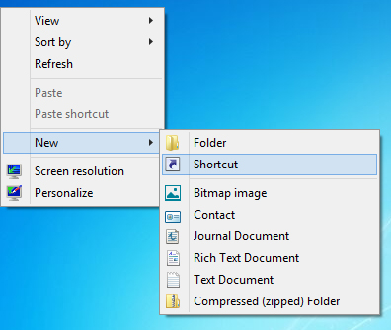

Type in the network location of the shared folder, with this syntax:

\\IP-ADDRESS\SHARE-NAME

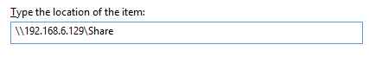

If you need the IP of your Linux computer, just issue the following command:

# ifconfig

Click Next, choose a name for the Shortcut, and click Finish. You should end up with a Shortcut on your Desktop that goes right to the Linux share.

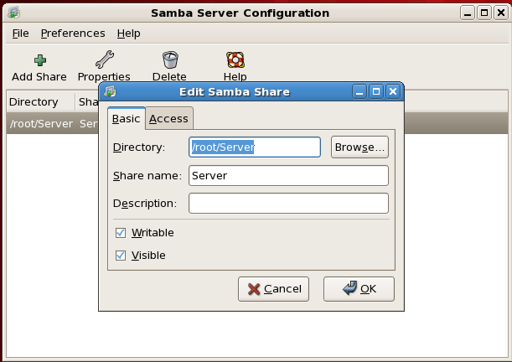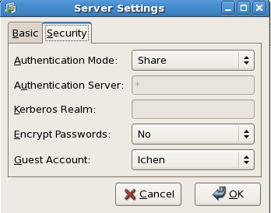

# chmod –R lchen:root /Server

Another way to share Windows Drive (directory) with VMWare Linux Server:

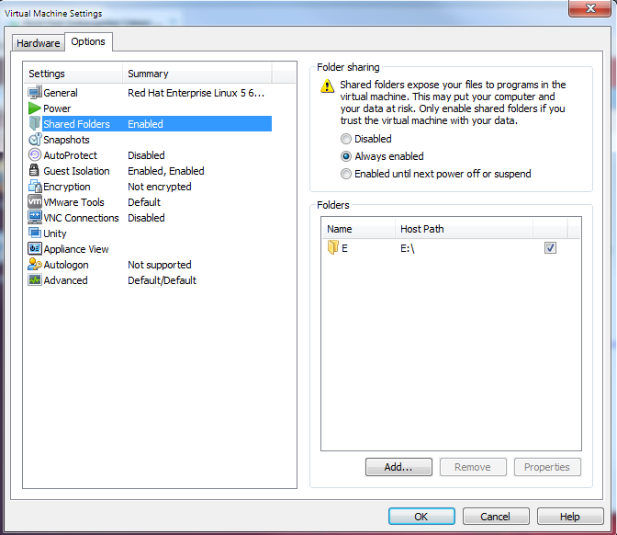

1. Need more storage space? Add new Storage(disks) to VMware workstation without reboot.

Scan this new disk to Linux system dynamically without reboot the system:

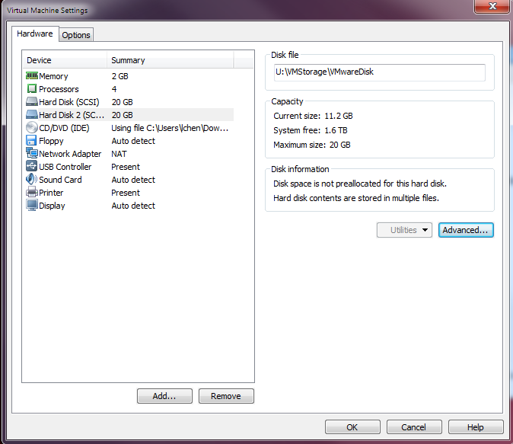

On Linux, Type the following to send a rescan request:  
# echo "- - -" > /sys/class/scsi_host/**host0**/scan  
# fdisk -l

You can find the new added disk:

Disk /dev/sdb: 21.4 GB, 21474836480 bytes

255 heads, 63 sectors/track, 2610 cylinders

Units = cylinders of 16065 * 512 = 8225280 bytes

Device Boot Start End Blocks Id System

/dev/sdb1 1 2610 20964793+ 83 Linux

Mount the disk on /root/Server directory:

# mount /dev/sdb1 /root/Server

## Install DB2 Enterprise Server Edition Version 9.5

IBM DB2 installation package “db2_v95_linuxia64_server.tar.gz”

#gunzip db2_v95_linuxia64_server.tar.gz

#tar xvf db2_v95_linuxia64_server.tar

#./db2setup

Tips: IBM DB2CM needs 64-bit DB2 database after DB2 V9.1, If you have pre-installed 32-bit IBM DB2, you should un-intall 32-bit db2:

* Stop running db2 instance:

# /opt/IBM/db2/V9.1/adm/db2stop force

* Disable the fault monitor daemon (db2fmcd) process

# /opt/IBM/db2/V9.1/bin/db2fmcu –d

* db2idrop delete db2 instance created by db2icrt.

# /opt/IBM/db2/V9.1/instance/db2idrop db2inst1

# userdel –fr db2inst1

# userdel –fr db2fenc1

# userdel –fr dasusr1

# rm –fr /opt/IBM/db2

Follows the DB2 Setup Wizard to install

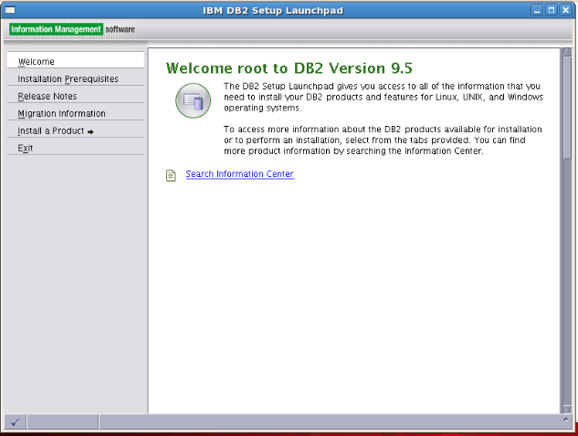

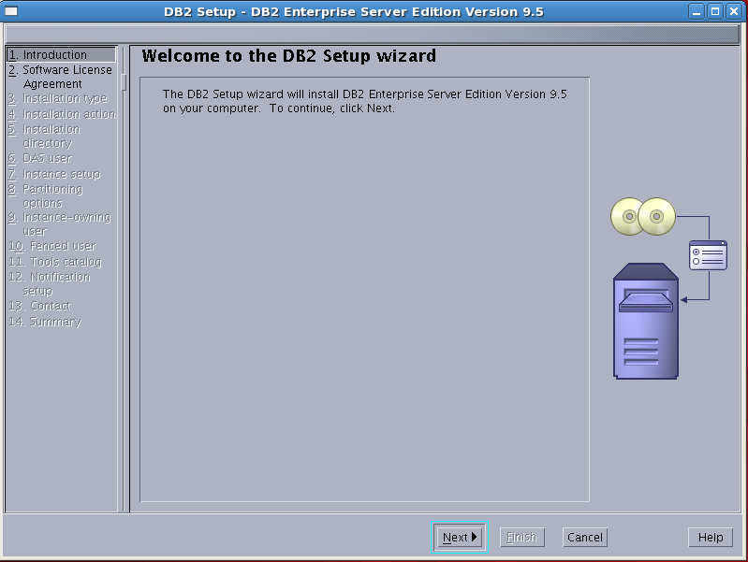

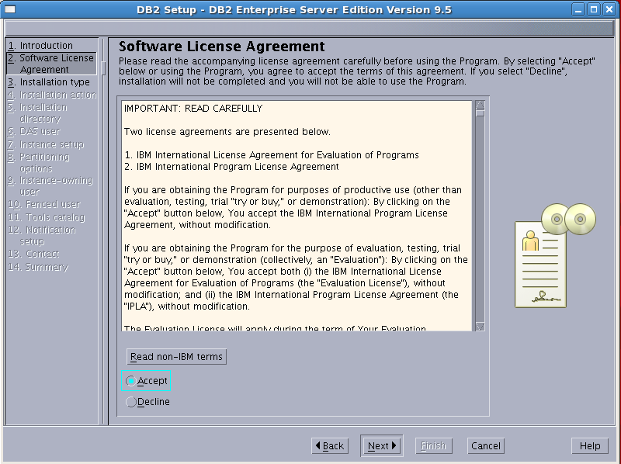

Accept license agreement

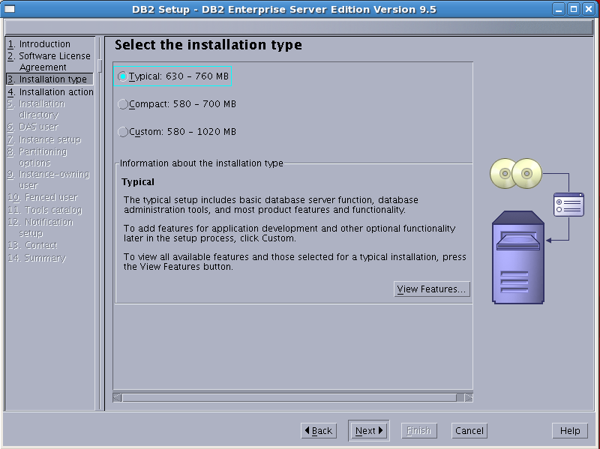

Select typical installation

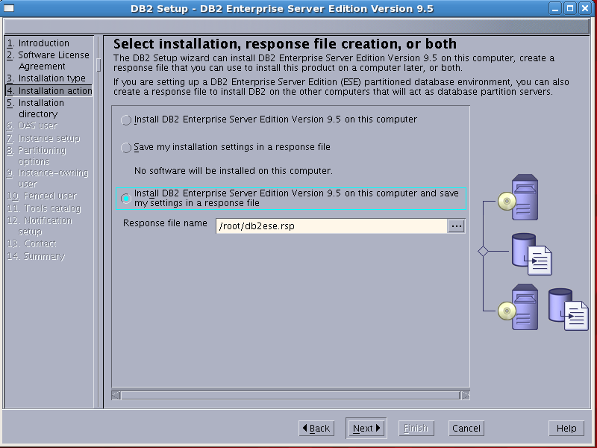

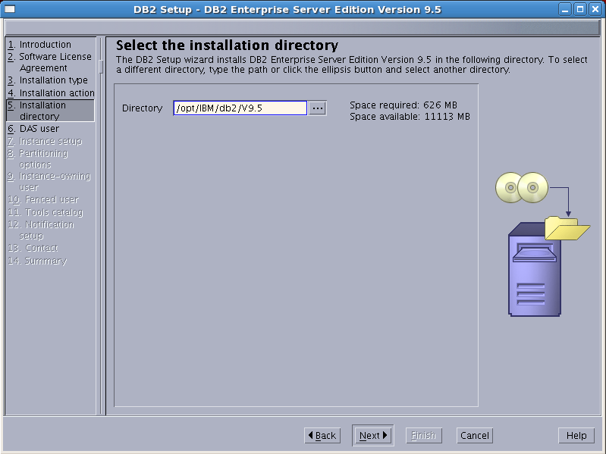

DB2 Products installation directory: /opt/IBM/db2/V9.5

DB2 Administration Server User: dasusr1; password: dasusr1; DB2 Administration Server (DAS) runs on your computer to provide support required by the DB2 tools.

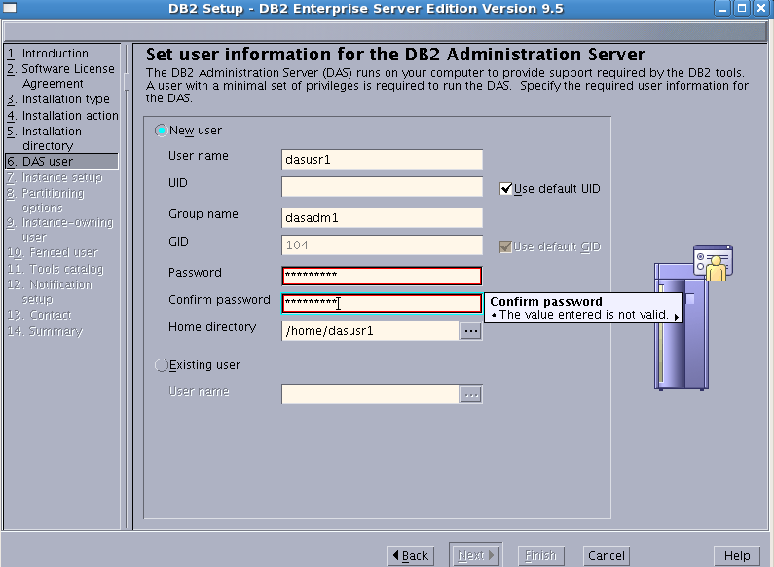

Setup DB2 instance: an environment in which you store data and run applications. If you would like to add this computer to an exiting partitioned database environment, you should not create an instance on this computer. The instance should be created on the instance-owning database partition server.

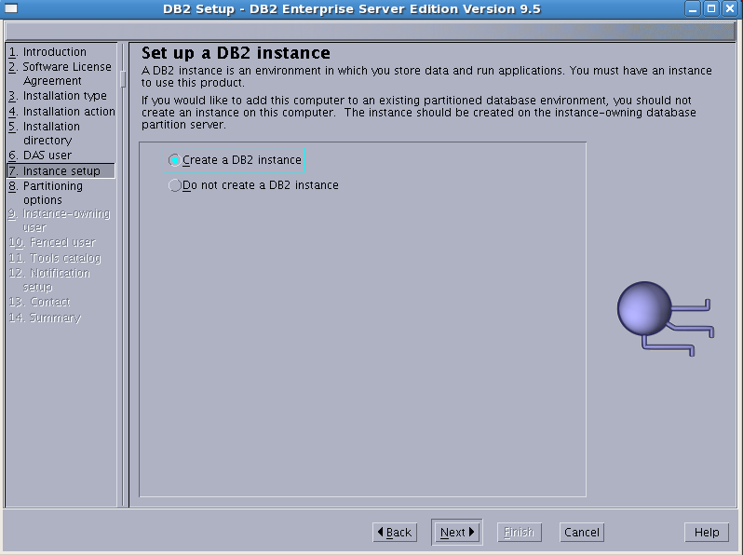

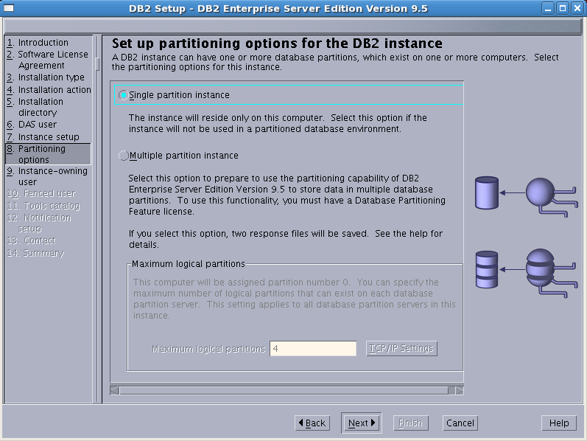

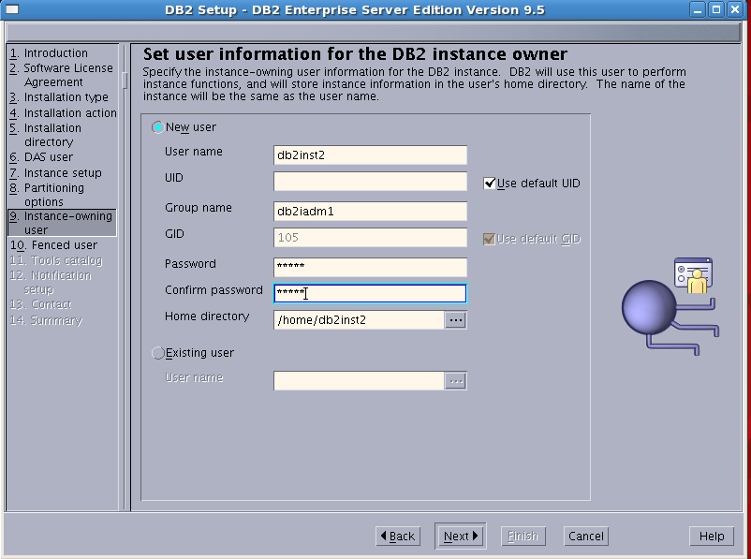

DB2 instance owner: db2inst1; group: db2iadm1; password: db2inst1; DB2 will use this user to perform instance functions, and will store instance information in ths user’s home directory.

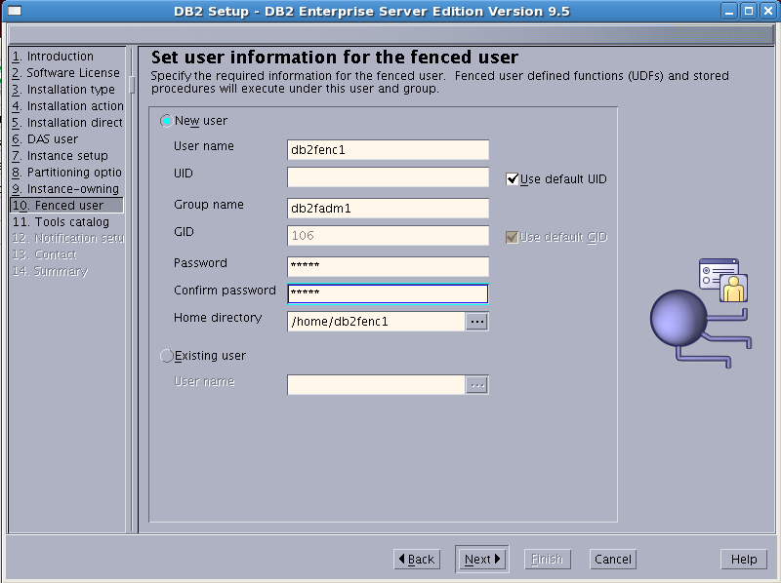

fenced user : db2fenc1; password: db2fenc1; Fenced user defined functions(UDFs) and stored procedures will executed under this user and group.

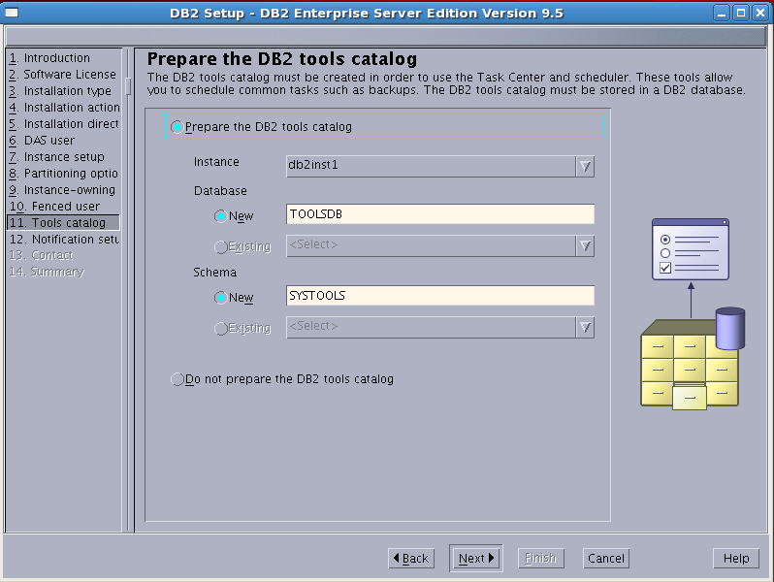

DB2 tools catalog must be created in order to use the Task Center and Scheduler. These tools allow you to schedule common tasks such as backups.

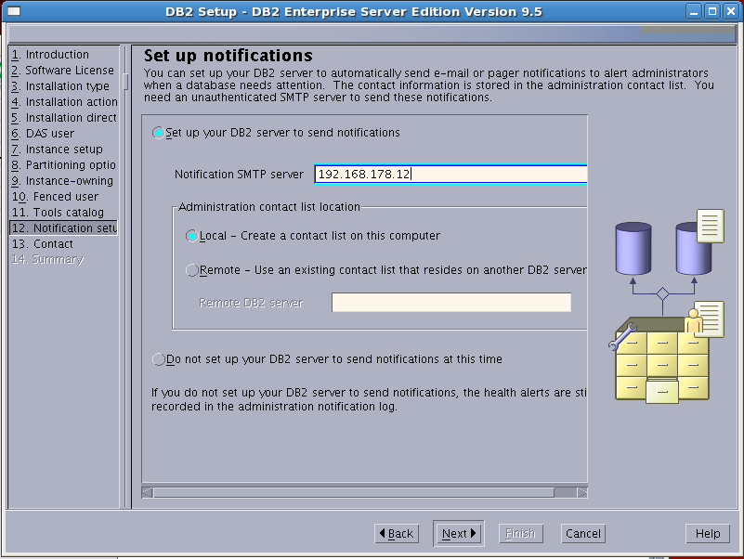

Livingston Intl. SMTP Server : 192.168.178.12

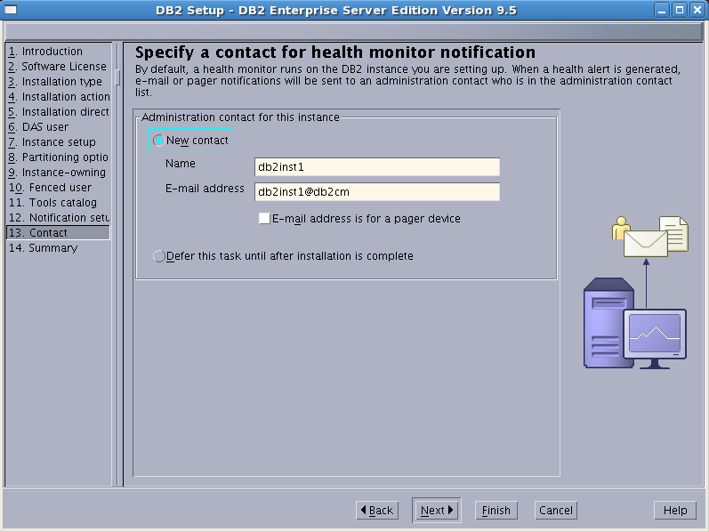

Contact for health monitor:

Name: db2inst1; Email address: db2inst1@ibmserver

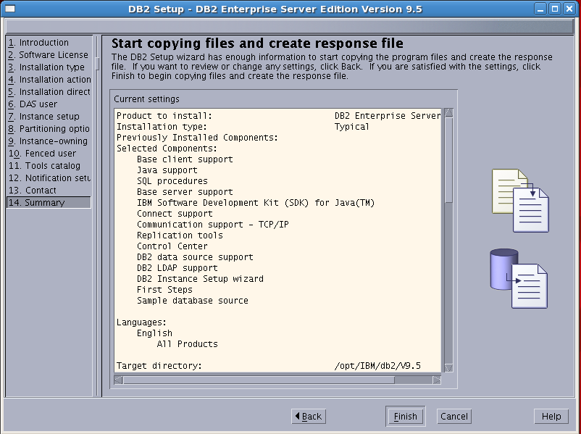

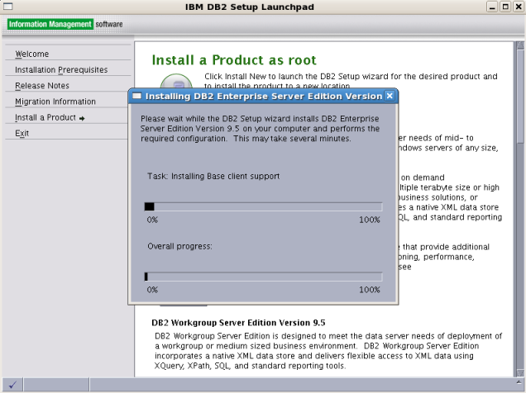

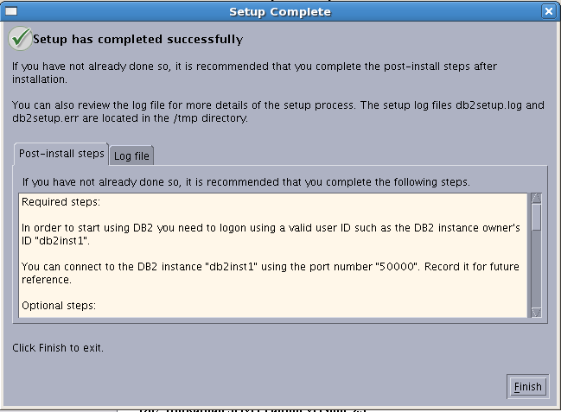

Installation completed.

Set License permanently:

[db2inst1@Linux1 ~]$ db2licm -l

Product name: "DB2 Enterprise Server Edition"

License type: "Trial"

Expiry date: "01/25/2014"

Product identifier: "db2ese"

Version information: "9.5"

Product name: "DB2 Connect Server"

License type: "Trial"

Expiry date: "01/25/2014"

Product identifier: "db2consv"

Version information: "9.5"

[db2inst1@Linux1 ~]$ cat /opt/installedApps/ibm/db2/V9.5/license/nodelock

# IBM Toronto Lab

5fbee0ee6feb.02.09.15.0f.48.00.00.00 tzyyedhqgtafsmbvafsanam8 "1;(_b)" "9.5"

#[admin_comment] "IBM Toronto Lab" "DB2 Enterprise Server Edition" "2145848400" "0" "1" ""

# tar xvf db2license.tar

# cd ./db2license; cp * /opt/ibm/db2/V9.5/license

[db2inst1@Linux1 ~]$ db2licm -l

Product name: "DB2 Enterprise Server Edition"

License type: "License not registered"

Expiry date: "License not registered"

Product identifier: "db2ese"

Version information: "9.5"

Start/Stop DB2 Server:

# su – db2inst1

# db2start

# db2stop

## Install IBM Websphere Application Server V8

Downloads WAS installation packages on ibmserver:/Server/ibmim

# cd /Server/ibmim; ls -l

-rwxr-xr-x 1 root root 119319511 Sep 12 13:34 IBMIM_linux_x86.zip

unzip zip package in the same directory

# unzip *.zip

Install IBM Installation Manager

# ./install

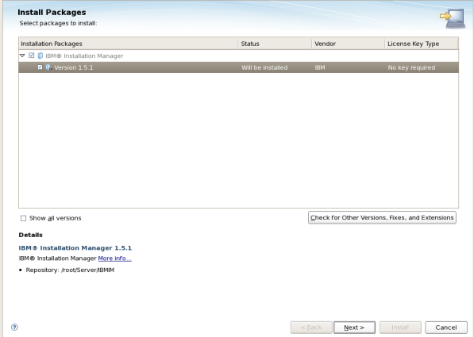

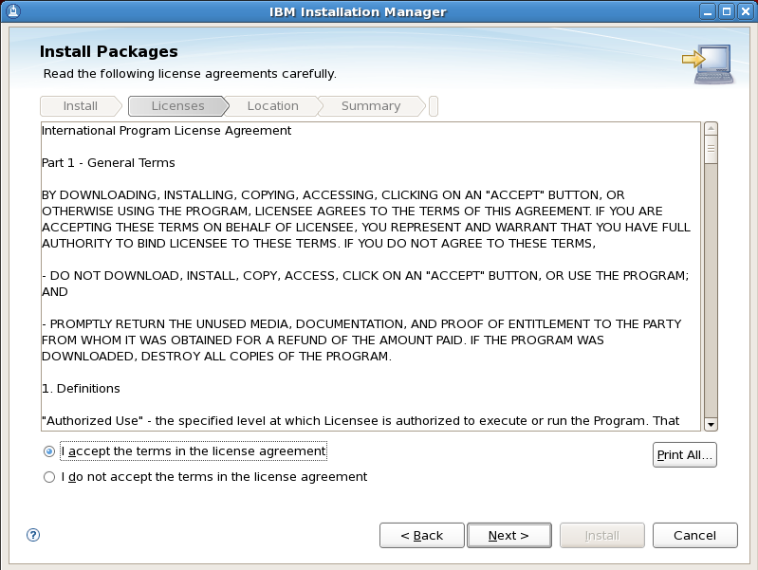

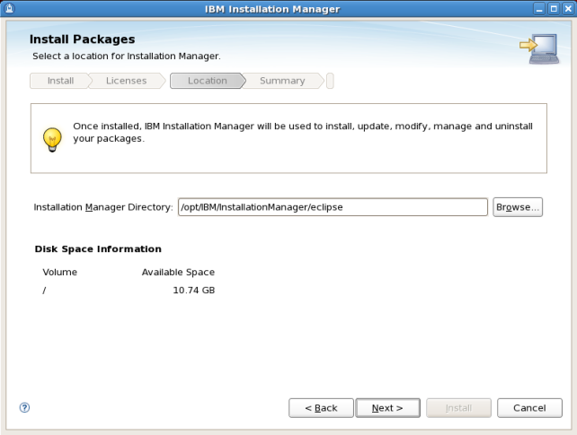

IBM Installation Manager Installed directory: /opt/IBM/InstallationManager/eclipse

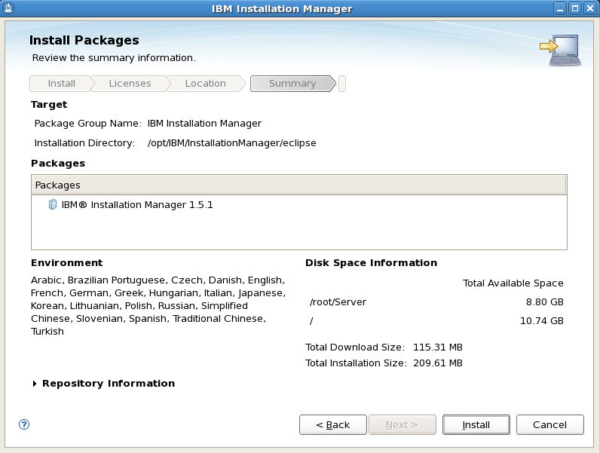

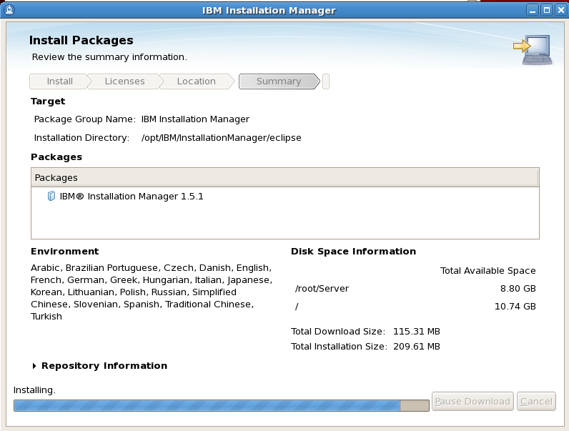

Launch IBM installation Manager

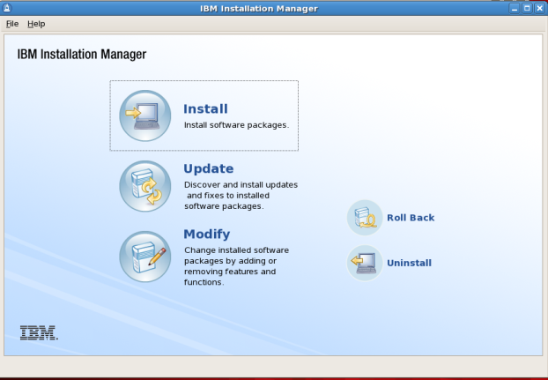

Downloads WAS packages on ibmserver:/Server/ibmwas, and Install WAS

# cd /Server/ibmwas; ls –l *.zip

-rwxr-xr-x 1 root root 951479147 Sep 12 13:38 was.repo.8000.developers.ilan_part1.zip

-rwxr-xr-x 1 root root 933989813 Sep 12 13:40 was.repo.8000.developers.ilan_part2.zip

-rwxr-xr-x 1 root root 857139022 Sep 12 13:42 was.repo.8000.developers.ilan_part3.zip

-rwxr-xr-x 1 root root 240634084 Sep 12 13:42 was.repo.8000.developers.ilan_part4.zip

unzip zip package in the same directory

# unzip *.zip

Start IBM Installation Manager

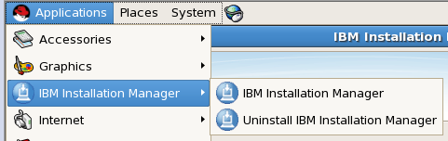

Start The repository connections of WAS:

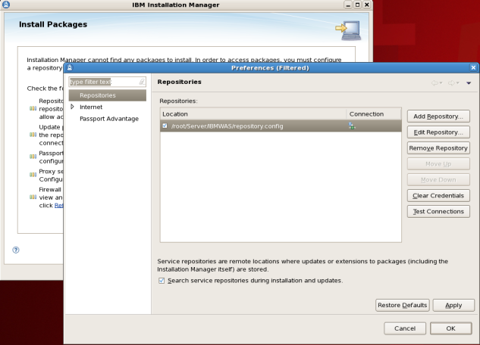

Repository location: /Server/ibmwas/repository.config

or Repository location: /Server/ibmwas/disk1/diskTag.inf

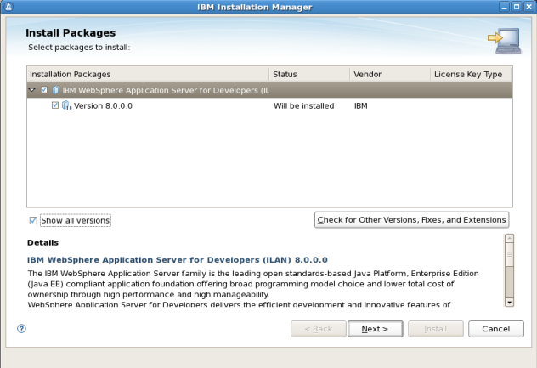

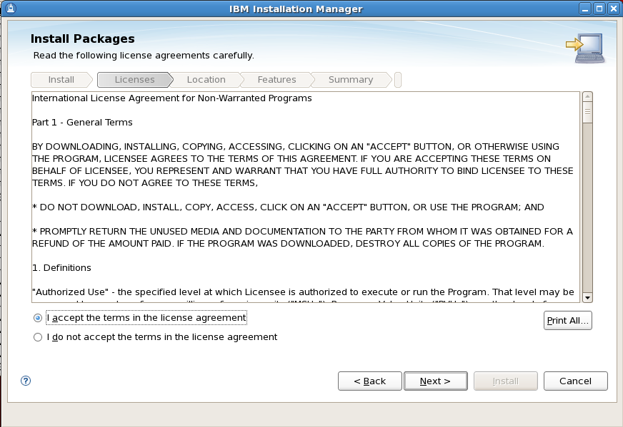

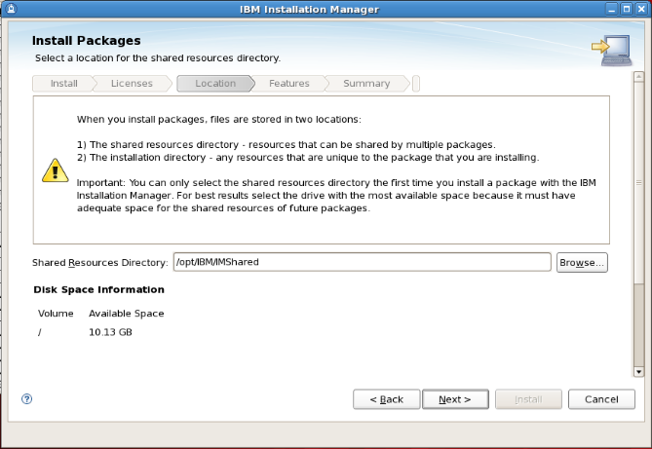

Shared Resources Directory : /opt/IBM/IMShared

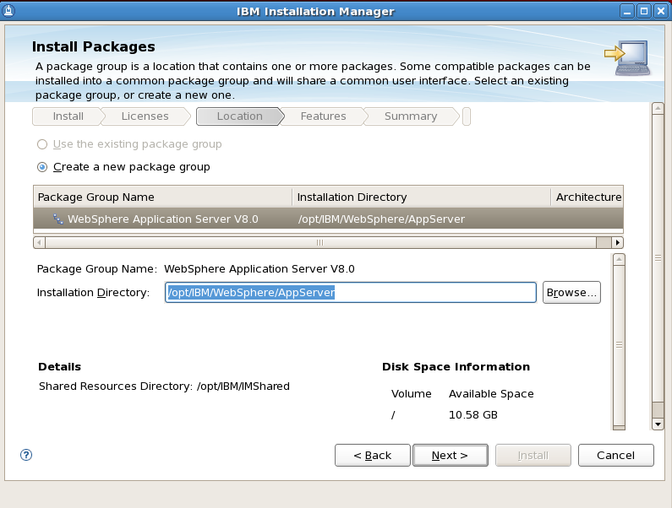

IBM WebSphere Installation Directory: /opt/IBM/WebSphere/AppServer; All WAS product software codes are installed under this directory.

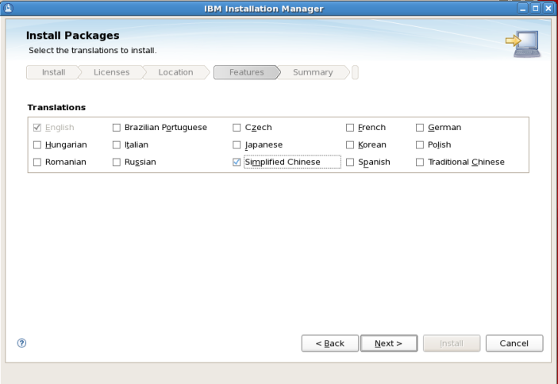

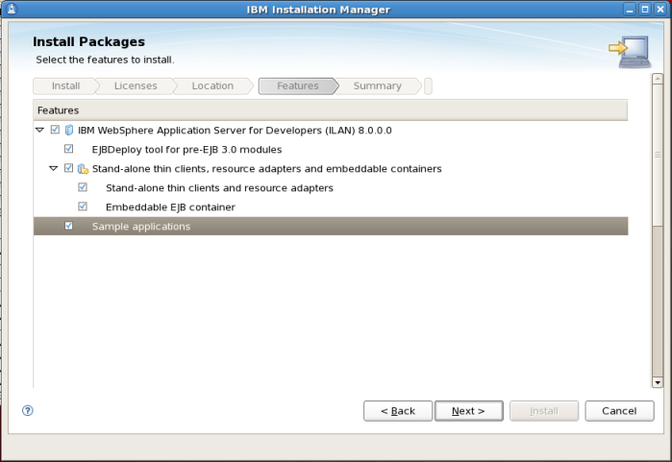

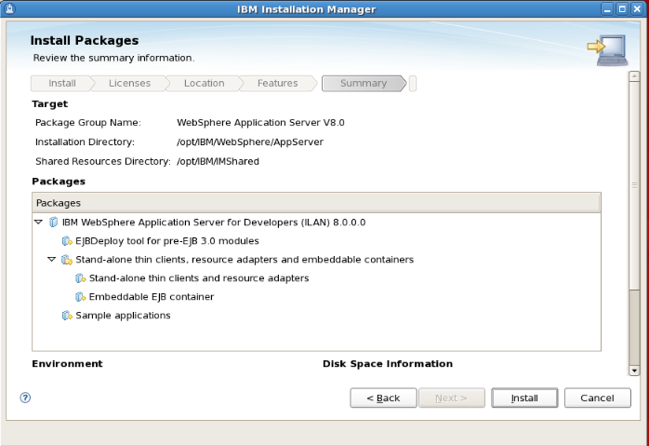

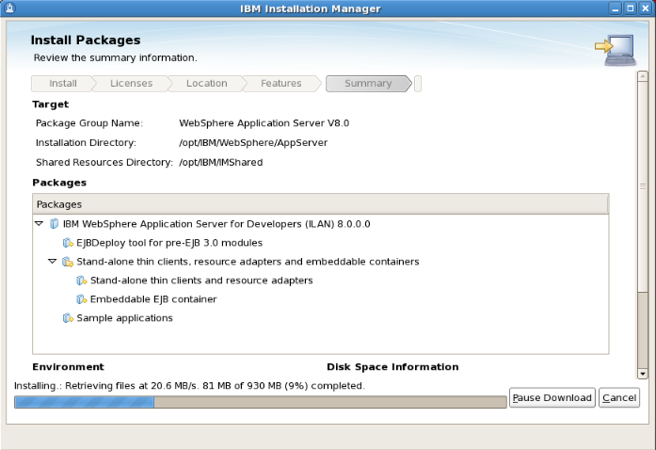

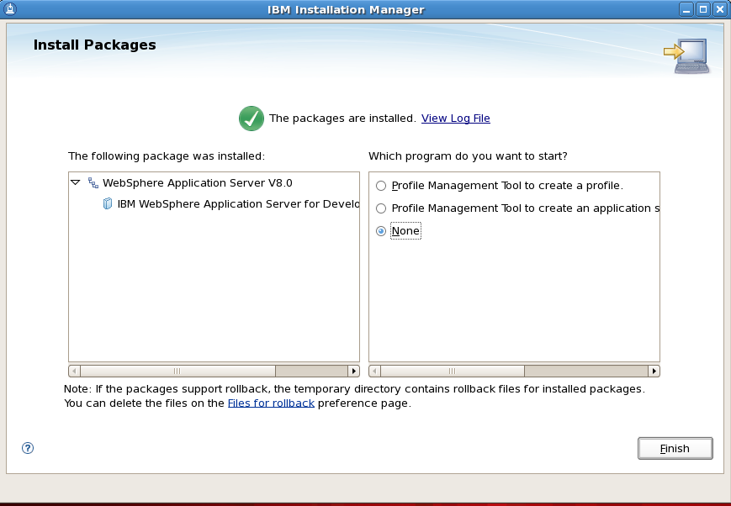

Installation completed.

Create an IBM Web Application Server:

Applications-> IBM Webshphere -> WebSphere Application Server V8.0 -> Tools -> Profile Management Tool

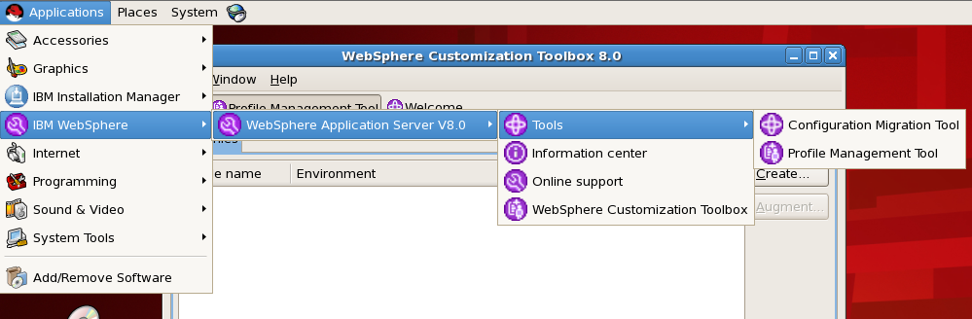

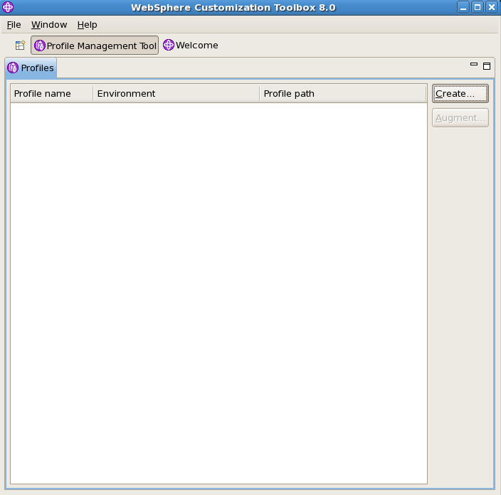

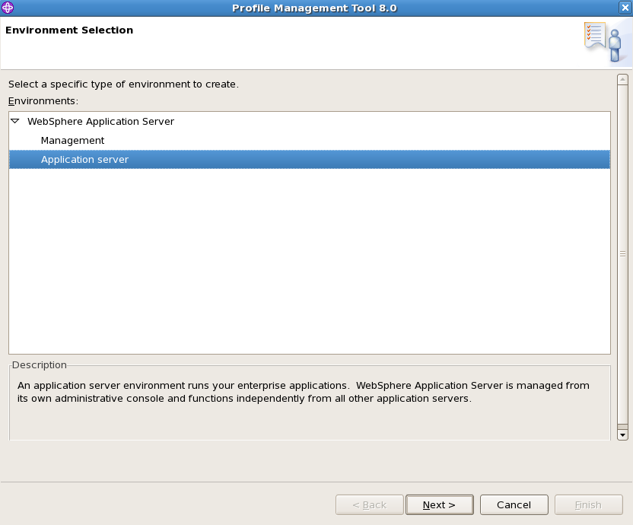

An Application server environment runs your enterprise applications;Normally, all new created WebSphere Application server(AppSrv01/AppSrv02….) are created under /opt/IBM/WebSphere/AppServer/profiles/

WebSphere Application Server is managed from its own administrative console (URL: https://localhost:9043/ibm/console/login.do) and functions independently from all other application servers.

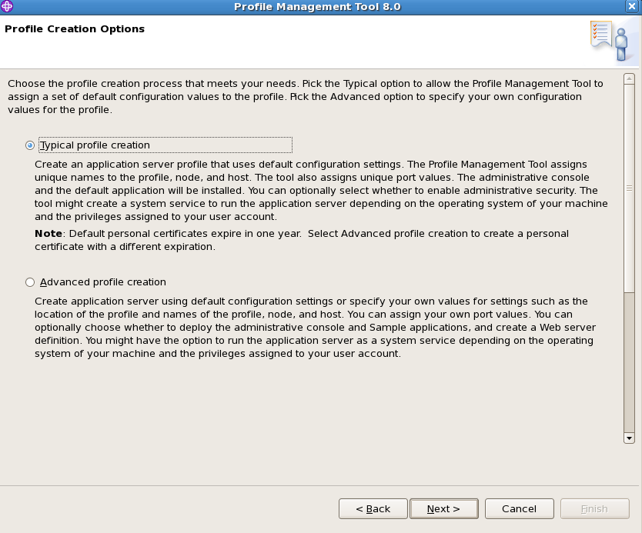

Create an application server profile that uses default configuration settings. The Profile Management Tool assigns unique names to the profile, node, and host. The tool also assigns unique port values. The administrative console and the default application will be installed. You can optionally select whether to administrative security. The tool might create a system service to run the application server depending on the operating system of your machine and the privileges assigned to your user account.

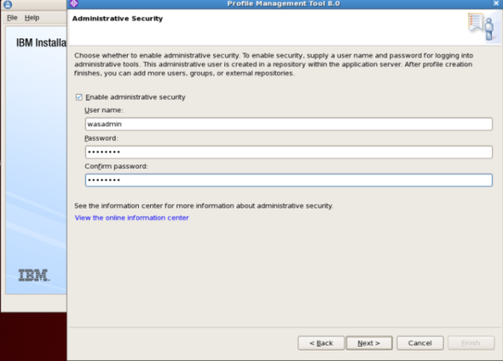

Websphere administrative security User name: wasadmin; password: wasadmin

Application server ports defination location: /opt/IBM/WebSphere/AppServer/profiles/AppSrv01/properties/portdef.props

Nodename: ibmserverNode01

Server name : server1

Hostname ibmserver

Administrative console port: 9060

Administrative console secure port: 9043

HTTP transport port: 9080

HTTPS transport port: 9443

Bootstrap port: 2809

SOAP connector port: 8880

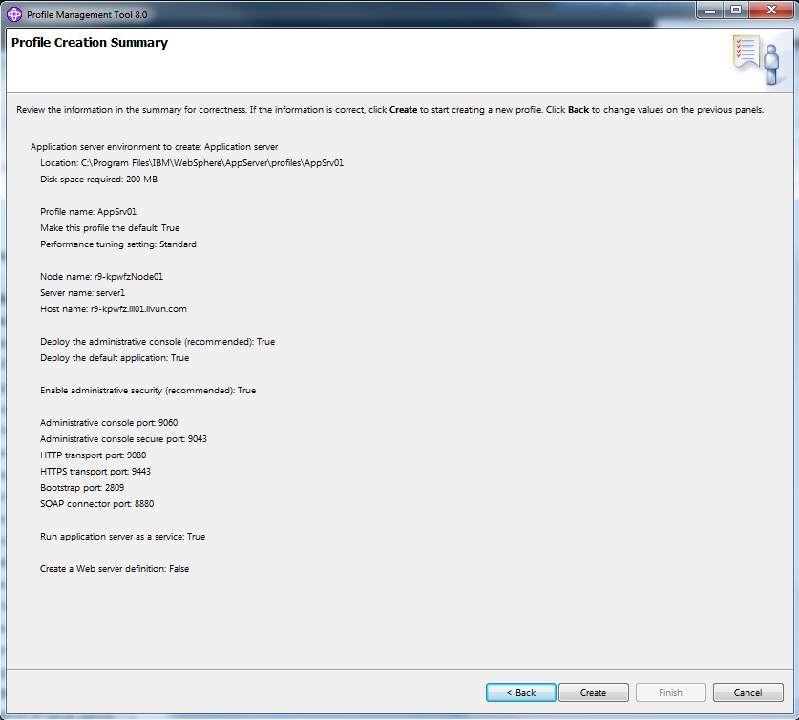

WebSphere Application Server ibmserver is running on port: 9080 for profile AppSrv01

login WAS URL: https://localhost:9043/ibm/console/login.do

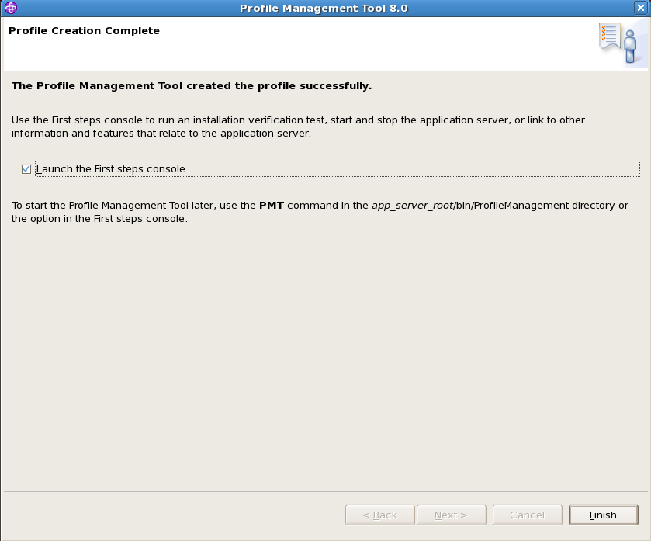

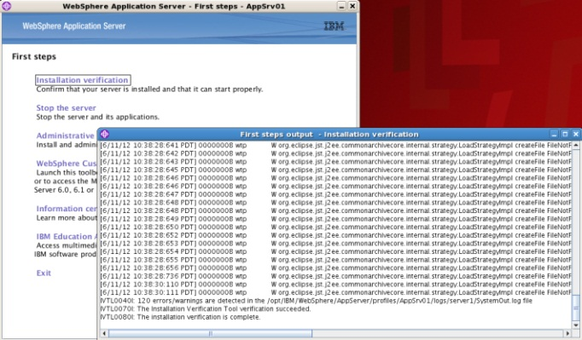

Install verification successfully.

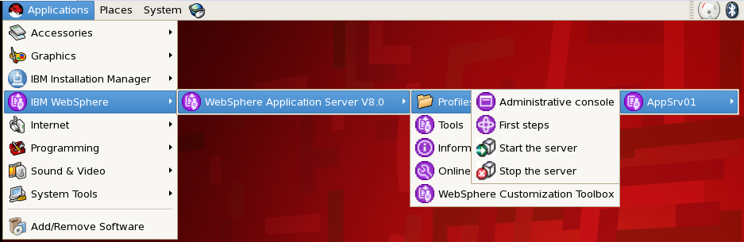

Start/Stop WebSphere Application Server

# /opt/IBM/WebSphere/AppServer/profiles/AppSrv01/bin/startNode.sh

# /opt/IBM/WebSphere/AppServer/profiles/AppSrv01/bin/startServer.sh server1 –nowait

# /opt/IBM/WebSphere/AppServer/profiles/AppSrv01/bin/stopServer.sh server1

# /opt/IBM/WebSphere/AppServer/profiles/AppSrv01/bin/stopNode.sh

When you got Error: WSVR0028I: The product has expired

[root@ibmserver properties]# pwd

/opt/IBM/WebSphere/AppServer/properties

[root@ibmserver properties]# mv was.license was.license.bkup

## Install IBM DB2 Content Manager V8

cd /Server/ibmcmv8; gunzip CZZ9FML.tar.gz | tar xvf -

./install_CM

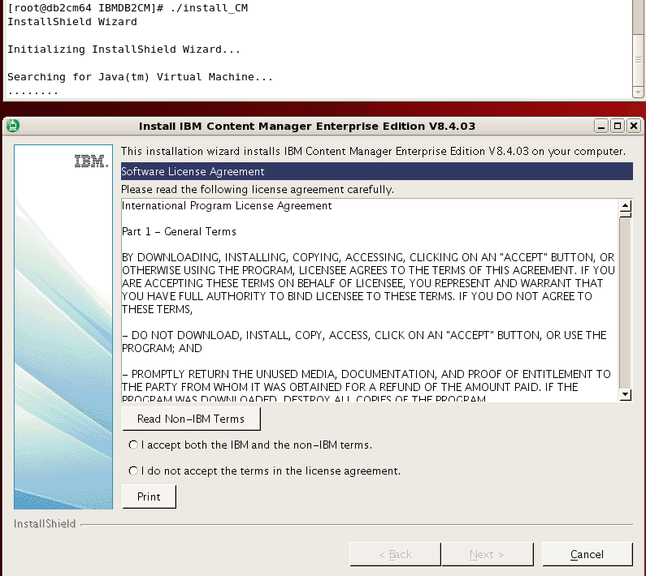

Accept license agreement.

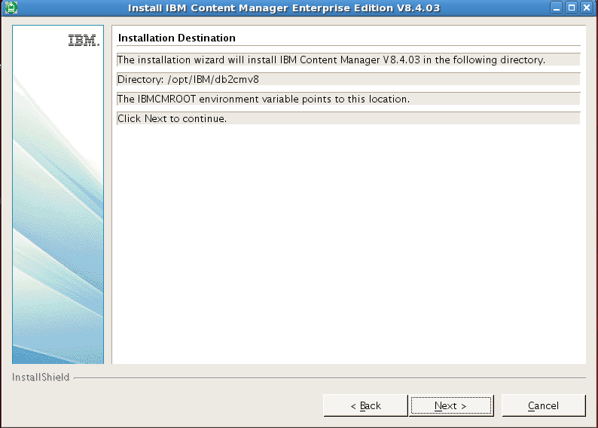

Installation Directory: /opt/IBM/db2cmv8

IBMCMROOT=/opt/IBM/db2cmv8

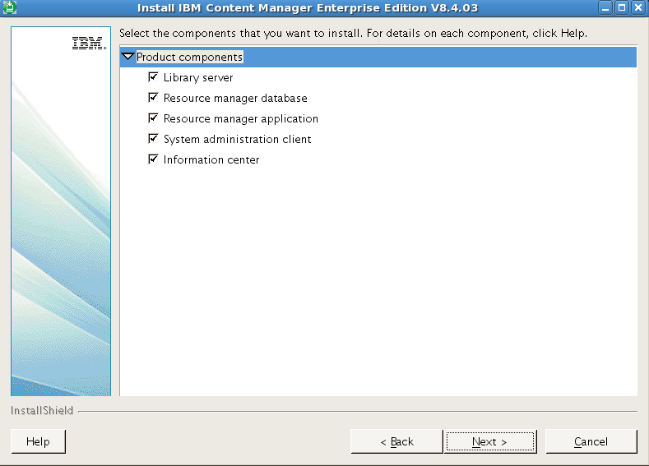

Installed Product components:

* Library server
* Resource manager database
* Resource manager application
* System administration client
* Information center

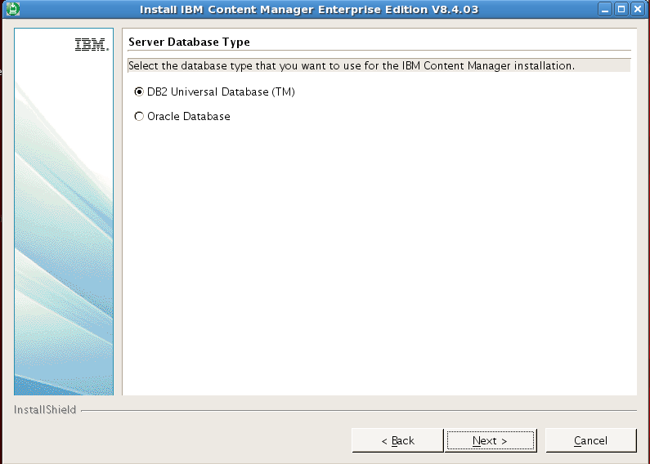

Select DB2 database for IBM Content Manager

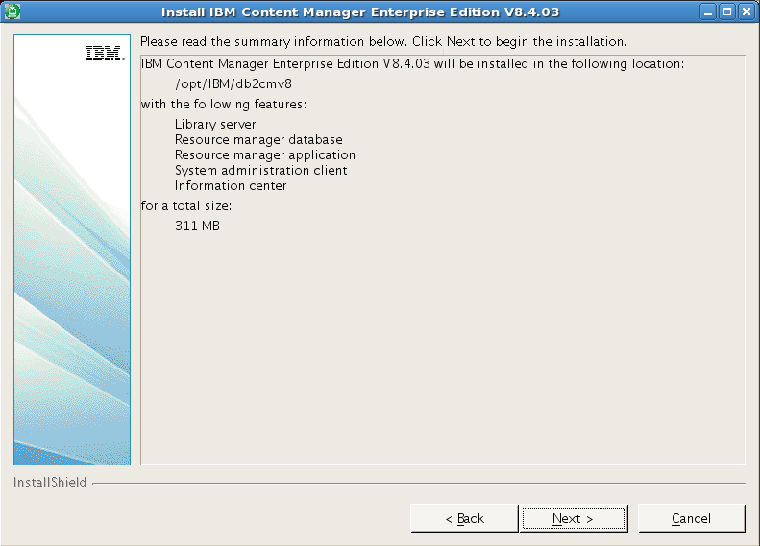

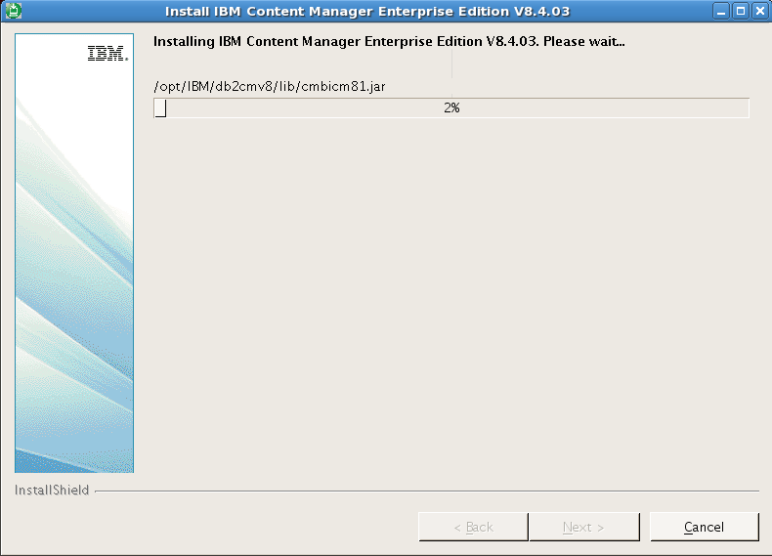

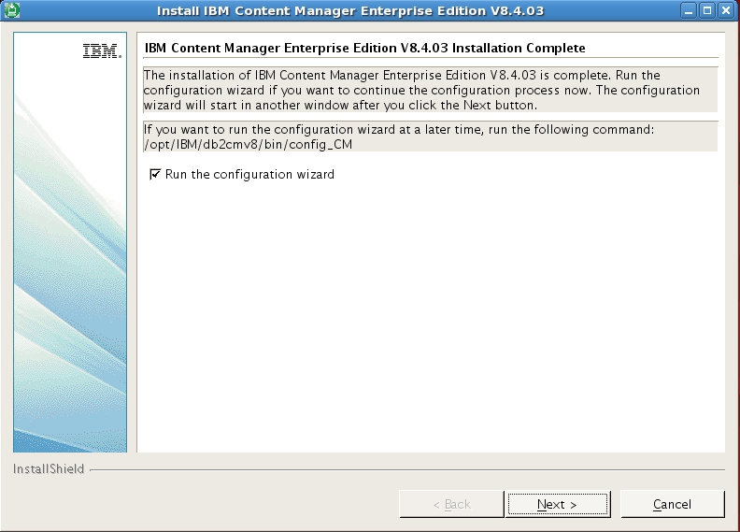

Check the Run the configuration wizard to configure the content manager

you can run /opt/IBM/db2cmv8/bin/config_CM to start CM configuration later

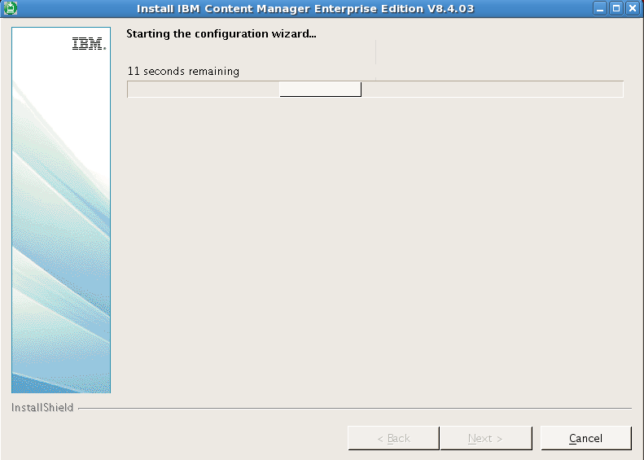

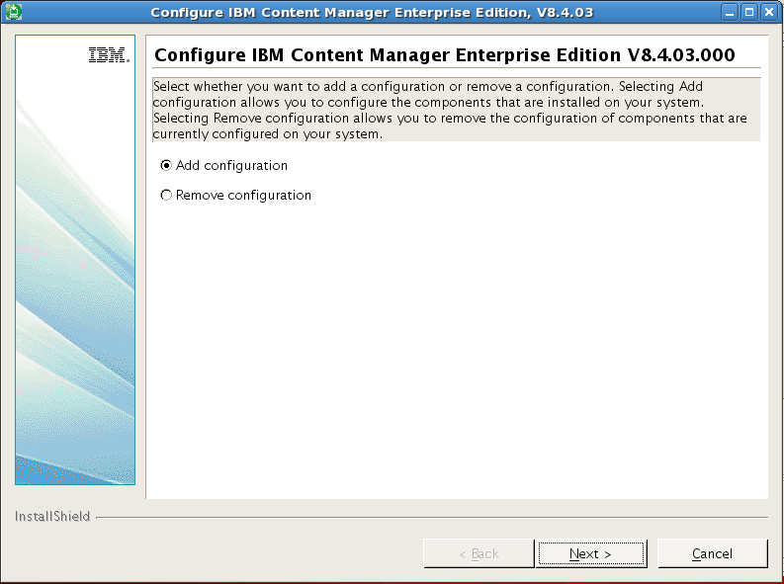

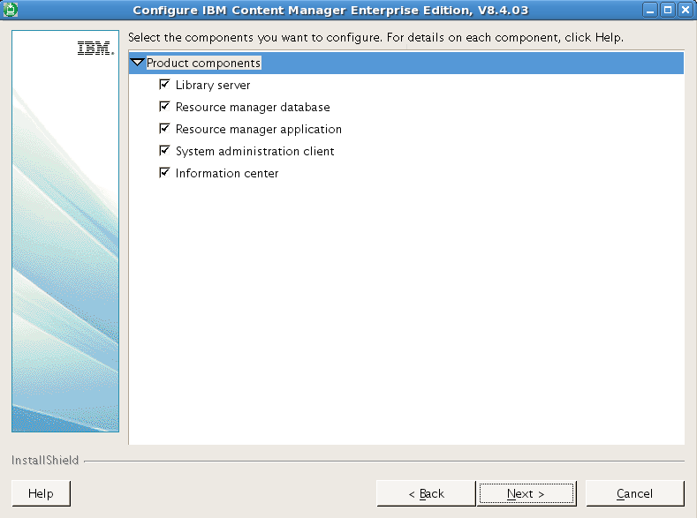

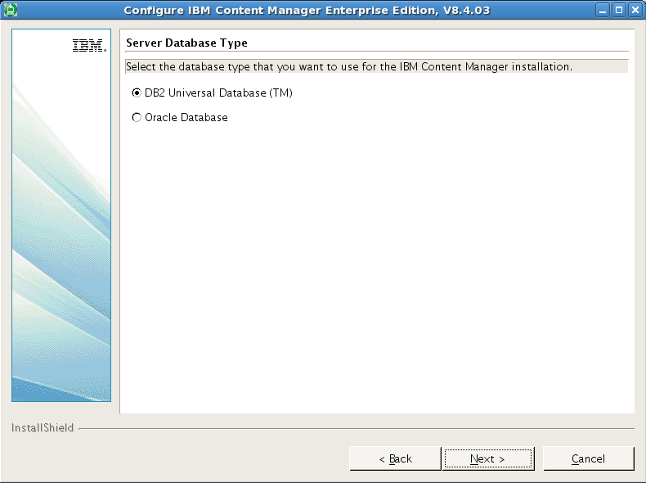

Select DB2 Universal Database

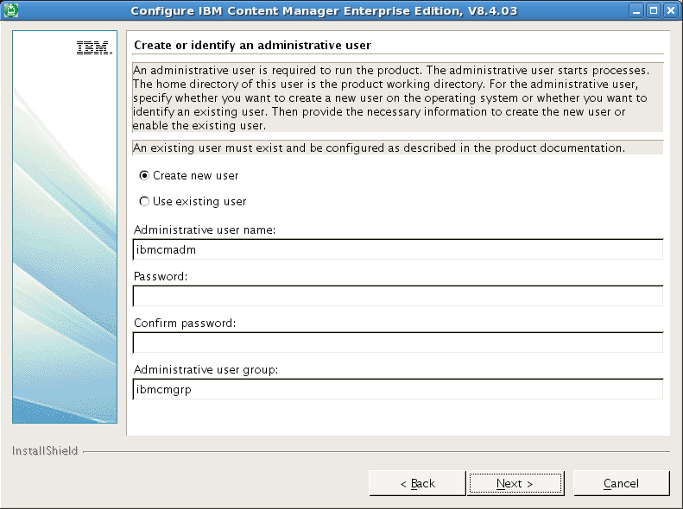

Create an administrative user: ibmcmadm; password: ibmcmadm

Administrative user group: ibmcmgrp

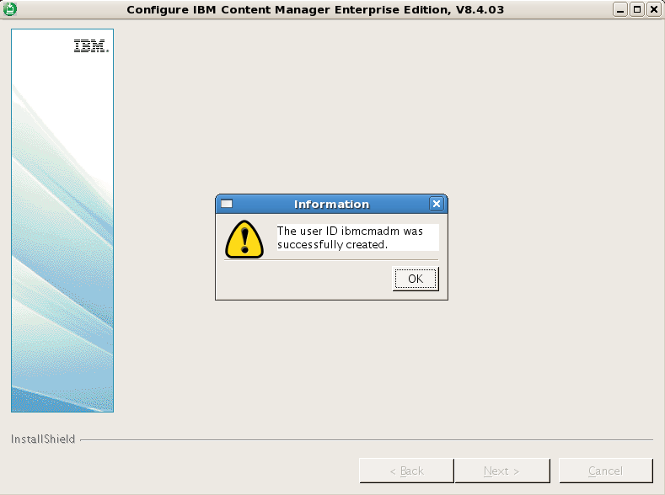

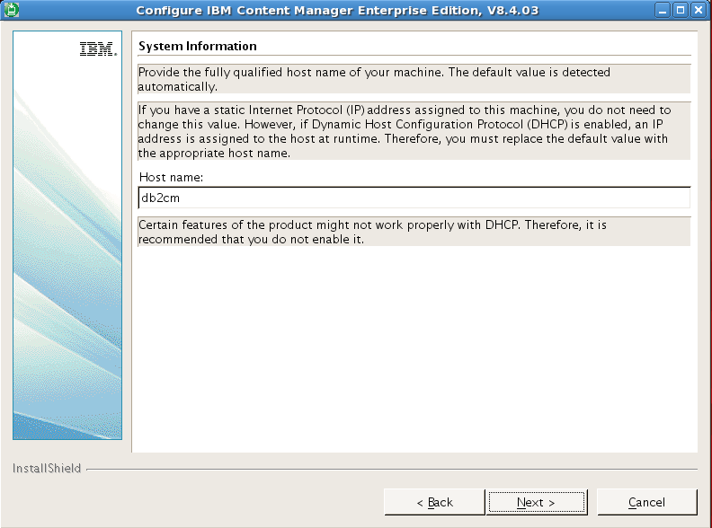

Hostname: ibmserver

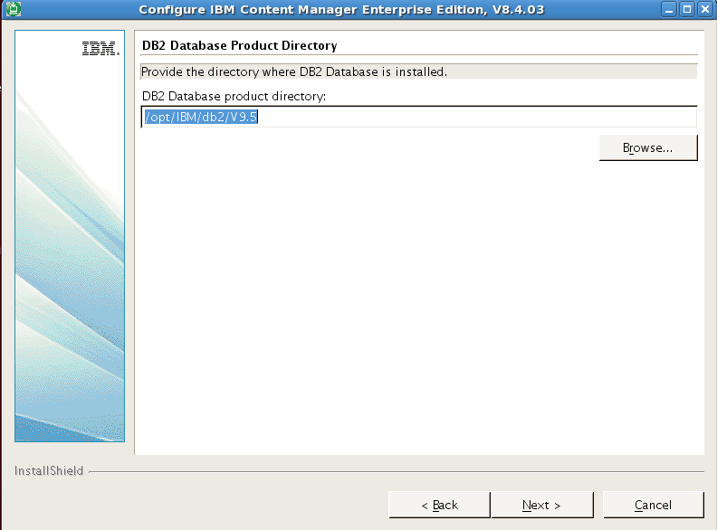

DB2 Database product directory: /opt/IBM/db2/V9.5

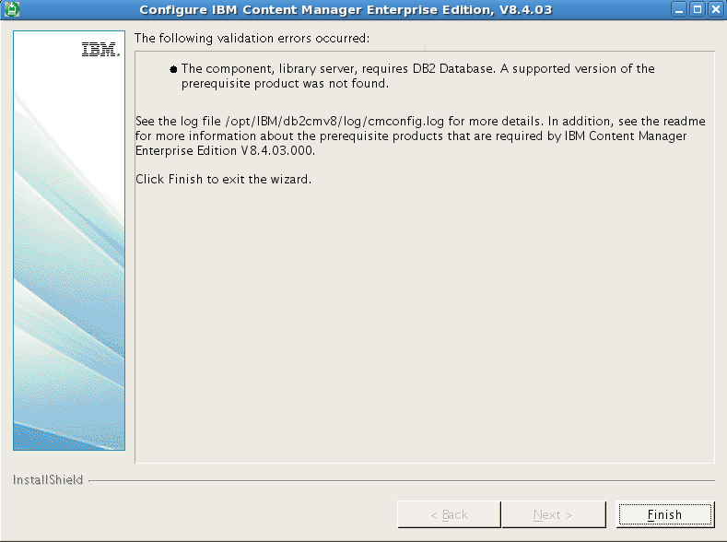

To create new database: icmnlsdb, make sure that db2 server is started

$ db2start

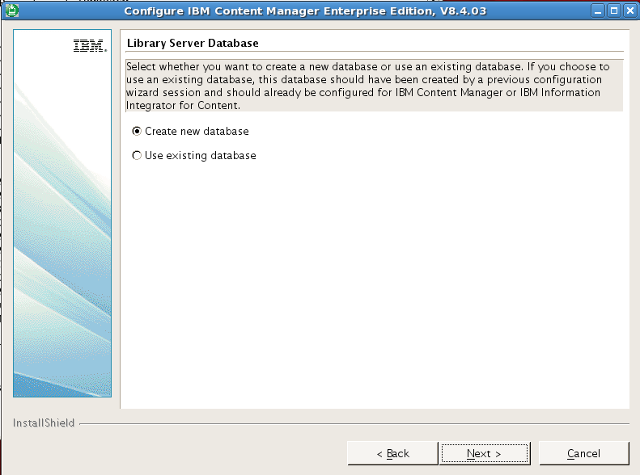

Select Create a new database

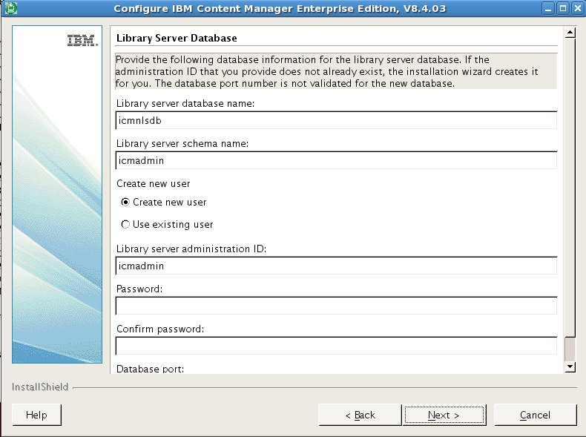

Library Server database name: icmnlsdb

Library server schema name: icmadmin

Library server administration ID: icmadmin; password: icmadmin

Database port: 50000

DB2 Database instance owner user ID: db2inst1

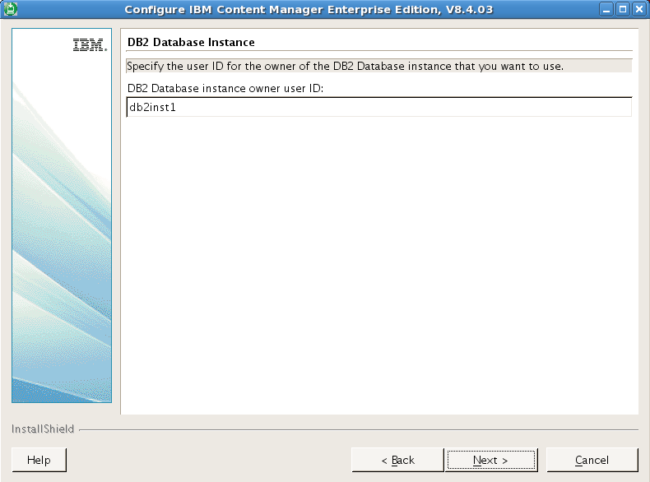

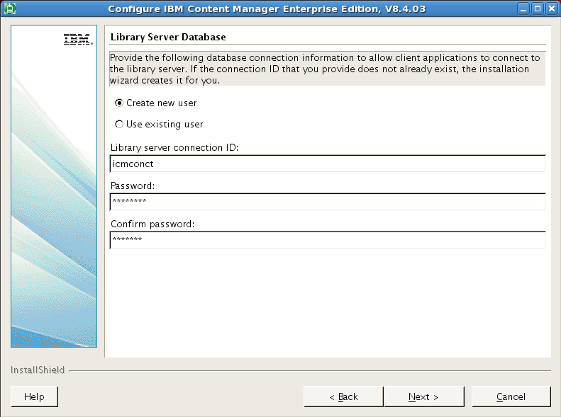

Client Application connection ID: icmconct; password: icmconct

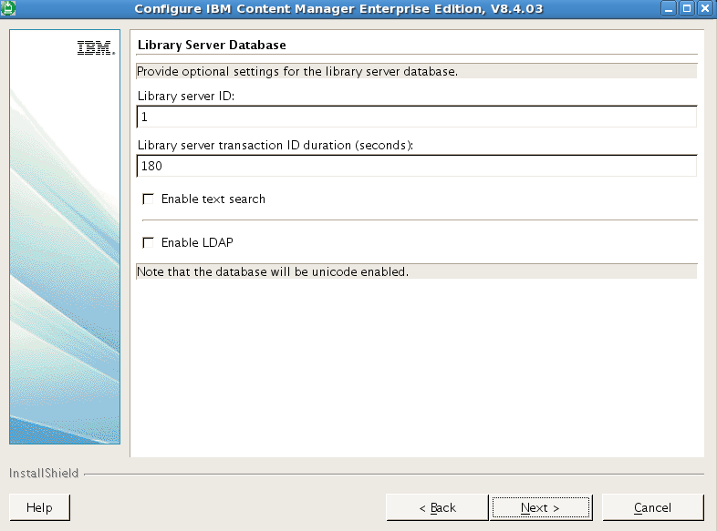

Library server ID: 1

Library server transaction ID duration (seconds): 180

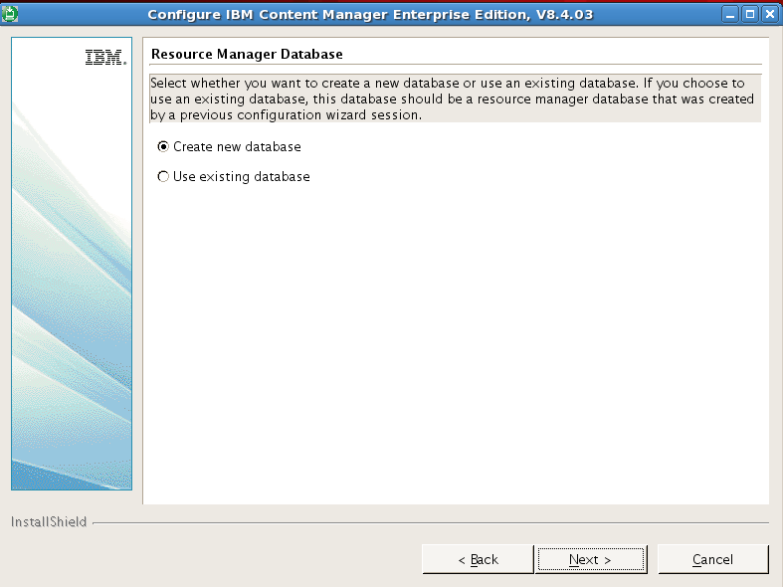

Create new Resource Manager Database.

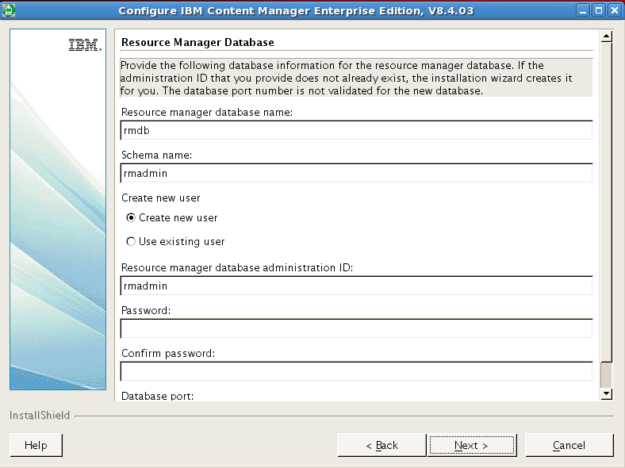

Resource manager database name: rmdb

schema name: rmadmin

Resource manager database administration ID: rmadmin; password: rmadmin

Database port: 50000

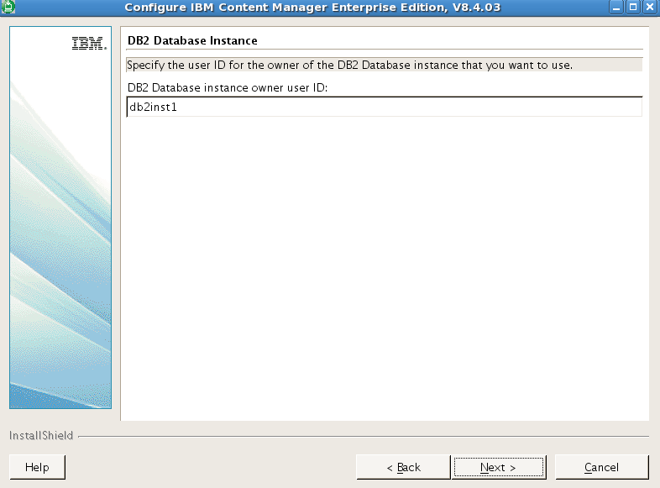

/home/db2inst1/db2inst1/NODE0000

* TOOLSDB
* **ICMNLSDB**
* **RMDB**
* SQL00001
* **SQL00002**
* **SQL00003**
* sqldbdir

Configure Resource manager Application:

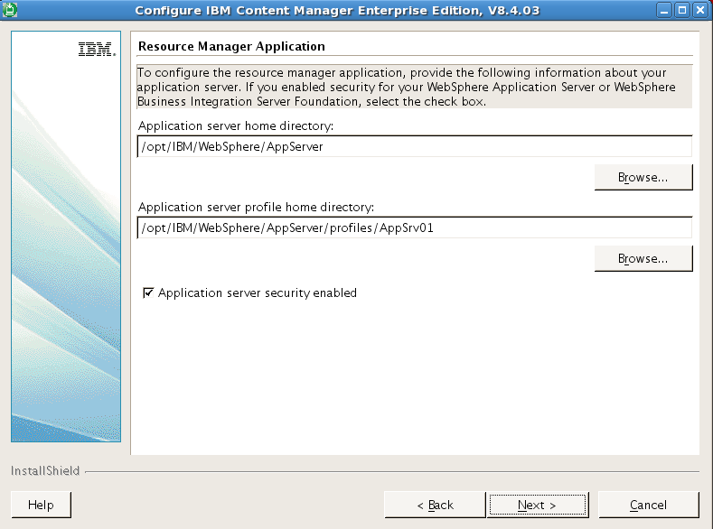

Application server home directory: /opt/IBM/WebSphere/AppServer

Application server profile home directory: /opt/IBM/WebSphere/AppServer/profiles/AppSrv01

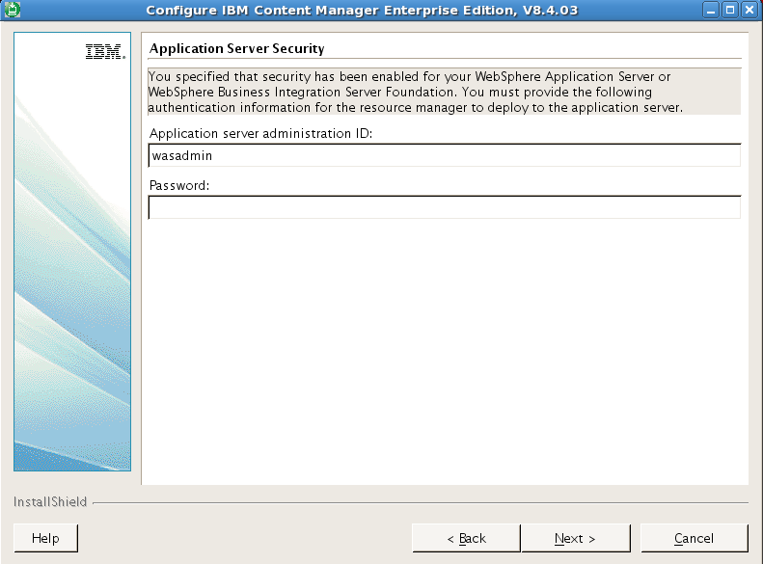

Application server administration ID: wasadmin; password: wasadmin

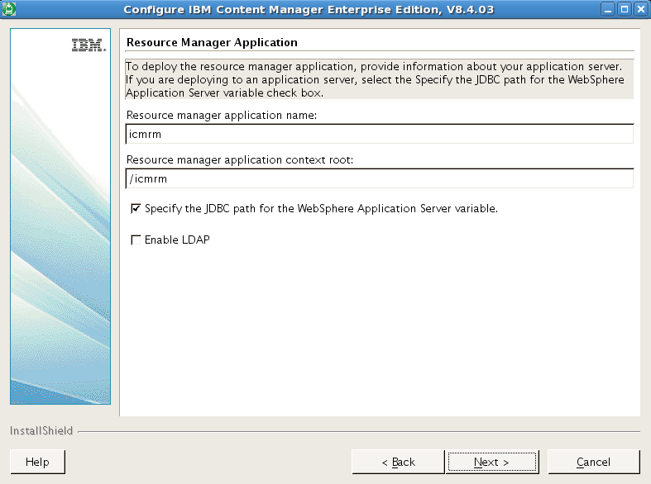

To deploy Resource manager application on IBM WebSphere Application server; one again, IBM DB2 Resource Manager is just a application named **icmrm** running under IBM WebSphere Application Server named **server1,** within profile named **AppSrv01**

/opt/IBM/WebSphere/AppServer/profile/installedApps/ibmserverNode01Cell

* DefaultApplication.ear
* **icmrm.ear**
* ivtApp.ear
* query.ear

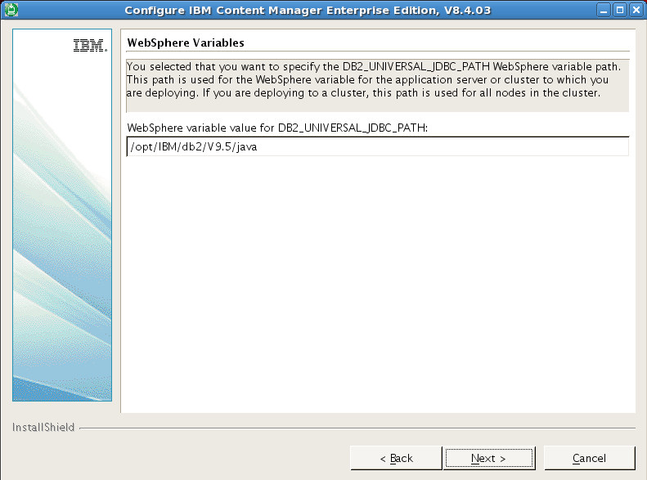

WebSphere JDBC path: /opt/IBM/db2/V9.5/java

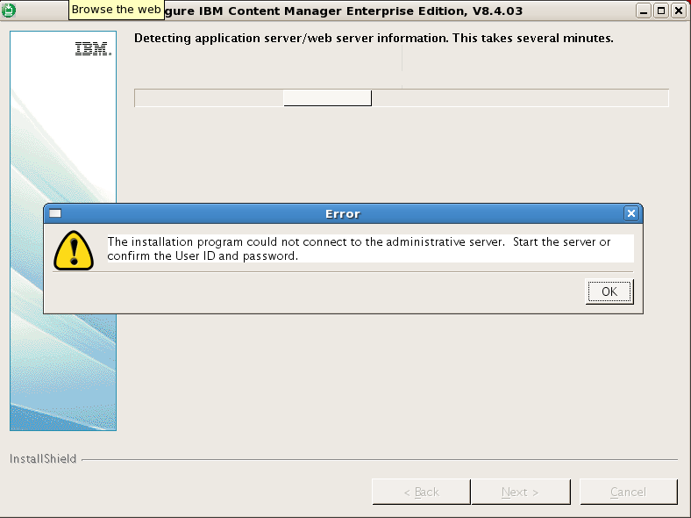

Start WebSphere Application Server:

# /opt/IBM/WebSphere/AppServer/profiles/AppSrv01/bin/startServer.sh server1 -nowait

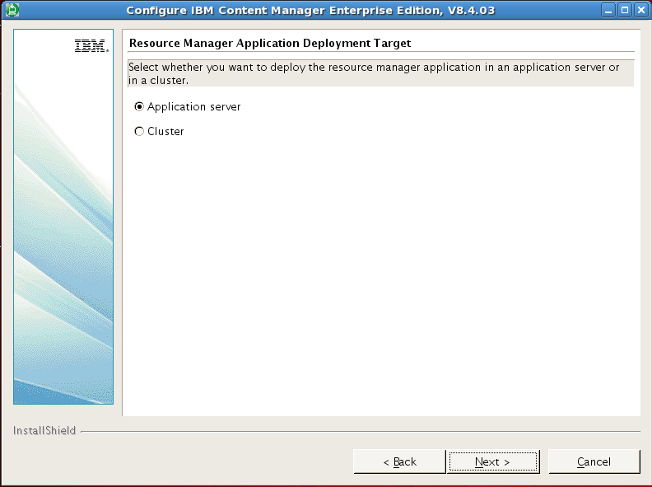

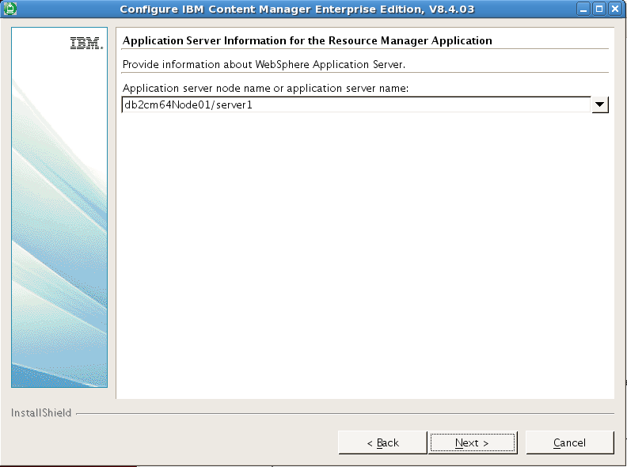

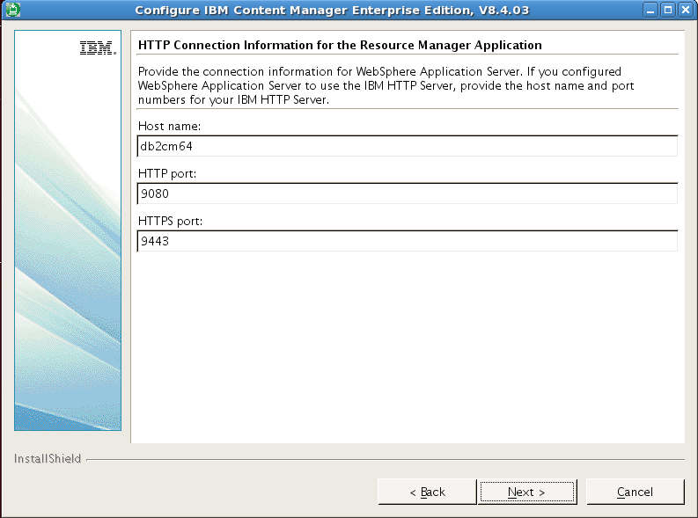

Provide HTTP connection Information to Resource Manager Application, this HTTP server is WebSphere embedded HTTP Server:

Host name: ibmserver

HTTP port: 9080

HTTPS port: 9443

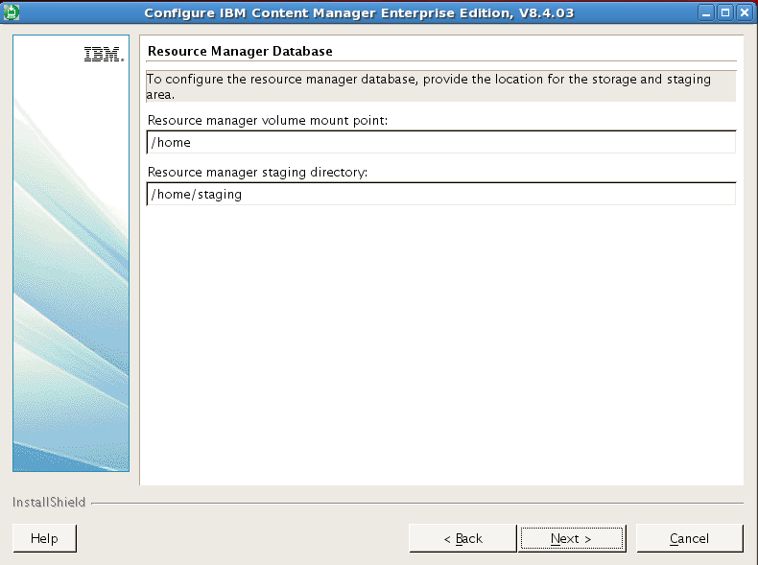

Resource Manager Database Volume mount point: /home

Resource Manager Database staging directory: /home/staging

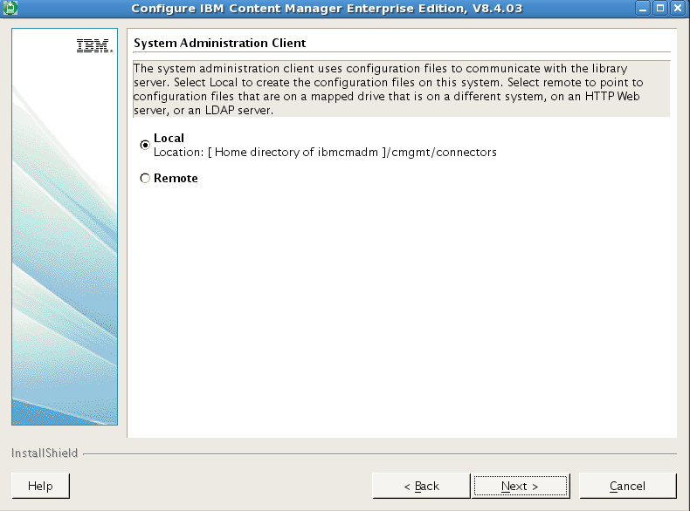

System Administration Clients uses configuration files to communicate with Library Server, Select Local to create the configuration files on this system.

/home/ibmcmadm/cmgmt/connectors

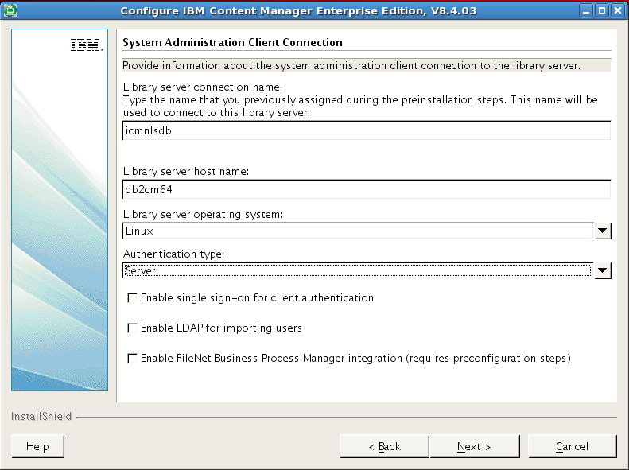

* Library server connection name: icmnlsdb
* Library server hostname: ibmserver
* Library server operation system: Linux
* Authentication type: Server

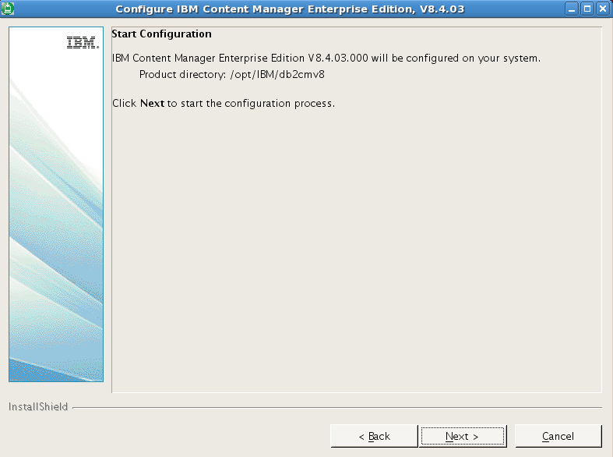

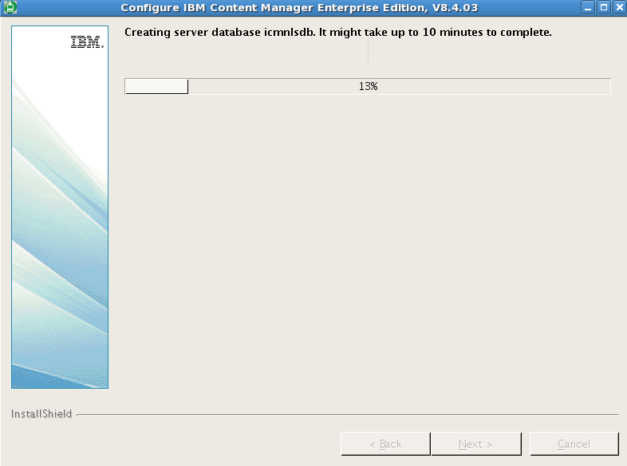

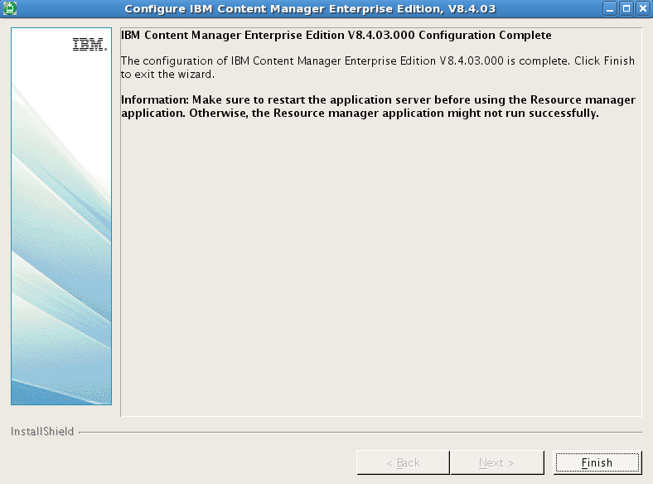

Installation completed.

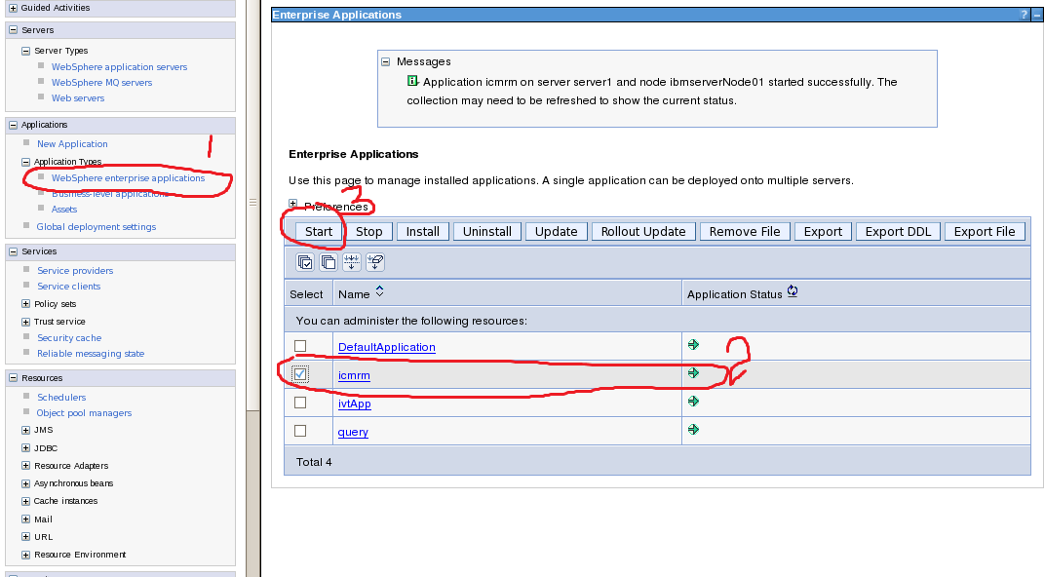

Starting the Content Manager System administration client

# chown -R ibmcmadm:ibmcmgrp /home/ibmcmadm/log/firststeps;

# xhost +

# su – icmadmin

$ cd /opt/IBM/db2cmv8/admin/common

$ ./cmadmin.sh

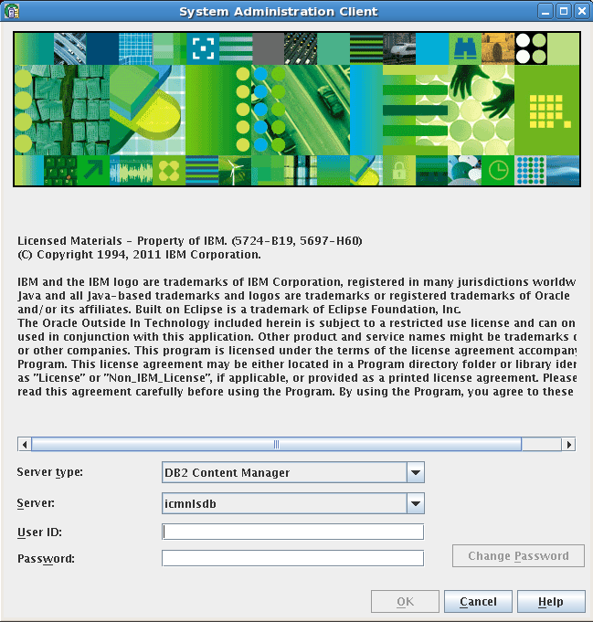

User ID: icmadmin; password: icmadmin

Add more Library Server (icmnlsdb)

-bash-3.2$ cd /home/ibmcmadm/cmgmt/connectors

-bash-3.2$ more cmbicmsrvs.ini

ICMSERVER=ibmserver(icmnlsdb)

ICMSERVERREPTYPE=DB2

ICMSCHEMA=icmadmin

ICMSSO=FALSE

ICMDBAUTH=SERVER

ICMREMOTE=TRUE

ICMHOSTNAME=ibmserver

ICMPORT=50000

ICMREMOTEDB=icmnlsdb

ICMNODENAME=

ICMOSTYPE=LINUX

ICMJDBCDRIVER=

ICMJDBCURL=

ICMJNDIREF=

ICMDBVER=

ICMGMTSYSATTRTS=

ICMSERVER=CM07(icmnlsdb)

ICMSERVERREPTYPE=DB2

ICMSCHEMA=icmadmin

ICMSSO=FALSE

ICMDBAUTH=SERVER

ICMREMOTE=TRUE

ICMHOSTNAME=cm07

ICMPORT=50000

ICMREMOTEDB=icmnlsdb

ICMNODENAME=TEST

ICMOSTYPE=AIX

ICMJDBCDRIVER=

ICMJDBCURL=

ICMJNDIREF=

ICMDBVER=

ICMGMTSYSATTRTS=

ICMSERVER=LMS(icmnlsdb)

ICMSERVERREPTYPE=DB2

ICMSCHEMA=icmadmin

ICMSSO=FALSE

ICMDBAUTH=SERVER

ICMREMOTE=TRUE

ICMHOSTNAME=admsrv1_svc

ICMPORT=50000

ICMREMOTEDB=icmnlsdb

ICMNODENAME=

ICMOSTYPE=AIX

ICMJDBCDRIVER=

ICMJDBCURL=

ICMJNDIREF=

ICMDBVER=

ICMGMTSYSATTRTS=

ICMSERVER=cm07

ICMSERVERREPTYPE=DB2

ICMSCHEMA=ICMADMIN

ICMSSO=FALSE

ICMDBAUTH=SERVER

ICMREMOTE=FALSE

ICMHOSTNAME=cm07

ICMPORT=50000

ICMREMOTEDB=icmnlsdb

ICMNODENAME=DB2INST1

ICMOSTYPE=AIX

ICMJDBCDRIVER=

ICMJDBCURL=

ICMSERVER=lmsls

ICMSERVERREPTYPE=DB2

ICMSCHEMA=ICMADMIN

ICMSSO=FALSE

ICMDBAUTH=SERVER

ICMREMOTE=true

ICMHOSTNAME=admsrv1_svc

ICMPORT=50000

ICMREMOTEDB=icmnlsdb

ICMNODENAME=lms

ICMOSTYPE=AIX

ICMJDBCDRIVER=

ICMJDBCURL=

ICMSERVER=CM05DB

ICMSERVERREPTYPE=DB2

ICMSCHEMA=ICMADMIN

ICMSSO=FALSE

ICMDBAUTH=SERVER

ICMREMOTE=FALSE

ICMHOSTNAME=cm05_svc

ICMPORT=50000

ICMREMOTEDB=icmnlsdb

ICMNODENAME=DB2INST1

ICMOSTYPE=AIX

ICMJDBCDRIVER=

ICMJDBCURL=

ICMSERVER=icmnlsdb

ICMSERVERREPTYPE=DB2

ICMSCHEMA=ICMADMIN

ICMSSO=FALSE

ICMDBAUTH=SERVER

ICMREMOTE=FALSE

ICMHOSTNAME=cm07

ICMPORT=50000

ICMREMOTEDB=icmnlsdb

ICMNODENAME=DB2INST1

ICMOSTYPE=AIX

ICMJDBCDRIVER=

ICMJDBCURL=

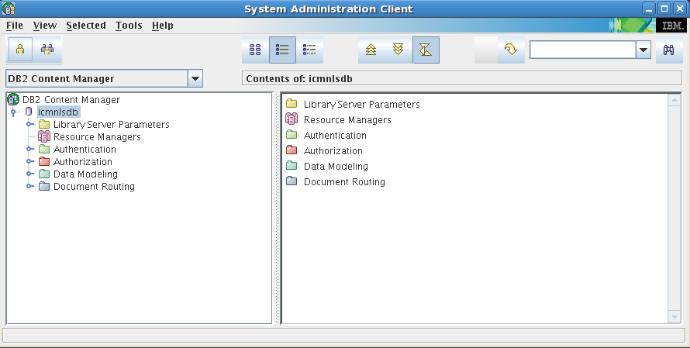

Resource Manager Administration console Website:

[https://ibmserver:9443/icmrm/admin/jsf/login.jsp](https://db2cm64:9443/icmrm/admin/jsf/login.jsp)?

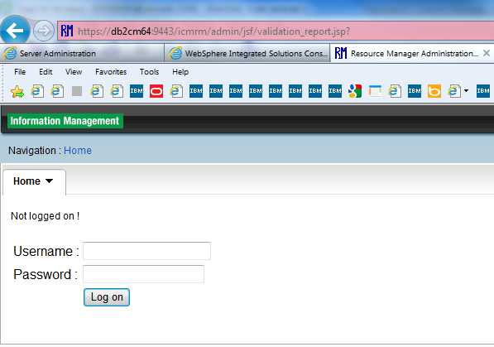

Username: rmadmin

Password: rmadmin

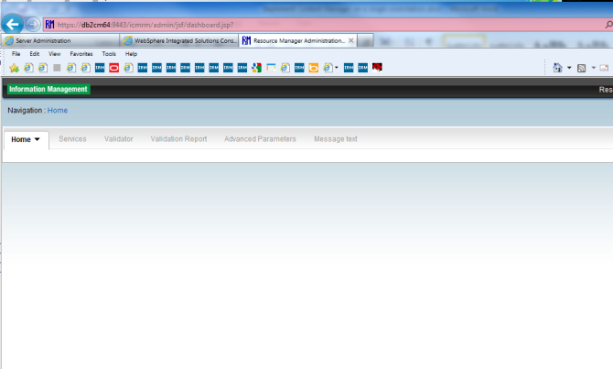

TIP:

Process to uninstall CM

[root@ibmserver _uninstCM]# ./uninstall_CM

InstallShield Wizard

Initializing InstallShield Wizard...

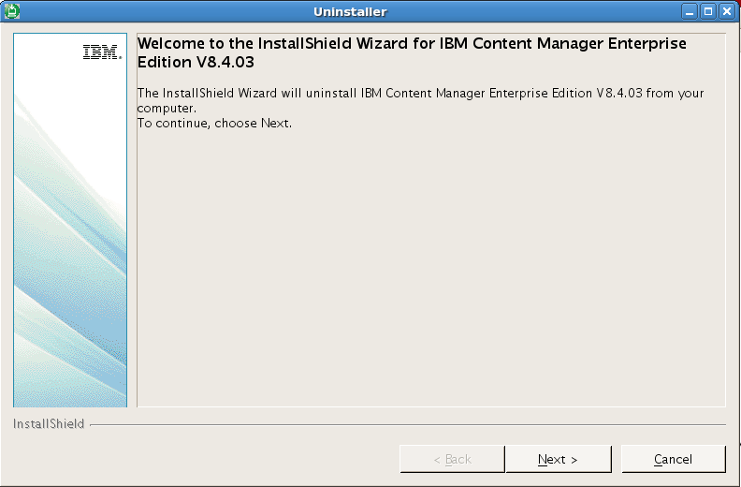

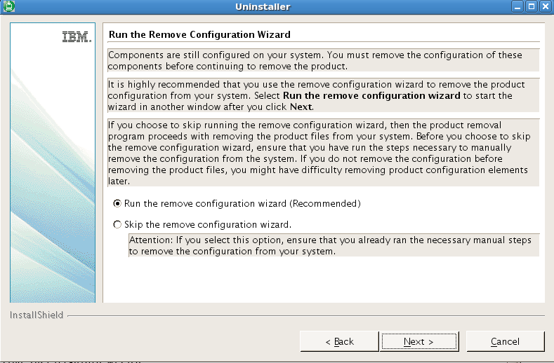

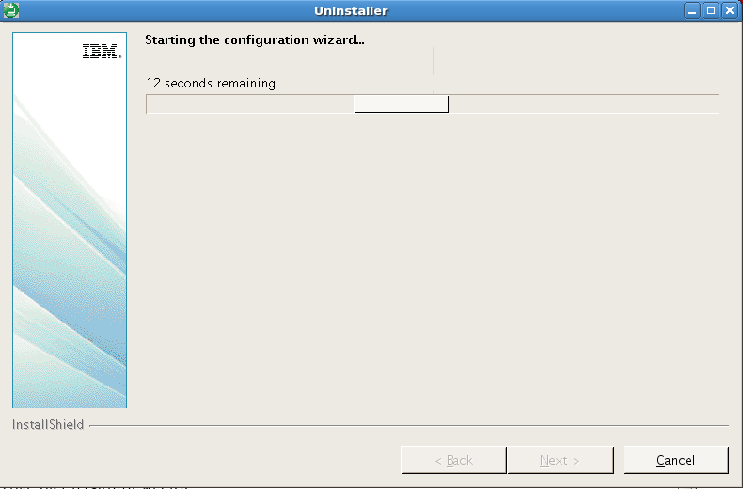

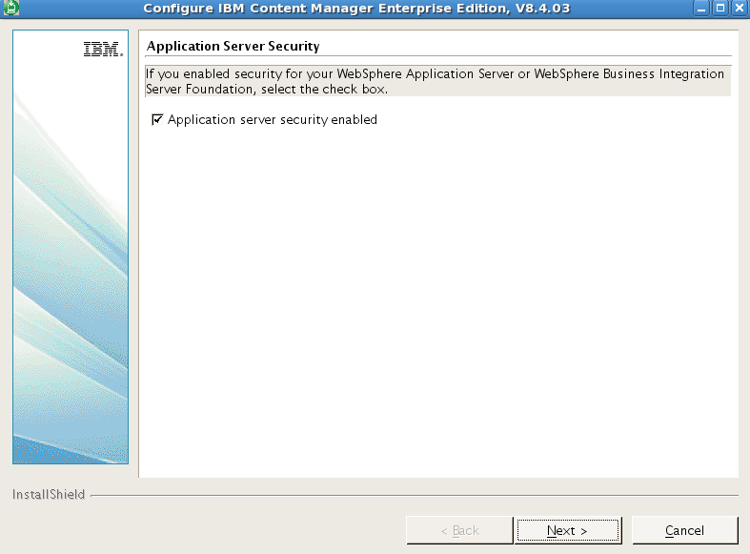

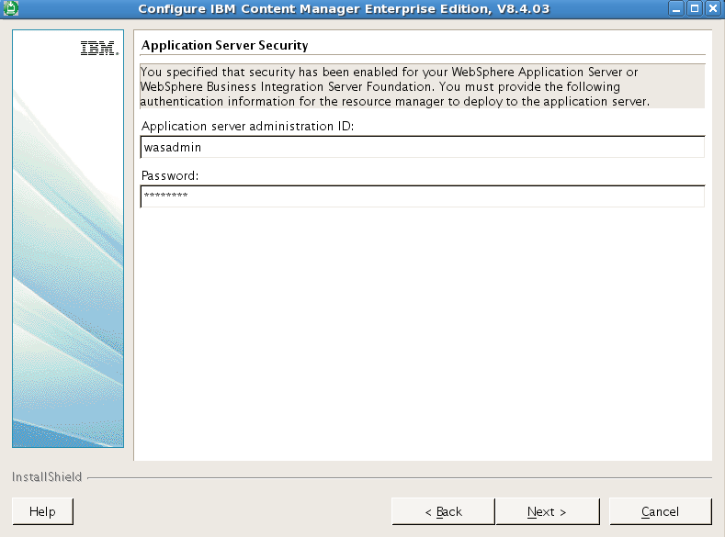

Application server administration ID: wasadmin; Password: wasadmin

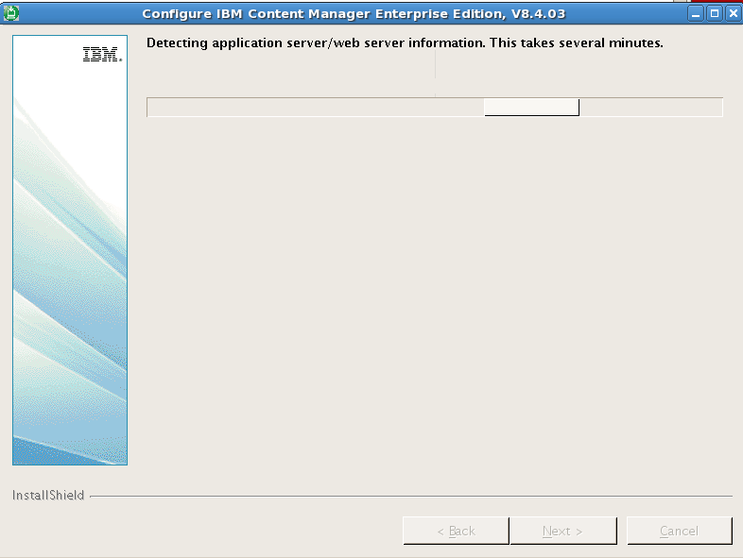

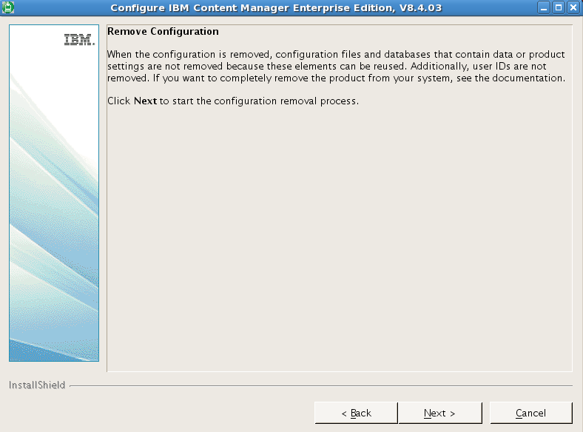

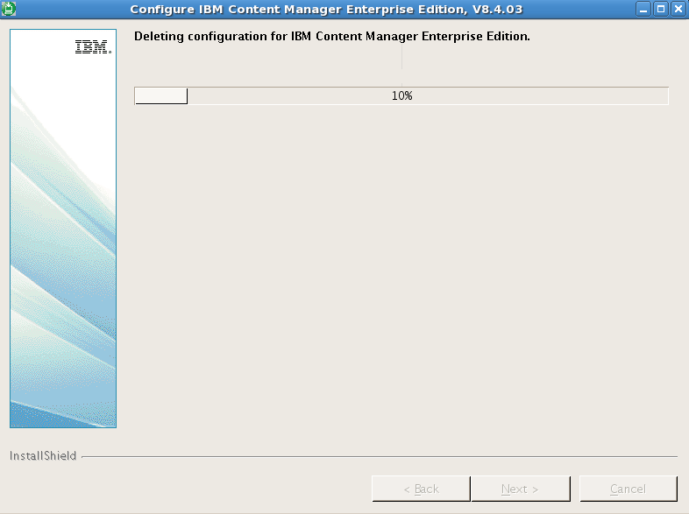

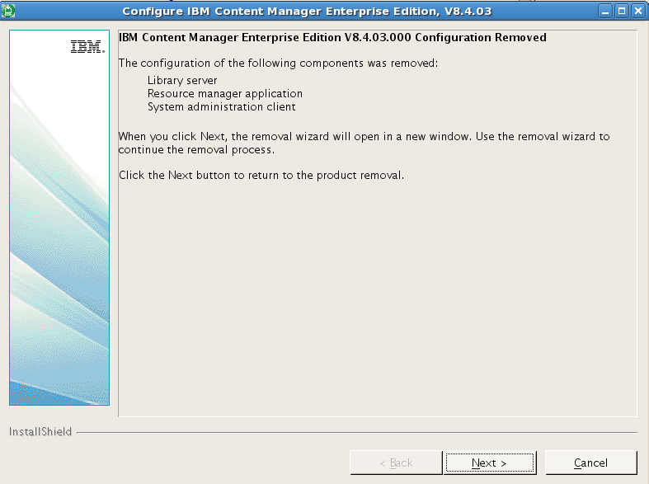

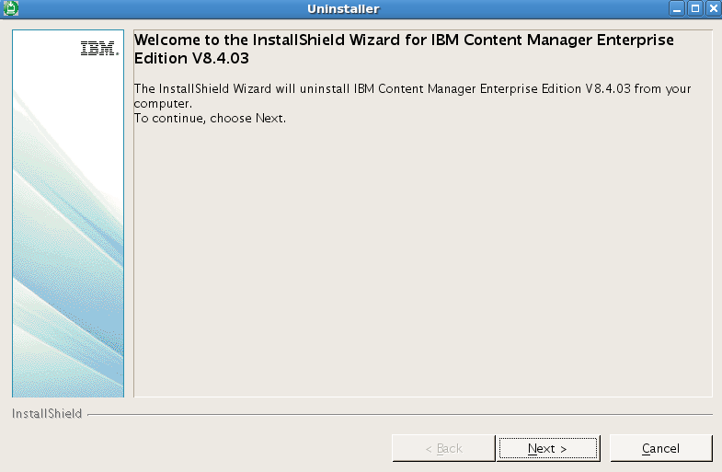

db2 => uncatalog database sample

DB20000I The UNCATALOG DATABASE command completed successfully.

DB21056W Directory changes may not be effective until the directory cache is refreshed.

db2 => uncatalog database rmdb

DB20000I The UNCATALOG DATABASE command completed successfully.

DB21056W Directory changes may not be effective until the directory cache is refreshed.

db2 => uncatalog database icmnlsdb

DB20000I The UNCATALOG DATABASE command completed successfully.

DB21056W Directory changes may not be effective until the directory cache is refreshed.

db2 =>

## Install IBM HTTP Server V7

# tar xvf ihs.7000.linux.ia32.tar

# ./install

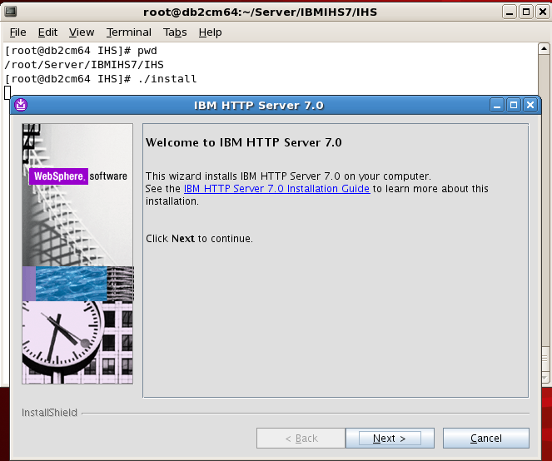

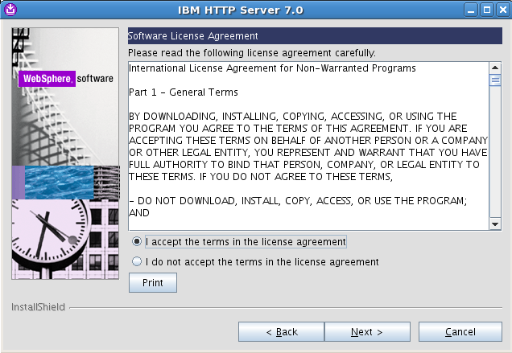

Accept license agreement

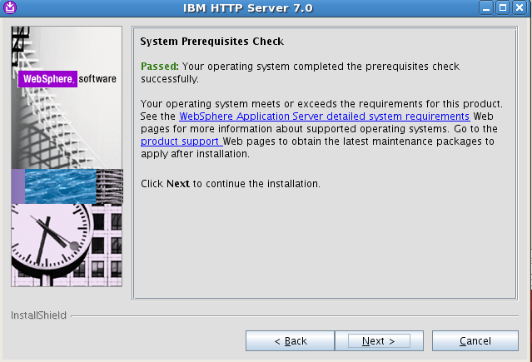

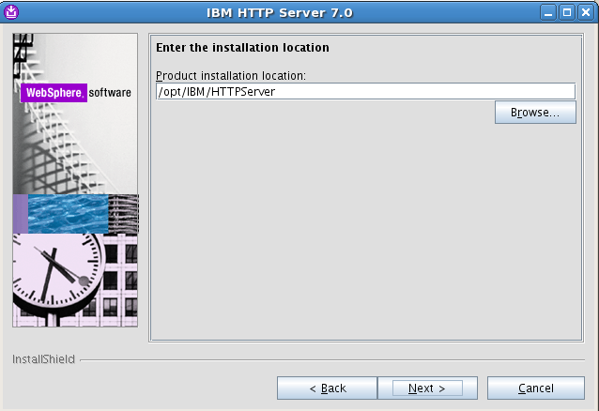

Installation location: /opt/IBM/HTTPServer

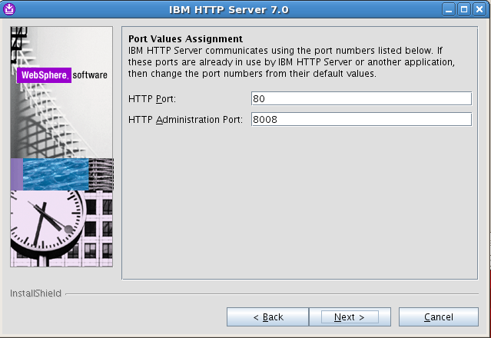

HTTP Port: 80

HTTP Administration Port: 8008

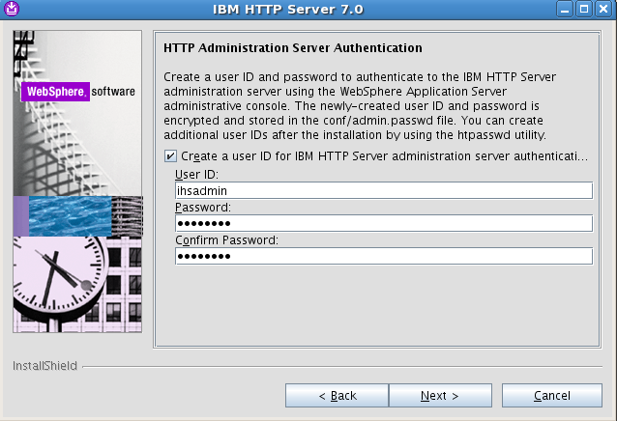

The WebSphere® Application Server administrative console can administer a remote IBM HTTP Server, on an unmanaged node, using IBM HTTPS Server administration server as the interface.

When Using WAS administrative console to access IHS sever administrative console, create a HTTP Administration Server User ID: ihsadmin; password: ihsadmin

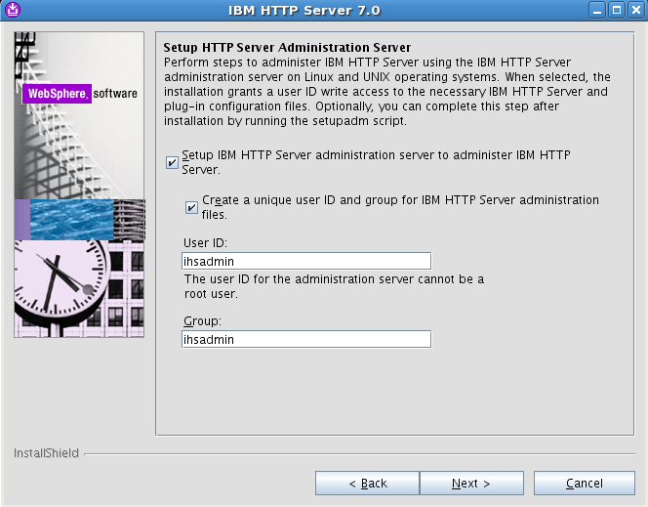

Create a user ID for HTTP Server administration: ihsadmin; Group: ihsgrp

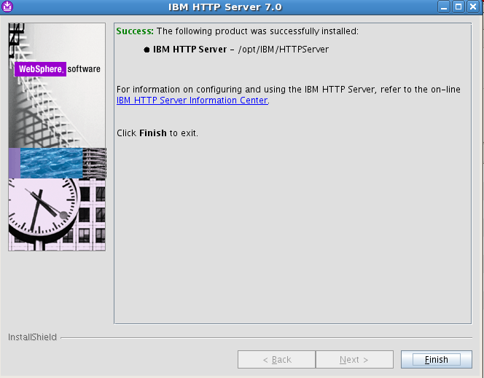

Installation completed.

Start Webshpere Application Server:

# cd /opt/IBM/WebSphere/AppServer/bin

# . /home/db2inst1/sqllib/db2profile

# ./startServer.sh server1

Start/Stop HTTP Administration Server(served on port 8008):

# /opt/IBM/HTTPServer/bin/adminctl start

# /opt/IBM/HTTPServer/bin/adminctl stop

Start/Stop HTTP Server(served on port 80):

# /opt/IBM/HTTPServer/bin/apachectl start

# /opt/IBM/HTTPServer/bin/apachectl stop

Tips: Just change User & Group value to nobody in {HPPT_ROOT}/conf/admin.conf if you cannot start adminctl

## Install IBM HTTP Server Plug-ins

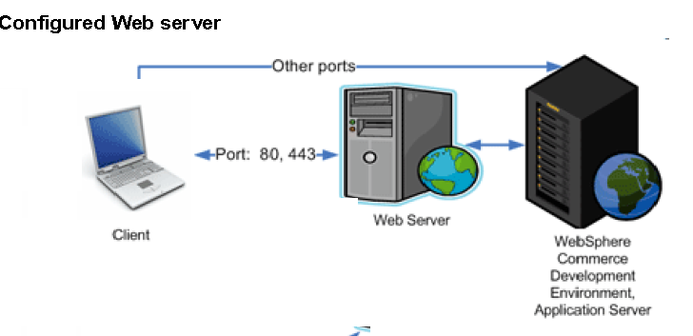

Figure 2. Plugins work mechanism

#cd /Server/ibmihs; gunzip trial_plugins_7000_linux.ia32.tar.gz | tar xvf –

# cd /Server/ibmihs/Plugins/plugin

# ./install

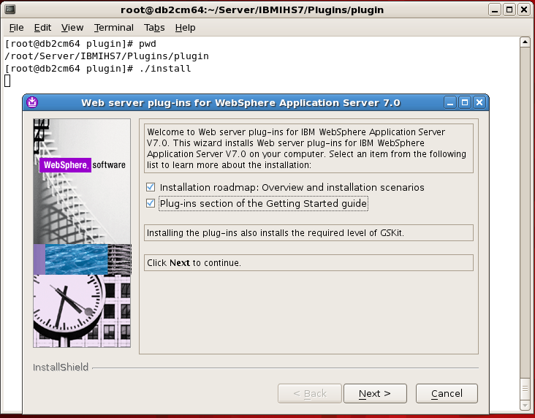

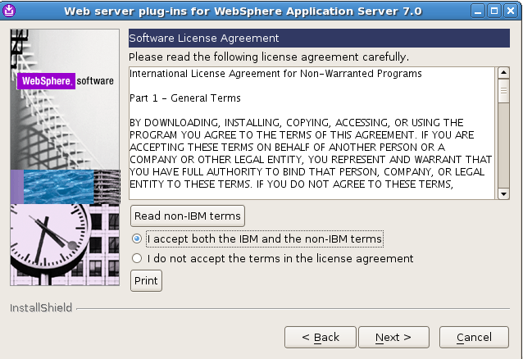

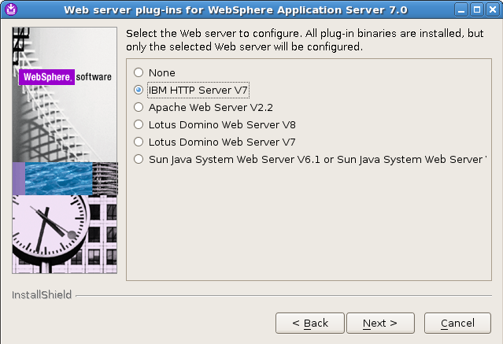

Select IBM HTTP Server V7

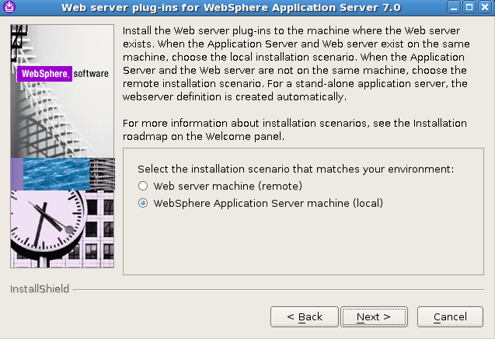

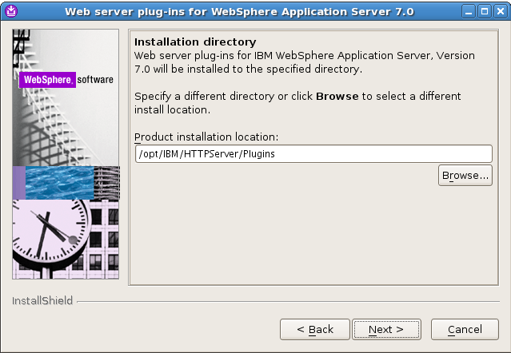

Product installation location: /opt/IBM/HTTPServer/Plugins

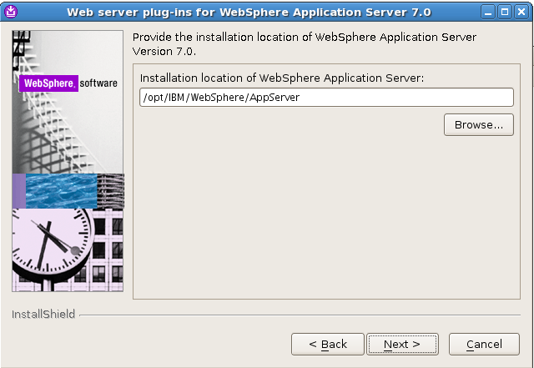

WAS installation location: /opt/IBM/Websphere/AppServer

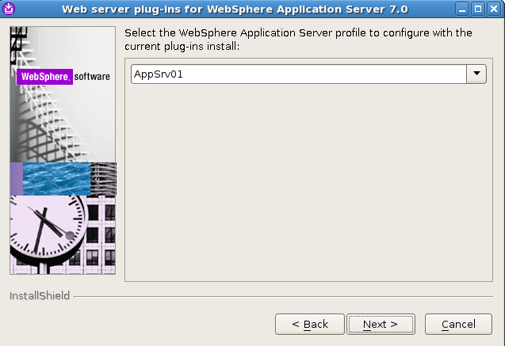

Application Server profile: AppSrv01

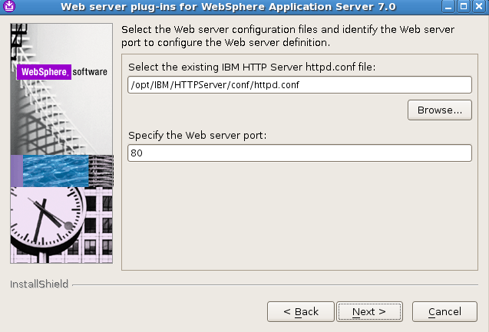

Web Server configuration file : /opt/IBM/HTTPServer/conf/httpd.conf;

Web server port: 80

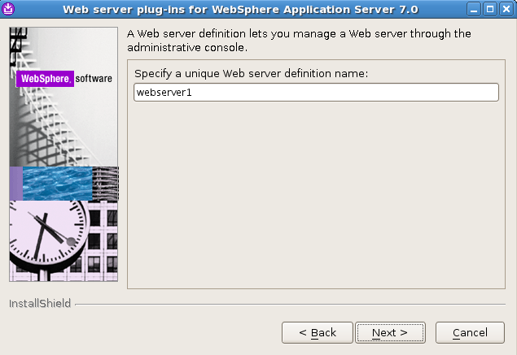

Specify a Web server name in WAS Server: webserver1

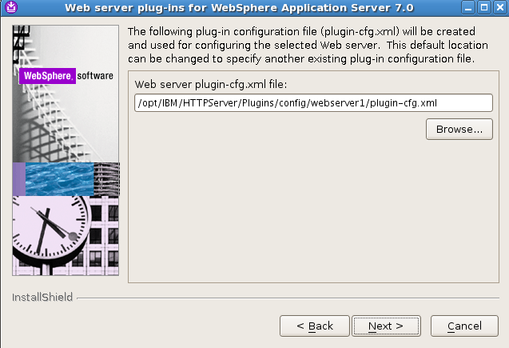

Plug-ins configuration file and location: /opt/IBM/HTTPServer/Plugins/config/webserver1/plugin-cfg.xml

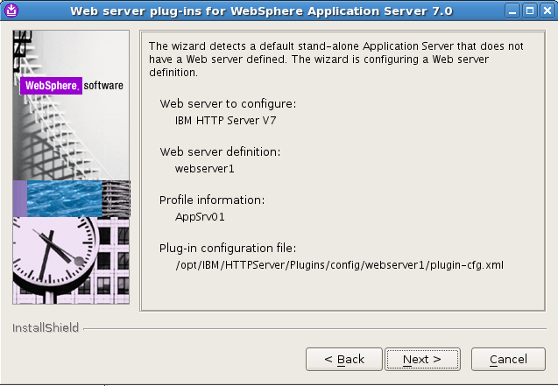

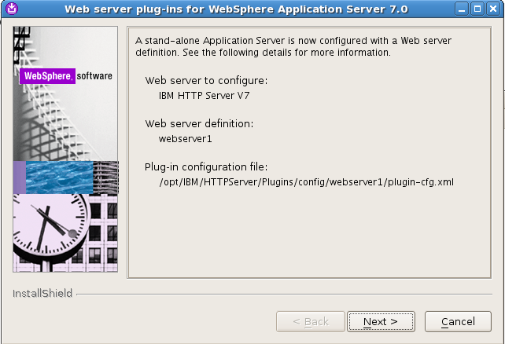

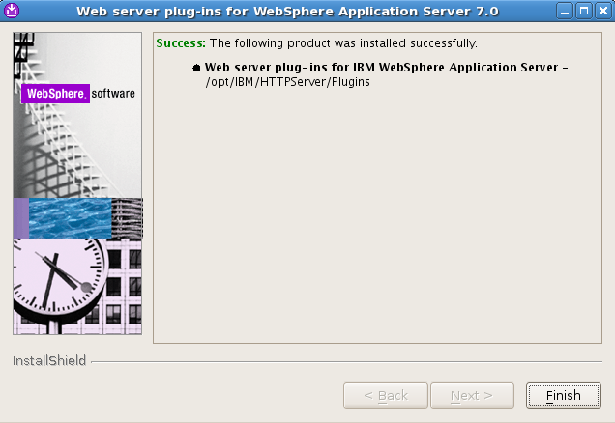

Re-Start HTTP Server:

# /opt/IBM/HTTPServer/bin/apachectl stop

# /opt/IBM/HTTPServer/bin/apachectl start

Try website: [http://ibmserver:9080/icmrm/snoop](http://db2cm64:9080/icmrm/snoop), and [http://ibmserver/icmrm/snoop](http://db2cm64/icmrm/snoop), you will find that Plug-ins is active now.

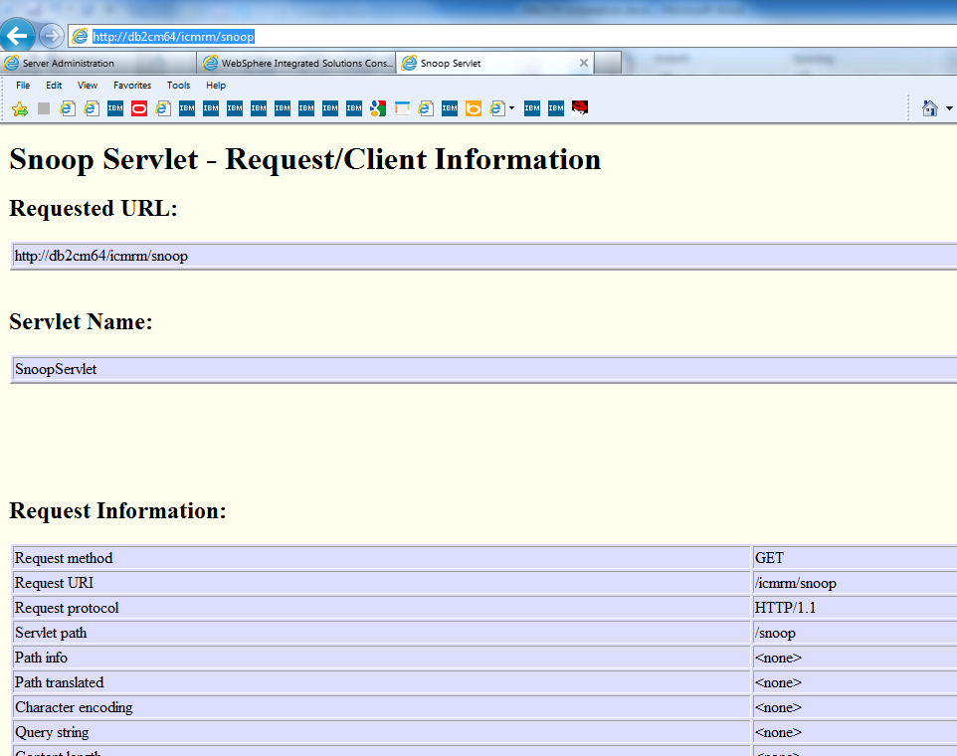

Login on WebSphere Administrative console: https://ibmserver:9043/ibm/console/login.do

WebSphere Integrated Solution Console User ID: wasadmin; PW: wasadmin

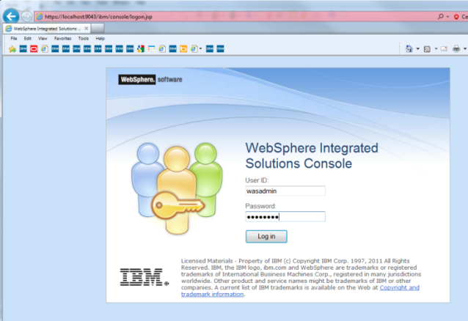

IBM Web Websphere Application Server: server1 is defined

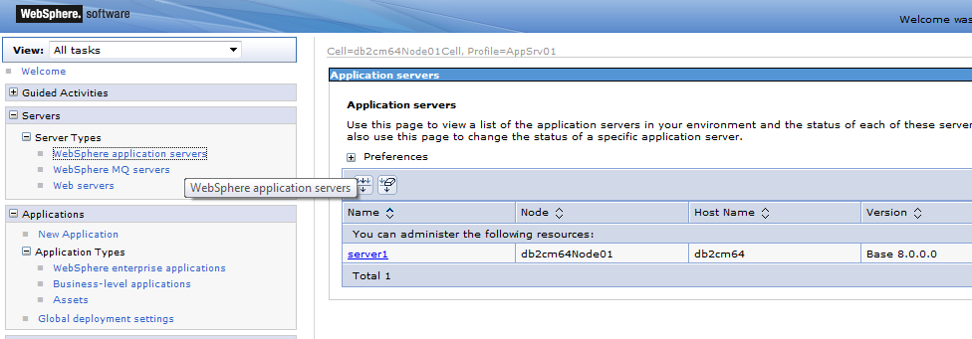

IBM Web Server: webserver1 is defined

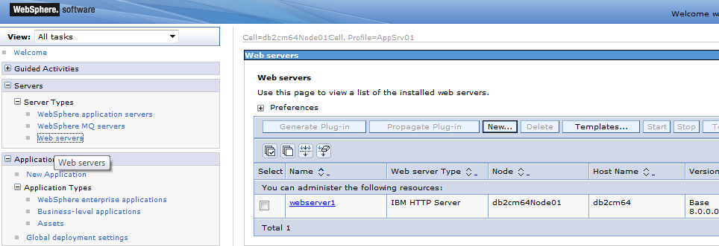

Resource Manager Application: icmrm is defined

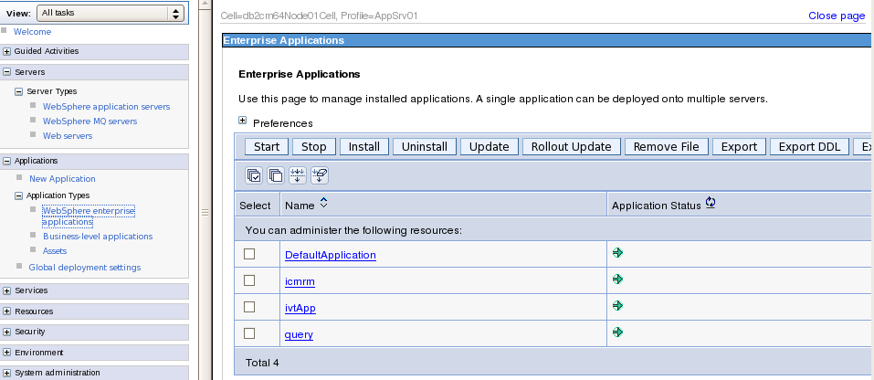

## Define Web Servers in Websphere Integrated solution sonsole

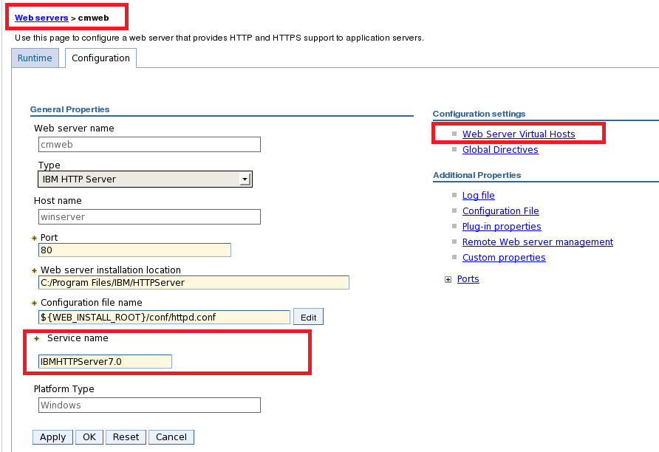

for IBM HTTP Server installed on windows with pluging package, the service name is IBM HTTP Service on windows

To create virtual host to support SSL support on IBM HTTP Server

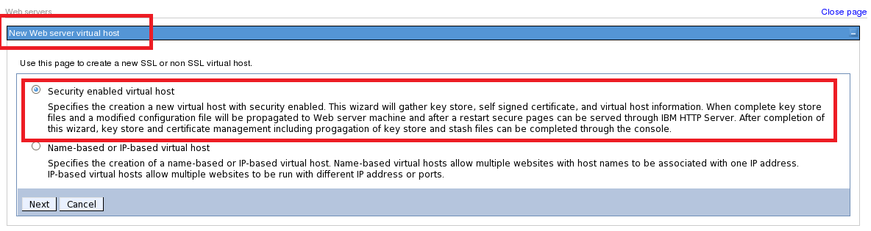

## Install IBM DB2 Content Manager Client for Windows

Unzip DB2 Content Manager Client with Winzip:

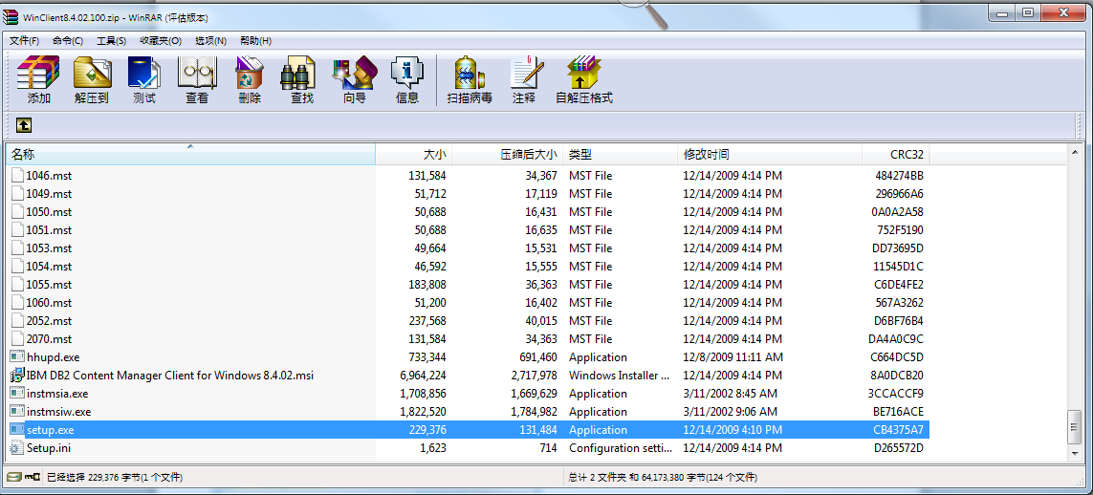

Double click setup.exe

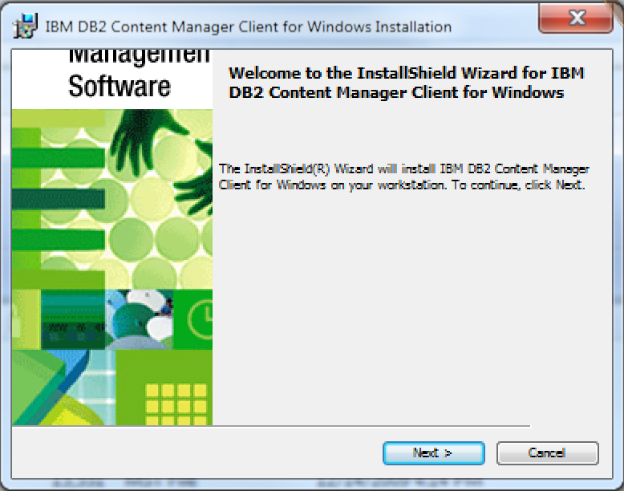

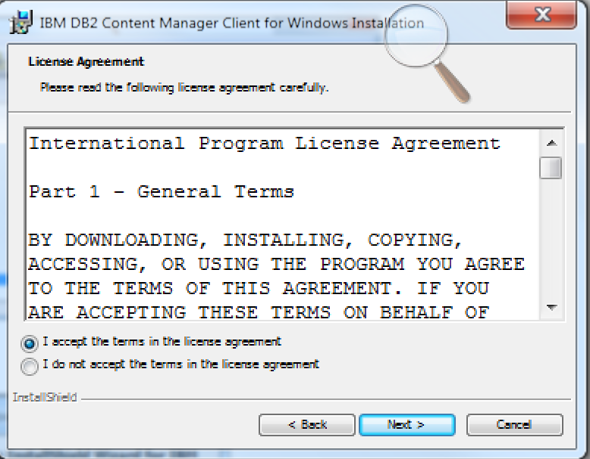

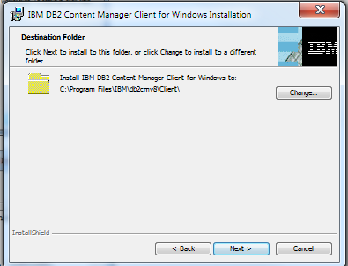

Installation directory: c:\Program Files\IBM\db2cmv8Client

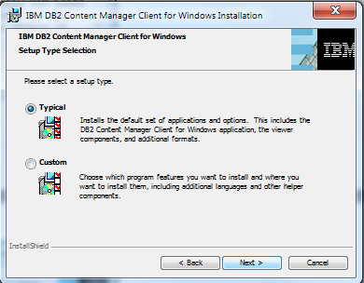

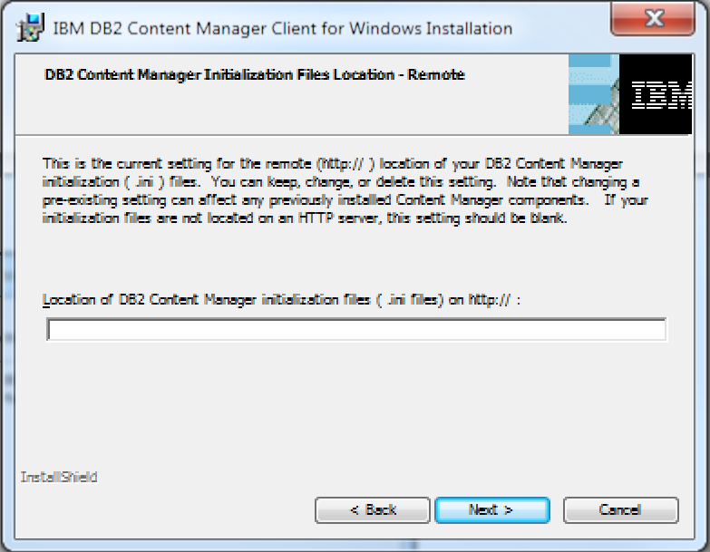

If Content Manager Initiation files are not located on an HTTP server, keep it blank.

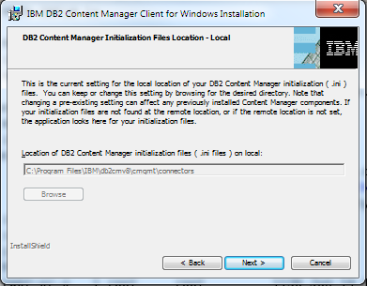

Content Manager Initiation files on local: c:\Program Files\IBM\db2cmv8\cmgml\connectors

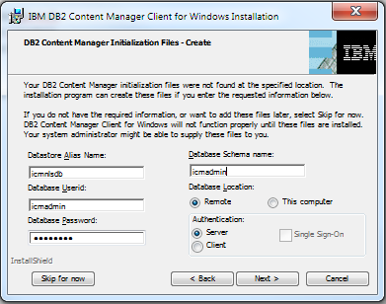

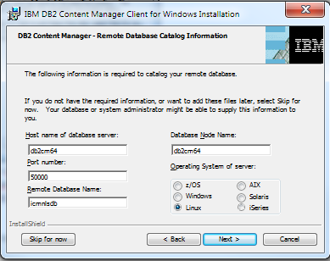

Library Server database name: icmnlsdb

Library server schema name: icmadmin

Library server administration ID: icmadmin; password: icmadmin

Database port: 50000

DB2 Database instance owner user ID: db2inst1

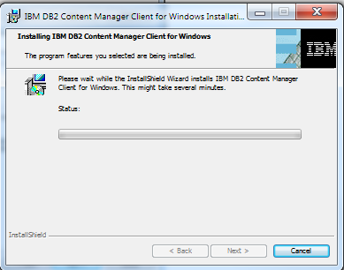

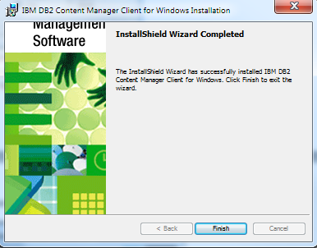

Installation completed

## Install IBM Data Server Client Version 9.7 on Windows

Download: DB2v9.7fp3_nt32_client.zip

unzip

Double click Setup program

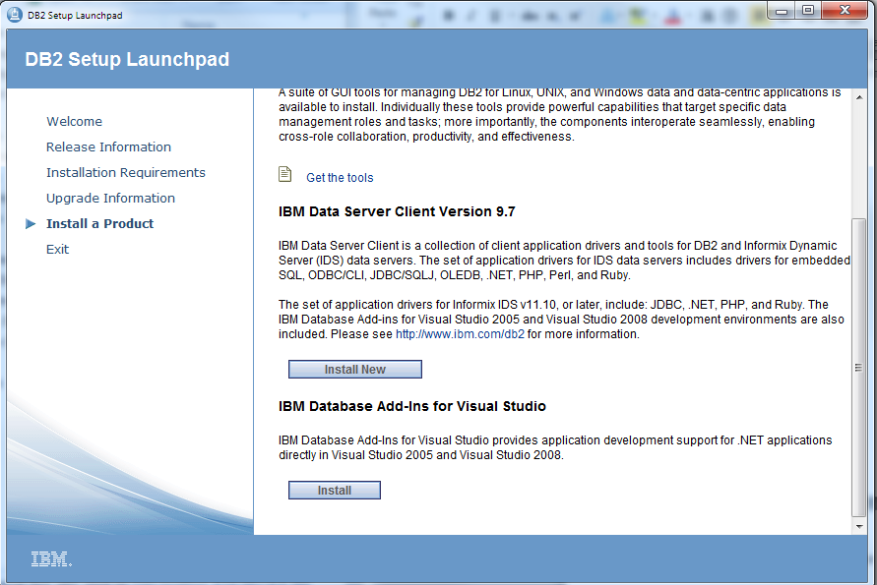

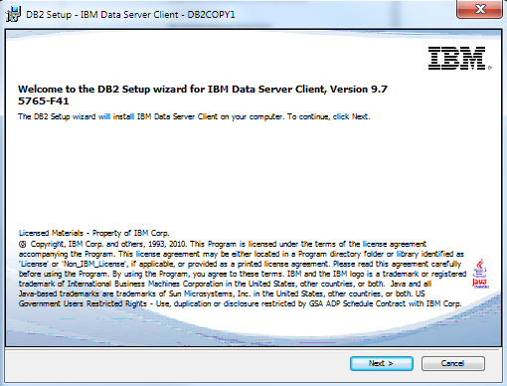

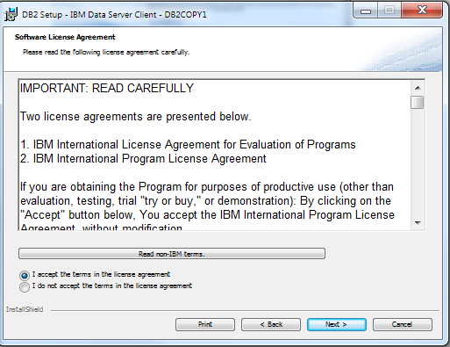

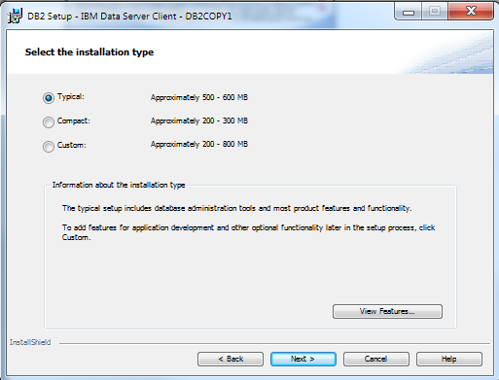

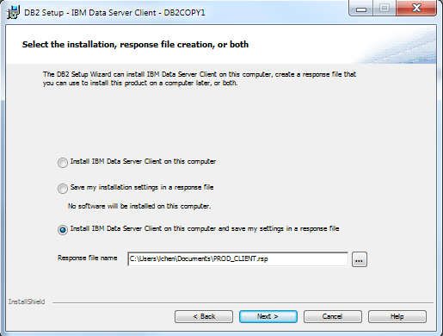

Install IBM Data Server Client and save settings in a response file: c:\User\lchen\Documents\PROD_CLIENT.rsp

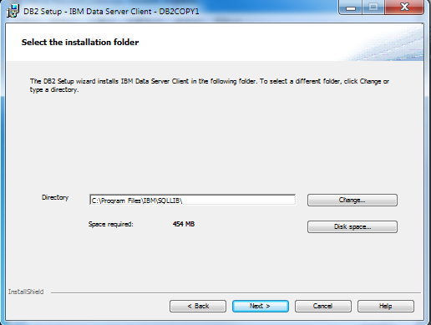

Installation directory: c:\Program Files\IBM\SQLLIB

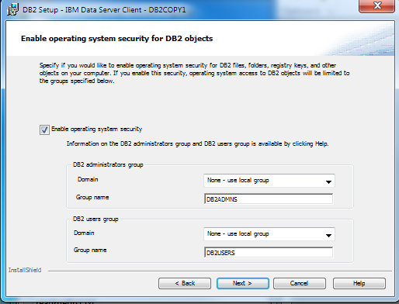

Enable operation system security

DB2 administrators group: DB2ADMNS

DB@ user group: DB2USERS

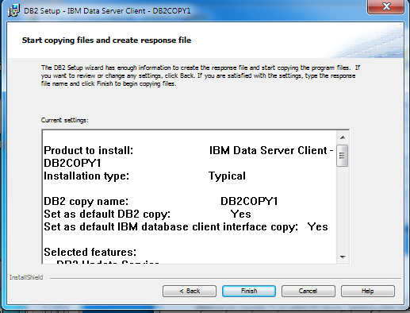

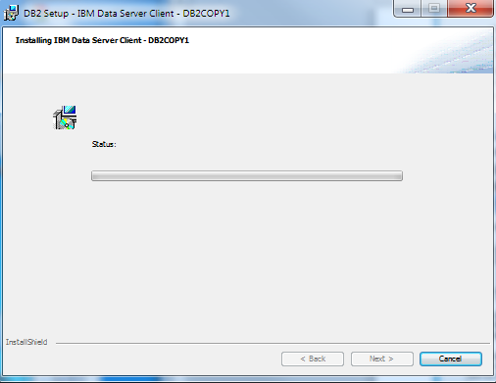

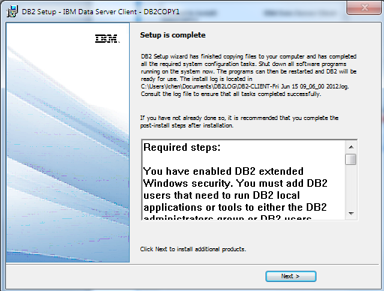

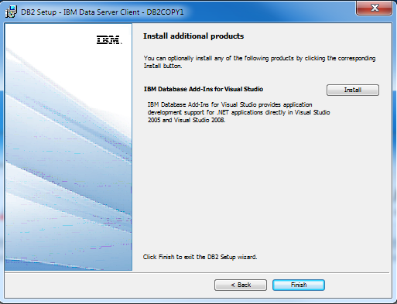

Installation Completed.

Start DB2 Client setup

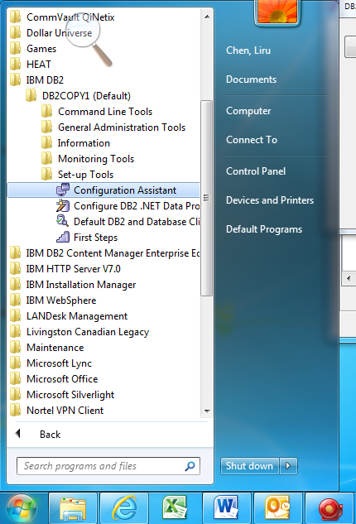

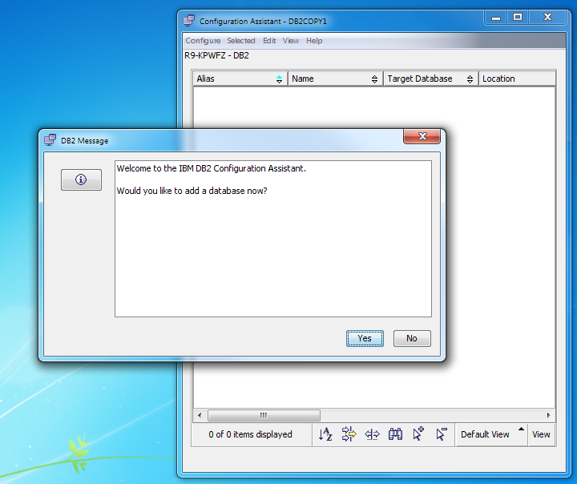

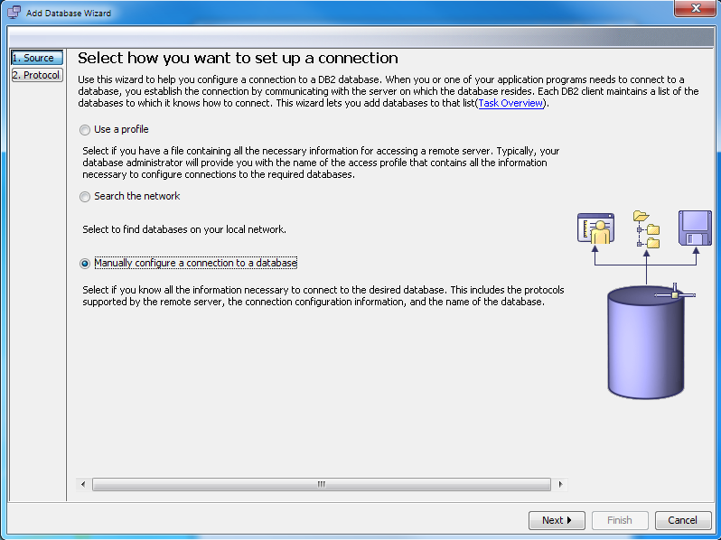

Select Manually configure a remote database

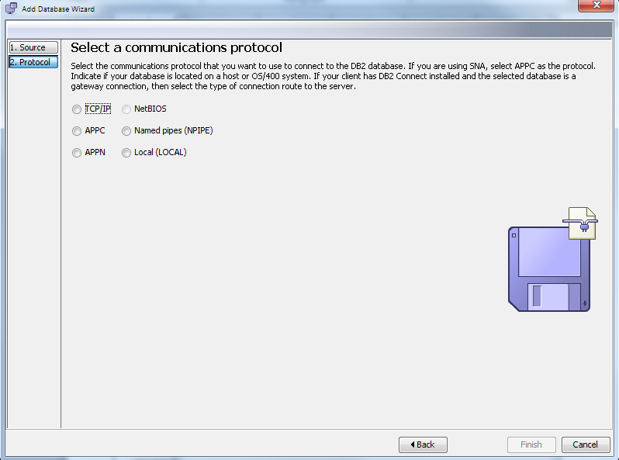

Select TCP/IP

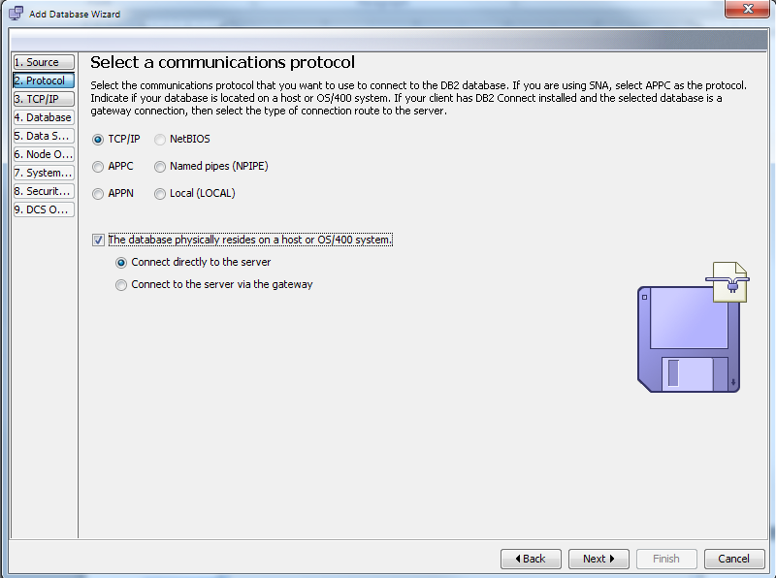

Connect directly to the server

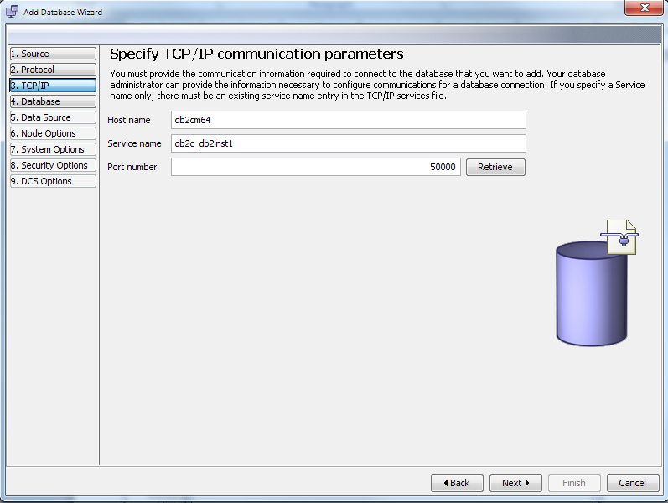

Hostname: ibmserver

Service Name: db2c_db2inst1

Port number: 50000

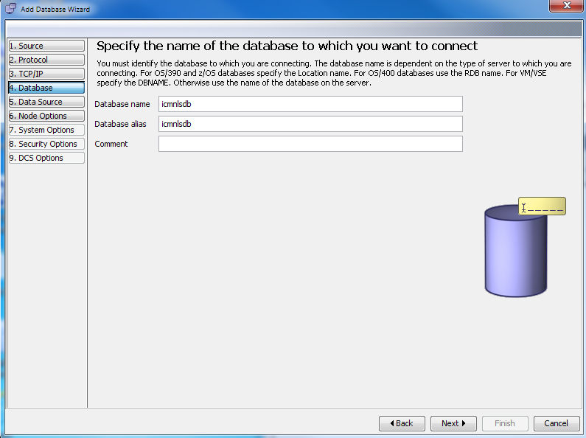

Database Name: icmnlsdb

Database alias: icmnlsdb

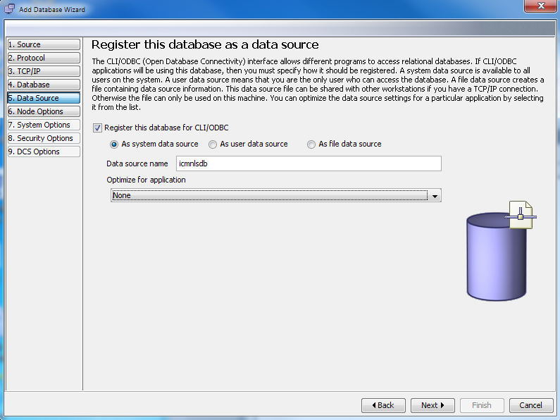

Register this database as system data source, Data source name: icmnlsdb

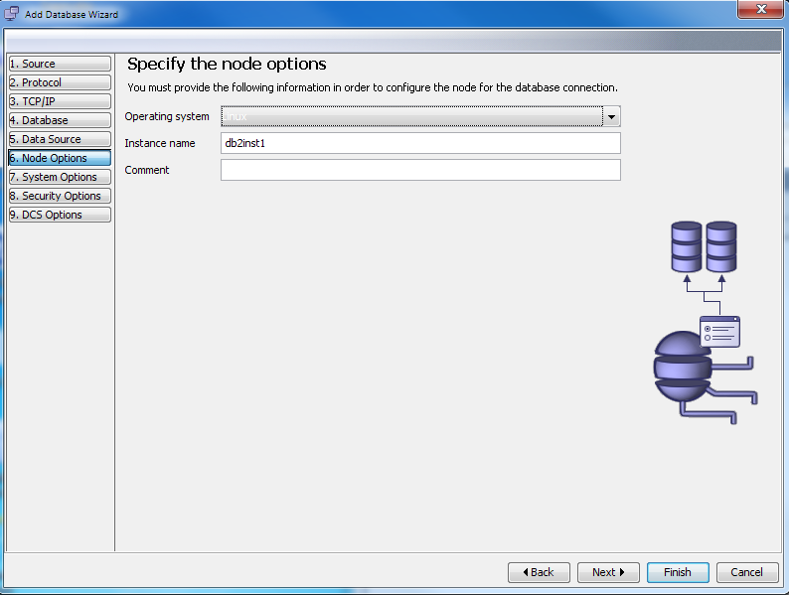

Specify the node for the database connection:

Operation system: Linux

Instance name: db2inst1

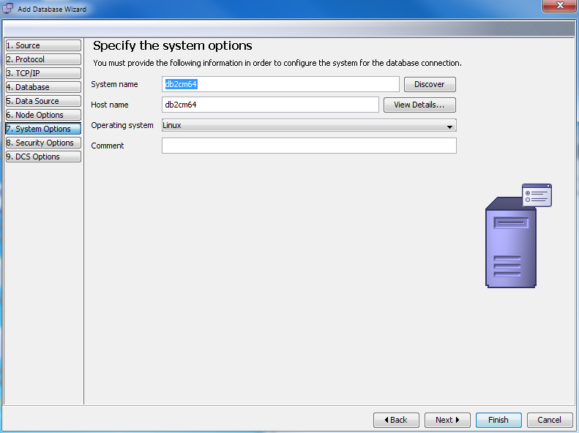

Specify the System options:

System name: ibmserver; Hostname: ibmserver; Operating system: Linux

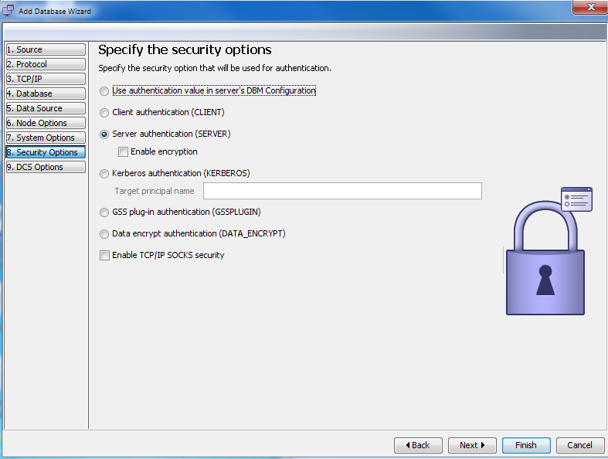

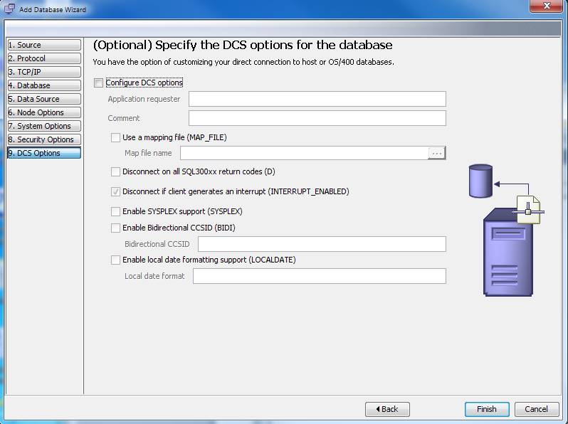

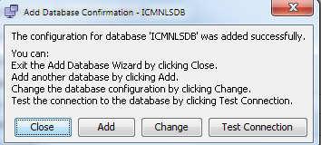

Test Connection, User ID: icmadmin; Password: icmadmin

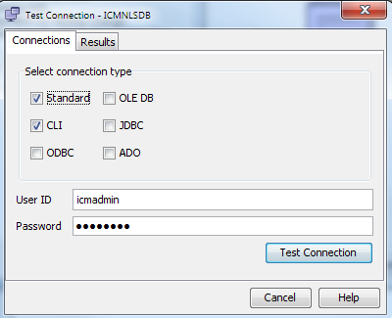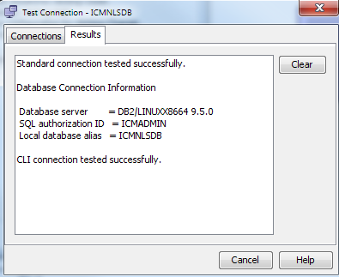

## Logon Content Manager Client for windows

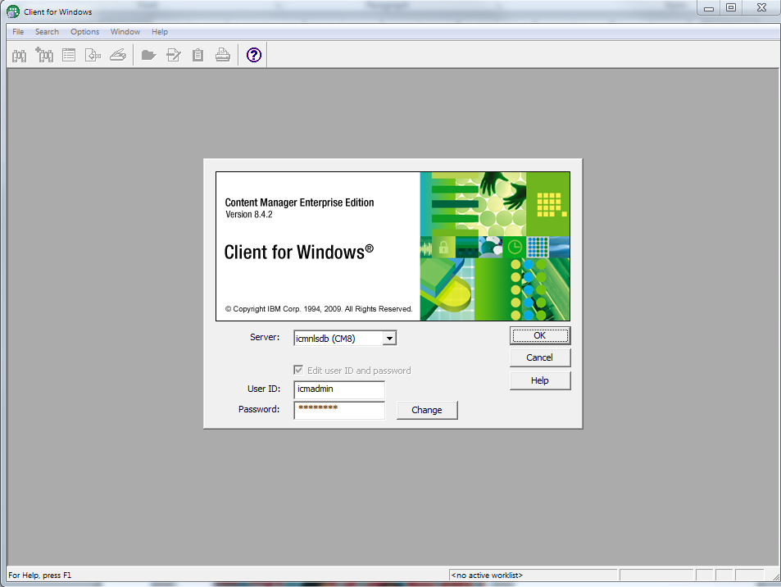

Server: icmnlsdb (CM8)

User ID: icmadmin

Password: icmadmin

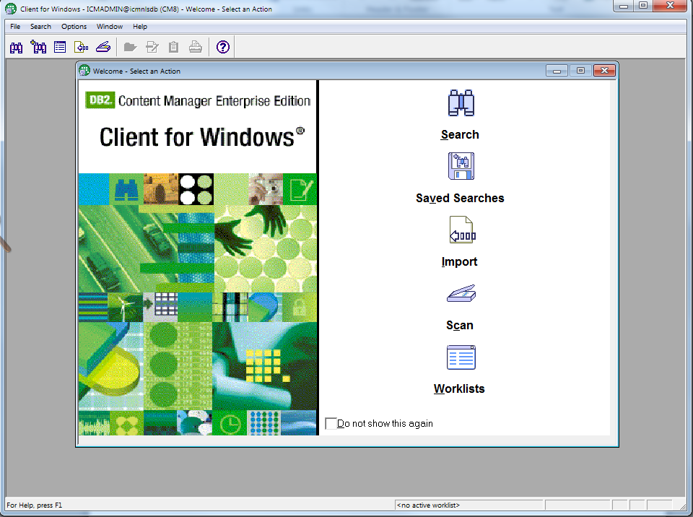

Import and Search the documents with Content Manager, Please enjoy it!

Enable import fuction on eClient

/opt/IBM/WebSphere/AppServer/profiles/AppSrv01/installedApps/ibmserverNode01Cell/eClient.ear/eclient.war

[root@ibmserver eclient.war]# vi IDM.properties

#-----------------------------------------------------------------------------------------------------------------------------

# Specifies if import is enabled

# Default: false

#

# Valid input: true false

#

importSupported=**true**

## Install TSM Server 5.5 for 64-bit Linux

Download TSM Server 5.5 and TSM Client 5.4 for 64-bit Linux from IBM website:

5.5.4.0-TIV-TSMBAC-LinuxX86.tar

5.5.6.0-TIV-TSMSRV-LinuxX64.tar.bz2

Unzip these two packages:

# bunzip2 5.5.6.0-TIV-TSMSRV-LinuxX64.tar.bz2

# tar xvf 5.5.6.0-TIV-TSMSRV-LinuxX64.tar

# ./install_server

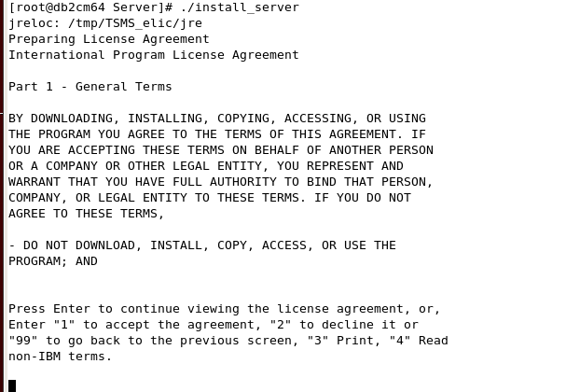

Enter “1” to accept the license agreement

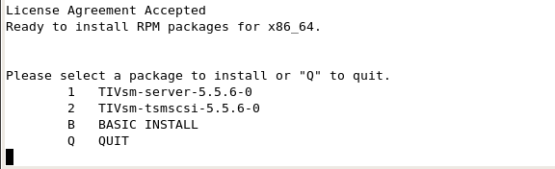

Enter “1” to install TIVsm-server-5.5.6-0

Start/Stop/Status of TSM Server:

# /opt/tivoli/tsm/server/bin/dsmserv.rc start | stop | status

## Install TSM Client for 64-bit Linux

uncompressing 5.5.4.0-TIV-TSMBAC-LinuxX86.tar :

# tar xvf 5.5.4.0-TIV-TSMBAC-LinuxX86.tar

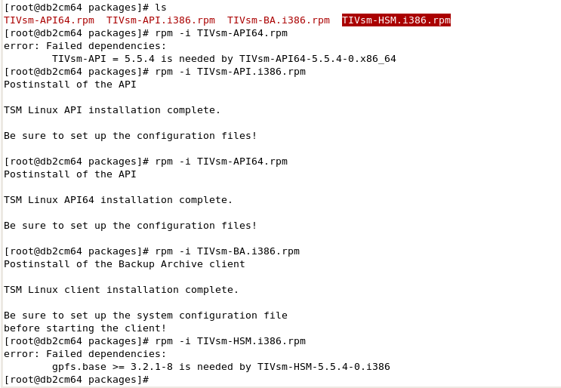

Install TSM Client:

[root@ibmserver packages]# rpm -i TIVsm-API.i386.rpm

Postinstall of the API

TSM Linux API installation complete.

Be sure to set up the configuration files!

[root@ibmserver packages]# rpm -i TIVsm-API64.rpm

Postinstall of the API

TSM Linux API64 installation complete.

Be sure to set up the configuration files!

[root@ibmserver packages]# rpm -i TIVsm-BA.i386.rpm

Or just run # rpm –i * if these packages are in current directory and no other files exist

Integrate Content Manager with TSM

define first tier DISK DEVICE CLASS storage pool CMDiskTier1 and volume

define second tier DEVICE CLASS FILECLASS storage pool and volume

define policy for content manager

define NODE cmrm for content manager

Configure TSM API option file:

[root@ibmserver packages]# cd /opt/tivoli/tsm/client/ba/bin

[root@ibmserver packages]# cp dsm.opt.smp dsm.opt; cp dsm.sys.smp dsm.sys

[root@ibmserver bin]# more dsm.sys

************************************************************************

* IBM Tivoli Storage Manager *

* *

* Sample Client System Options file for UNIX (dsm.sys.smp) *

************************************************************************

* This file contains the minimum options required to get started using TSM.

* Copy dsm.sys.smp to dsm.sys. In the dsm.sys file, enter the appropriate values for each option listed below and

* remove the leading asterisk (*) for each one.

* If your client node communicates with multiple TSM servers, be sure to add a stanza,

* beginning with the SERVERNAME option, for each additional server.

************************************************************************

SErvername server_a

COMMMethod TCPip

TCPPort 1500

TCPServeraddress ibmserver

Nodename ibmserver

SErvername server_b

COMMMethod TCPip

TCPPort 1500

TCPServeraddress ibmserver

* Specify management class

* Include ?:CMDISK*CMDISK

* Nodename to use when connecting to TSM server

NODEname cmrm

* Authentication mode to use when connecting to TSM server

PasswordAccess Prompt

[root@ibmserver bin]# more /opt/tivoli/tsm/client/ba/bin/dsm.opt

************************************************************************

* IBM Tivoli Storage Manager *

* *

* Sample Client User Options file for UNIX (dsm.opt.smp) *

************************************************************************

* This file contains an option you can use to specify the TSM

* server to contact if more than one is defined in your client

* system options file (dsm.sys). Copy dsm.opt.smp to dsm.opt.

* If you enter a server name for the option below, remove the

* leading asterisk (*).

************************************************************************

* SErvername A server name defined in the dsm.sys file

SErvername server_a

[root@ibmserver bin]# more /opt/tivoli/tsm/client/api/bin64/cmrmdsm.opt

************************************************************************

* IBM Tivoli Storage Manager *

* *

* Sample Client User Options file for UNIX (dsm.opt.smp) *

************************************************************************

* This file contains an option you can use to specify the TSM

* server to contact if more than one is defined in your client

* system options file (dsm.sys). Copy dsm.opt.smp to dsm.opt.

* If you enter a server name for the option below, remove the

* leading asterisk (*).

************************************************************************

* SErvername A server name defined in the dsm.sys file

SErvername server_b

Change the configuration files access mode:

# cd /opt/tivoli/tsm/client/api/bin64

# cp /opt/tivoli/tsm/client/ba/bin/dsm.sys .

# chmod 755 dsm.sys

# chmod 755 cmrmdsm.opt

[root@ibmserver bin]# mkdir –p /tsmstorage/tier1; mkdir –p /tsmstorage/tier2

[root@ibmserver bin]# ./dsmfmt -m -data /tsmstorage/tier1/tier1a1.dsm 20 /tsmstorage/tier1/tier1a2.dsm 20 /tsmstorage/tier1/tier1a3.dsm 20

Allocated space for /tsmstorage/tier1/tier1a1.dsm: 20971520 bytes

Allocated space for /tsmstorage/tier1/tier1a2.dsm: 20971520 bytes

Allocated space for /tsmstorage/tier1/tier1a3.dsm: 20971520 bytes

Configuration in TSM:

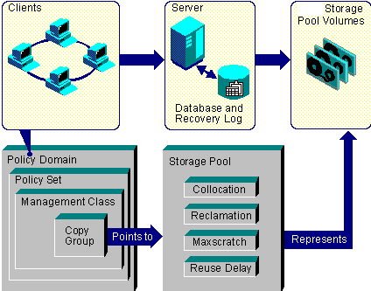

TSM Basic concepts and relationships

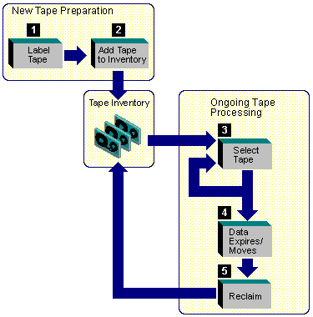

Label 1 and check in 2 the media

Checking media into a manual library simply means storing them (for example, on shelves).

Checking media into an automated library involves adding them to the library volume inventory)

[root@ibmserver bin]# ./dsmadmc

IBM Tivoli Storage Manager

Command Line Administrative Interface - Version 5, Release 5, Level 4.0

(c) Copyright by IBM Corporation and other(s) 1990, 2012. All Rights Reserved.

Enter your user id: admin

Enter your password:admin

Session established with server SERVER1: Linux/x86_64

Server Version 5, Release 5, Level 6.0

Server date/time: 06/21/2012 07:57:04 Last access: 06/21/2012 07:19:36

tsm: SERVER1>define stgpool CMDISKTier1A disk pooltype=primary description='CM Disk Storage Pool for backup' access=readwrite maxsize=nolimit

ANR2200I Storage pool CMDISKTIER1A defined (device class DISK).

tsm: SERVER1>define stgpool CMDISKTier1B disk pooltype=primary description='CM Disk Storage Pool for backup' access=readwrite maxsize=nolimit

ANR2200I Storage pool CMDISKTIER1B defined (device class DISK).

tsm: SERVER1>define vol cmdisktier1a /tsmstorage/tier1/tier1a1.dsm

Session established with server SERVER1: Linux/x86_64

Server Version 5, Release 5, Level 6.0

Server date/time: 09/13/2012 10:38:53 Last access: 09/13/2012 10:07:40

ANR2206I Volume /tsmstorage/tier1/tier1a1.dsm defined in storage pool CMDISKTIER1A(device class DISK).

tsm: SERVER1>define vol cmdisktier1a /tsmstorage/tier1/tier1a2.dsm

ANR2206I Volume /tsmstorage/tier1/tier1a2.dsm defined in storage pool CMDISKTIER1A(device class DISK).

tsm: SERVER1>define vol cmdisktier1a /tsmstorage/tier1/tier1a3.dsm

ANR2206I Volume /tsmstorage/tier1/tier1a3.dsm defined in storage pool CMDISKTIER1A(device class DISK).

tsm: SERVER1>define devclass FILECLASS1 devtype=FILE mountlimit=20 directory=/tsmstorage/tier2

ANR2203I Device class FILECLASS1 defined.

tsm: SERVER1>define stgpool CMDiskTier2A FILECLASS1 pooltype=primary description='CM Disk Storage Pool for archive' access=readwrite maxscratch=10

ANR2200I Storage pool CMDISKTIER2A defined (device class FILECLASS1).

tsm: SERVER1>define domain CMDomain Description='Content Manager Domain' backretention=60 archretention=356

ANR1500I Policy domain CMDOMAIN defined.

tsm: SERVER1>define policyset CMDomain CMPolicy

ANR1510I Policy set CMPOLICY defined in policy domain CMDOMAIN.

tsm: SERVER1>define mgmtclass CMDomain CMPolicy CMClass description='Content Manager TSM Class'

ANR1520I Management class CMCLASS defined in policy domain CMDOMAIN, set CMPOLICY.

tsm: SERVER1>define copygroup CMDomain CMPolicy CMClass type=backup destination=CMDiskTier1A

tsm: SERVER1>define copygroup CMDomain CMPolicy CMClass type=archive destination=CMDiskTier2A

tsm: SERVER1>assign defmgmtclass CMDomain CMPolicy CMClass

ANR1538I Default management class set to CMCLASS for policy domain CMDOMAIN, set CMPOLICY.

tsm: SERVER1>validate policyset CMDomain CMPolicy

ANR1556W The ARCHIVE copy group in management class CMCLASS specifies a destination that does not refer to a defined storage pool: CMDSIKTIER2A. If this pool does not exist when policy set CMPOLICY is activated, clients will fail when using this management class to archive files to the server.

ANR1515I Policy set CMPOLICY validated in domain CMDOMAIN (ready for activation).

tsm: SERVER1>activate policyset CMDomain CMPolicy

ANR1556W The ARCHIVE copy group in management class CMCLASS specifies a destination that does not refer to a defined storage pool: CMDSIKTIER2A. If this pool does not exist when policy set CMPOLICY is activated, clients will fail when using this management class to archive files to the server.

Do you wish to proceed? (Yes (Y)/No (N)) y

ANR1556W The ARCHIVE copy group in management class CMCLASS specifies a destination that does not refer to a defined storage pool: CMDSIKTIER2A. If this pool does not exist when policy set CMPOLICY is activated, clients will fail when using this management class to archive files to the server.

ANR1514I Policy set CMPOLICY activated in policy domain CMDOMAIN.

tsm: SERVER1>update copygroup CMDomain CMPolicy CMCLass Type=Archive destination=CMDiskTier2A

ANR1537I Archive copy group STANDARD updated in policy domain CMDOMAIN, set CMPOLICY, management class

CMCLASS.

tsm: SERVER1>Register node ibmserver ibmserver userid=admin domain=standard

ANR2060I Node IBMSERVER registered in policy domain STANDARD.

ANR2099I Administrative userid ADMIN defined for OWNER access to node IBMSERVER.

tsm: SERVER1>Register node cmrm cmrm userid=admin DOMAIN=CMDomain

ANR2060I Node CMRM registered in policy domain CMDOMAIN.

ANR2099I Administrative userid ADMIN defined for OWNER access to node CMRM.

Configure Resource Manager Storage:

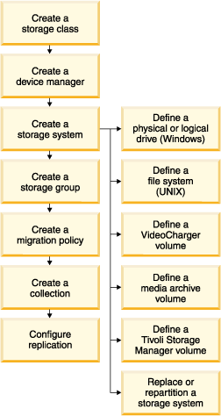

Create new Server definition in Resource Manager

# xhost +

/opt/tivoli/tsm/server/bin/dsmserv.rc start;su - dasusr1 "-c db2admin start"; su - db2inst1 "-c db2start"; /opt/IBM/W*/A*/bin/startServer.sh server1

# su – icmadmin

$ cd /opt/IBM/db2cmv8/admin/common

$ ./cmadmin.sh

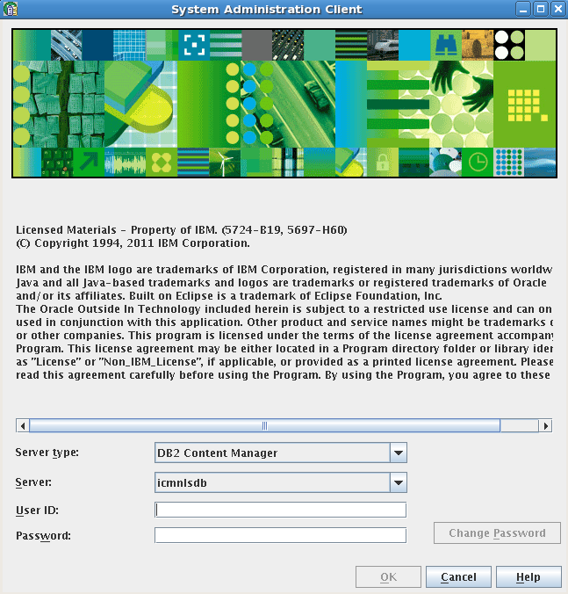

User ID: icmadmin Password: icmadmin

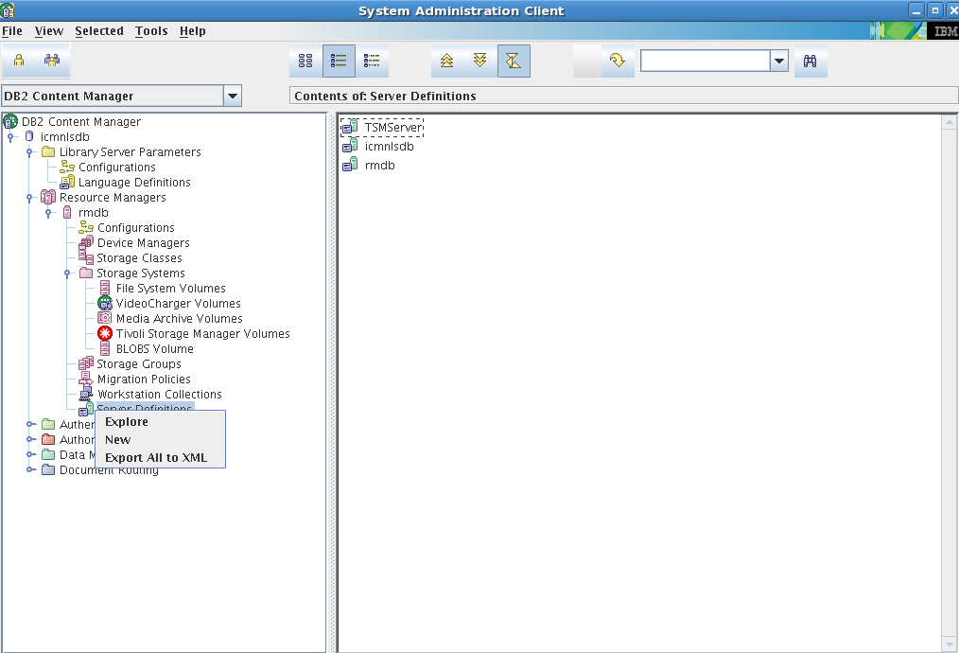

Open CM System Administration Client, expend ‘Resource Managers’ item, right click ‘Server Definitions’, and Select ‘New’:

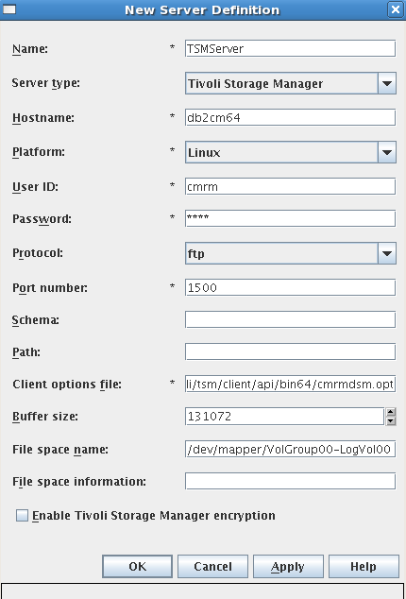

Define a new Server: TSMServer

Name: TSMServer

Hostname: ibmserver

Platform: Linux

User ID: cmrm

Password: cmrm

Protocol: ftp

Port number: 1500

Client options file: /opt/tivoli/tsm/client/api/bin64/cmrmdsm.opt

Buffer size: 131072

File space name:

Configure New Storage Class in Resource Managers

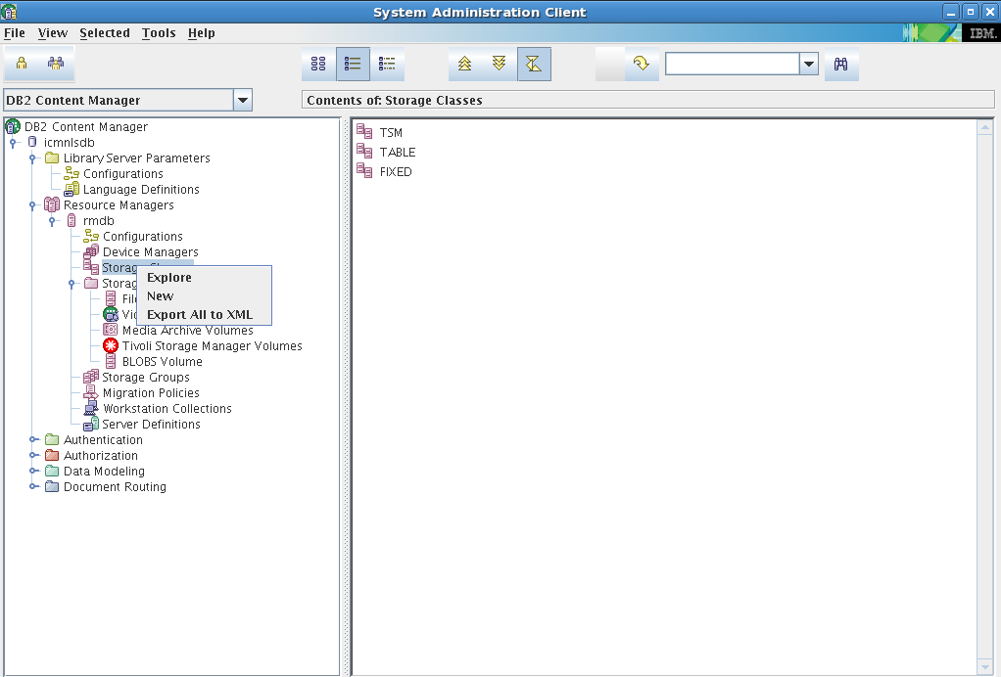

Expend ‘Resource Managers’ item, right click ‘Storage Classes’, and Select ‘New’:

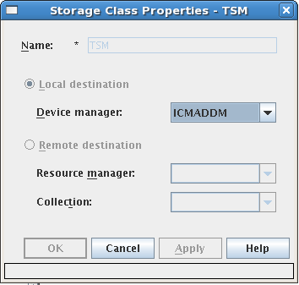

Name: TSM

Device manager: ICMADDM

Configure Tivoli Storage Manager Volumes

Add new Storage Group:

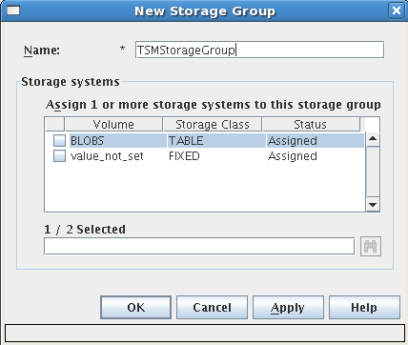

Name:TSMStorageGroup

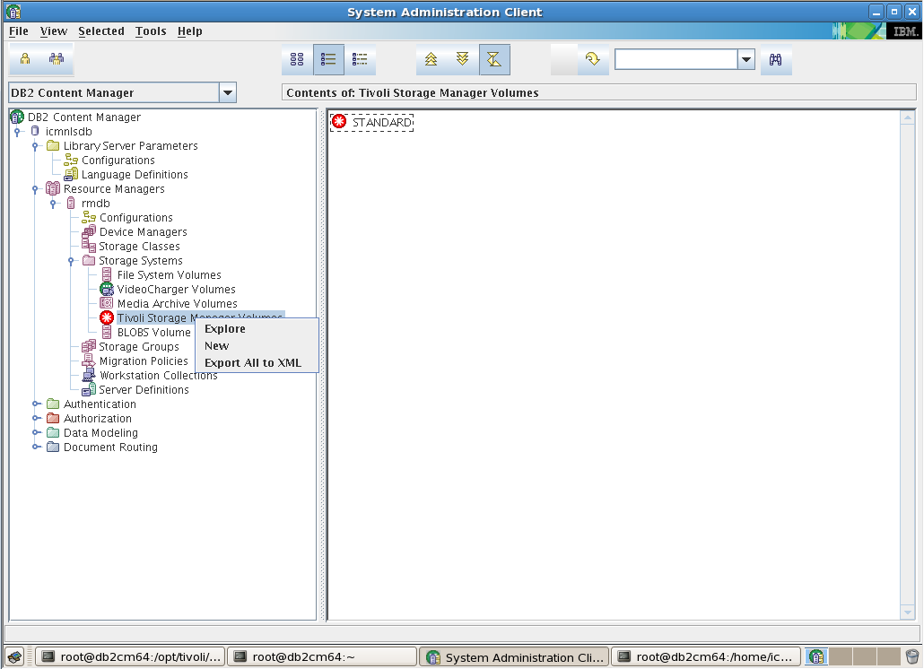

Expend ‘Resource Managers’ item, right click ‘Tivoli Storage Manager Volumes’, and Select ‘New’:

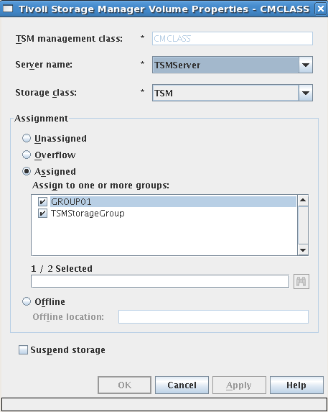

TSM management class: CMClass

Server name: TSMServer

Storage class: TSM

Assigned Storage Group: GROUP1, TSMStorageGroup

Create new Migration Policy:TSMMigrationPolicyCLASS

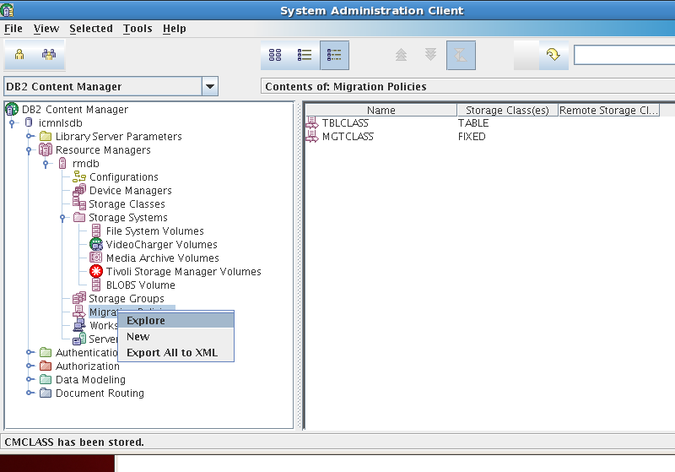

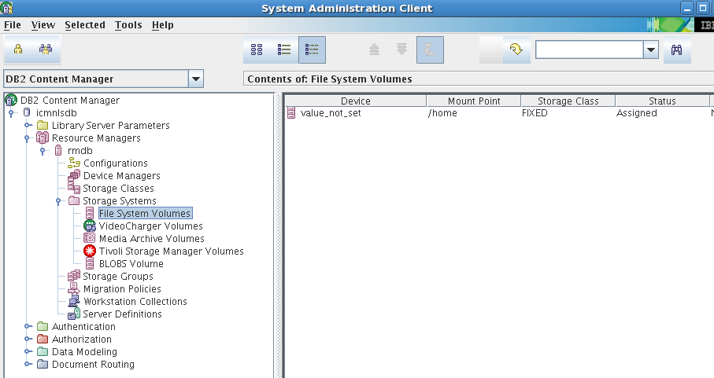

FIXED Storage Class is mounted on /home

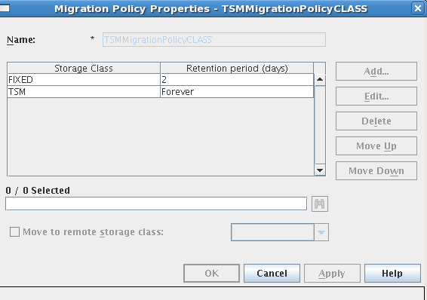

Data Items are stored on FIXED Storage Class for 2 days, then moved to TSM Storage Class forever

Create a workstation collection:TSMWorkstationCollection

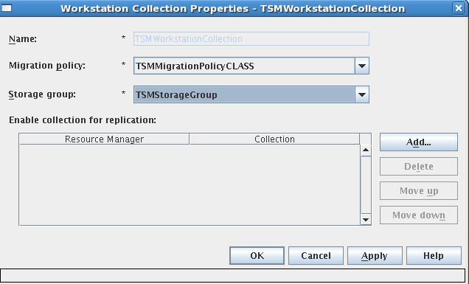

This definition is needed in Data Type Define.

Define an item type for testing

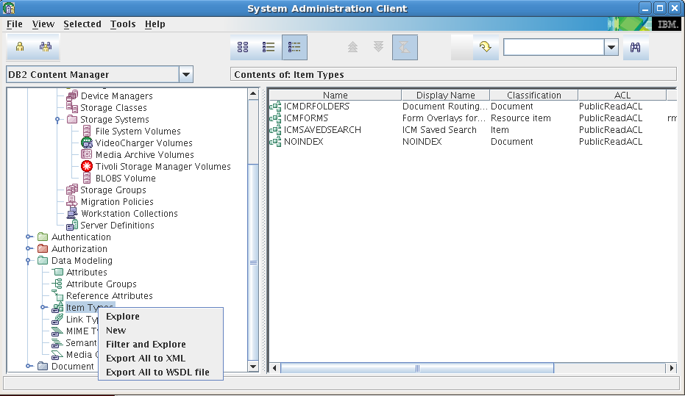

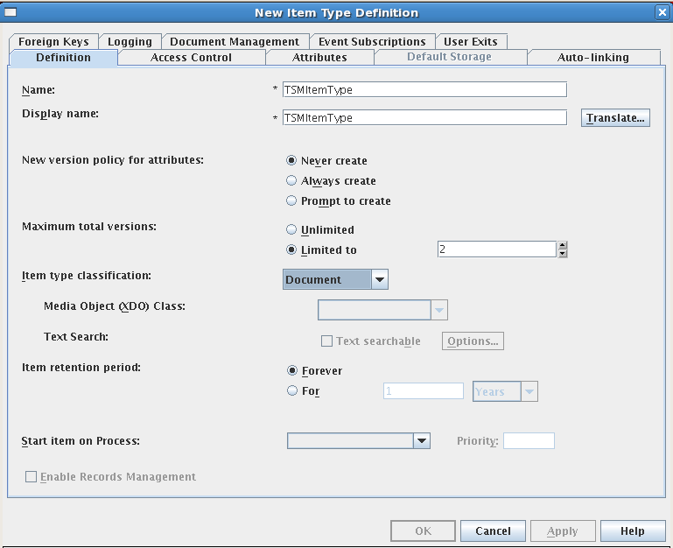

For Label Document Management, click Add…

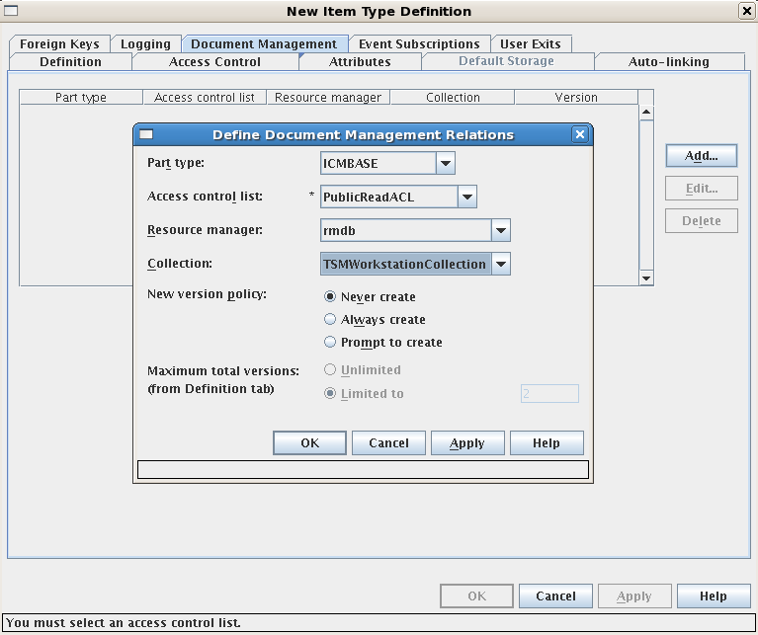

Part type: ICMBASE

Access Control List: PublicReadACL

Resource manager: rmdb

Collection: TSMWorkstationCollection

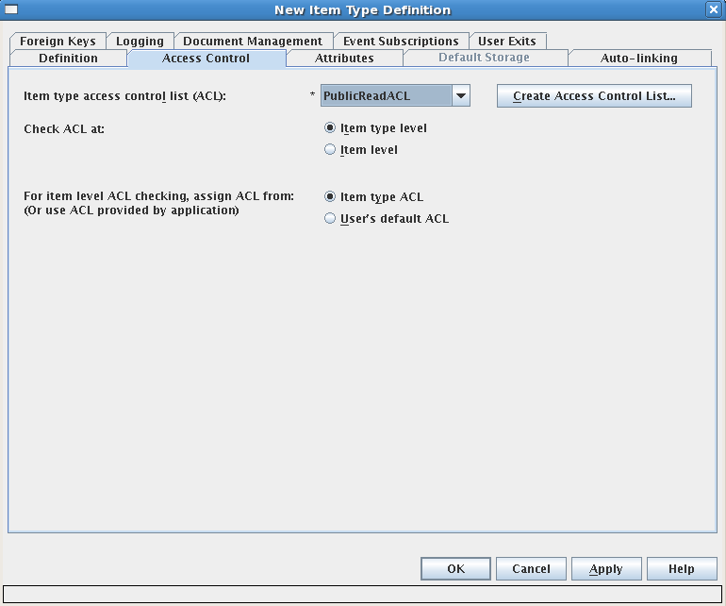

On Access Control, select: Item type access control list (ACL): PUBLICREADACL

Logon pClient:

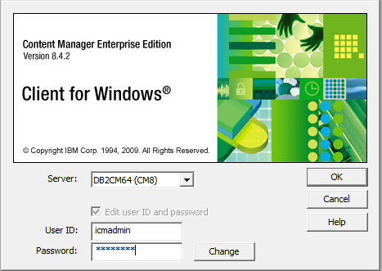

Import Document as type: TSMItem Type

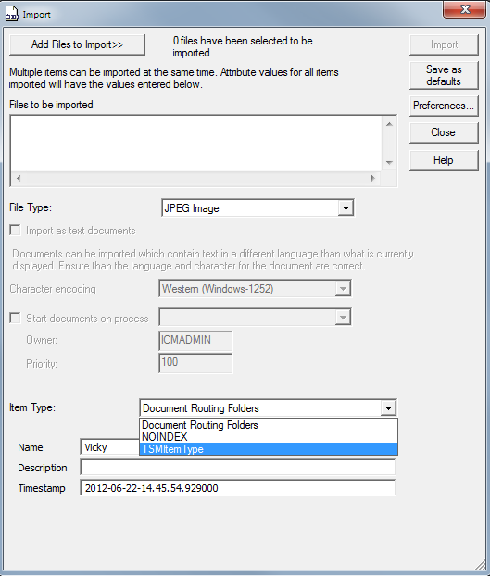

The import Document is on

[root@ibmserver 29]# pwd

/home/lbosdata/00003/29

[root@ibmserver 29]# ls -la

total 2196

drwx------ 2 root root 4096 Sep 13 16:52 .

drwx------ 3 root root 4096 Sep 13 16:52 ..

-r-------- 1 root root 2235304 Sep 13 16:53 L1.A1001001A12I13B65258G06336.V1

TIPS: IF you import a document with the type TSMItem Type, you CANNOT delete TSMItemType/WorkstationCollection in Resource Manager define, you should delete all the imported documents in this TSMItem Type before you can delete TSMItem Type.

TIP: uninstall TSM:

# su - dasusr1 "-c db2admin stop"; su - db2inst1 "-c db2stop force"; /opt/tivoli/tsm/server/bin/dsmserv.rc stop; /opt/IBM/W*/A*/bin/stopServer.sh server1

[root@ibmserver Server]# rpm -aq | grep TIV

TIVsm-API64-5.5.4-0

TIVsm-BA-5.5.4-0

TIVsm-API-5.5.4-0

TIVsm-server-5.5.6-0

[root@ibmserver Server]# rpm -e TIVsm-server-5.5.6-0

[root@ibmserver Server]# rpm -e TIVsm-API-5.5.4-0

[root@ibmserver Server]# rpm -e TIVsm-API64-5.5.4-0

## Start DB2CM Server automatically when Linux Server started

prepare auto-start script db2cmServer.rc, and copy it to /ect/init.d

#!/bin/bash

#

# db2cmServ.rc Start/Stop IBM DB2 Content Manager Service

#

# chkconfig: - 98 18

# description: Starts/Stops the IBM DB2 Content Manager Server Service

# processname: dsmserv

# pidfile: /var/run/dsmserv.pid

#***********************************************************************

# DB2 Content Manager (DB2CM) *

# Server Component *

# *

# IBM Confidential *

# (IBM Confidential-Restricted when combined with the Aggregated OCO *

# Source Modules for this Program) *

# *

# OCO Source Materials *

# *

# 5765-303 (C) Copyright IBM Corporation 1990, 2003 *

#***********************************************************************

# First of all, check for syntax

set -x

set -v

if [[ $# != 1 ]]

then

echo $"Usage: $0 {start|stop|status|restart}"

exit 1

fi

prog="dsmserv"

# determine which version of the server is installed

# server_version=`rpm -q TIVsm-server`

# determine where the server is installed

# if string server_version is not NULL, it means we got something

# if [[ -n "$server_version" ]]

# then

# prefix=`rpm -q --queryformat %'{INSTALLPREFIX}' $server_version`

# else

# echo "IBM Tivoli Storage Manager Server not found on this system"

# exit -1

#fi

# PATH=/sbin:/bin:/usr/bin:/usr/sbin:opt/tivoli/tsm/server/bin:/opt/IBM/WebSphere/AppServer/bin:/opt/IBM/HTTPServer/bin

HOMENODE="ibmserver"

HOSTNODE=`hostname`

logFile=/admsrv/hacmp/imaging_start_now.log

if [[ ! -e /opt/tivoli/tsm/server/bin/dsmserv ]]

then

echo "IBM Tivoli Storage Manager Server not found on this system"

exit 0

fi

rc=0

SLEEP_INTERVAL=2

MAX_SLEEP_TIME=10

function check_pid_file()

{

test -f /var/run/dsmserv.pid

}

function check_process()

{

ps -p `cat /var/run/dsmserv.pid` > /dev/null

}

function check_running()

{

check_pid_file && check_process

}

function msgLog()

{

echo `date` "$1" >> $logFile

}

function startDB2NODE()

{

set -v

set -x

if [ $HOMENODE = $HOSTNODE ]; then

cp /home/db2inst1/sqllib/db2nodes.cfg.ibmserver /home/db2inst1/sqllib/db2nodes.cfg

else

cp /home/db2inst1/sqllib/db2nodes.cfg.ibmserver /home/db2inst1/sqllib/db2nodes.cfg

fi

if [ $HOMENODE = $HOSTNODE ]; then

cp /home/db2inst2/sqllib/db2nodes.cfg.ibmserver /home/db2inst2/sqllib/db2nodes.cfg

else

cp /home/db2inst2/sqllib/db2nodes.cfg.ibmserver /home/db2inst2/sqllib/db2nodes.cfg

fi

return 0

}

function startTSMClient()

{

set -v

set -x

cd /opt/tivoli/tsm/client/ba/bin

./dsmcad -optfile=/opt/tivoli/tsm/client/api/bin64/db2dsm.opt

return 0

}

function startDAS()

{

set -v

set -x

su - dasusr1 >> /dev/null 2>&1 <<EOF

db2admin start

if [ $? -ne 0 ]; then

msgLog "Error: DAS failed ..." >> $logFile

exit 1

fi

exit

EOF

return 0

}

function startDB2INST1()

{

set -v

set -x

su - db2inst1 >> /dev/null 2>&1 <<EOF

db2start

if [ $? -ne 0 ]; then

msgLog "Error: DB2 engine failed ..." >> $logFile

exit 1

fi

exit

EOF

return 0

}

function startHTTP()

{

set -v

set -x

#cd /usr/IBMHttpServer/bin

cd /opt/IBM/HTTPServer/bin

./apachectl start

if [ $? -ne 0 ]; then

msgLog "Error: HTTP failed ..." >> $logFile

exit 1

fi

return 0

}

function startCMLSmonitor()

{

set -v

set -x

. /home/db2inst1/sqllib/db2profile

cd /etc

./rc.cmlsproc

if [ $? -ne 0 ]; then

msgLog "Error: CMLS failed ..." >> $logFile

exit 1

fi

return 0

}

#function startWASECLIENT(){

# set -v

# set -x

# . /home/db2inst1/sqllib/db2profile

# cd /opt/IBM/WebSphere/AppServer/bin

# ./startServer.sh eClient_Server

# if [ $? -ne 0 ]; then

# msgLog "Error: WASECLIENT failed ..." >> $logFile

# exit 1

# fi

# return 0

#}

#function startDB2INST2(){

# set -v

# set -x

# su - db2inst2 >> /dev/null 2>&1 <<EOF

# db2start

# if [ $? -ne 0 ]; then

# msgLog "Error: DB2 engine failed ..." >> $logFile

# exit 1

# fi

# exit

# EOF

# return 0

#}

#startCMRMServices(){

# set -v

# set -x

# . /home/db2inst2/sqllib/db2profile

# cd /etc

# ./rc.cmrmproc

# if [ $? -ne 0 ]; then

# msgLog "Error: CLRM failed ..." >> $logFile

# exit 1

# fi

# return 0

#}

function startWASICMRM()

{

set -v

set -x

. /home/db2inst1/sqllib/db2profile

cd /opt/IBM/WebSphere/AppServer/bin

#cd /opt/IBM/WebSphere/AppServer/profiles/AppSrv02/bin

./startServer.sh server1 #icmrm

if [ $? -ne 0 ]; then

msgLog "Error: WASICMRM failed to start..." >> $logFile

exit 1

fi

return 0

}

function stopWASICMRM()

{

set -v

set -x

. /home/db2inst1/sqllib/db2profile

cd /opt/IBM/WebSphere/AppServer/bin

#cd /usr/IBM/WebSphere/AppServer/profiles/AppSrv02/bin

#./stopServer.sh server1 #icmrm

./stopServer.sh server1 -username wasadmin -password wasadmin

if [ $? -ne 0 ]; then

msgLog "Error: WASICMRM failed to stop ..." >> $logFile

exit 1

fi

return 0

}

function stopCMRM()

{

set -v

set -x

. /home/db2inst1/sqllib/db2profile

cd /etc

./rc.cmrmproc -act stop

if [ $? -ne 0 ]; then

msgLog "Error: CMRM is failed ..." >> $logFile

exit 1

fi

return 0

}

function stopDB2INST1()

{

set -v

set -x

su - db2inst1 >> /dev/null 2>&1 <<EOF

db2 force applications all

if [ $? -ne 0 ]; then

msgLog "Error: DB2 apps failed ..." >> $logFile

exit 1

fi

db2stop force

if [ $? -ne 0 ]; then

msgLog "Error: DB2 engine is failed ..." >> $logFile

exit 1

fi

exit

EOF

return 0

}

#stopWASECLIENT(){

#set -v

#set -x

# . /home/db2inst1/sqllib/db2profile

# cd /usr/WebSphere/AppServer/bin

# ./stopServer.sh eClient_Server

# if [ $? -ne 0 ]; then

# msgLog "Error: WASECLIENT failed ..." >> $logFile

# exit 1

# fi

# return 0

#}

function stopCMLS()

{

set -v

set -x

. /home/db2inst1/sqllib/db2profile

cd /etc

./rc.cmlsproc -shutdown

if [ $? -ne 0 ]; then

msgLog "Error: CMLS is failed ..." >> $logFile

exit 1

fi

return 0

}

function stopHTTP()

{

set -v

set -x

#cd /opt/IBMHttpServer/bin

cd /opt/IBM/HTTPServer/bin

./apachectl stop

if [ $? -ne 0 ]; then

msgLog "Error: HTTP failed ..." >> $logFile

exit 1

fi

return 0

}

function stopDAS()

{

set -v

set -x

su - dasusr1 >> /dev/null 2>&1 <<EOF

db2admin stop

if [ $? -ne 0 ]; then

msgLog "Error: DAS failed ..." >> $logFile

exit 1

fi

EOF

return 0

}

function stopTSMClient()

{

set -v

set -x

dsmcadpslist=$(ps -ef | egrep "dsmcad" | awk '{ print $2 }')

kill $dsmcadpslist

return 0

}

start() {

# make sure that the server CAN create a core dump in the event of an error

ulimit -c unlimited

echo -n "Starting dsmserv... "

DSMSERV_DIR=/opt/tivoli/tsm/server/bin

export DSMSERV_DIR

cd $DSMSERV_DIR

#if we're already running, say so

status 0

if [[ $g_status == "running" ]]

then

echo "dsmserv already running..."

break

#exit 0

else

nohup ./dsmserv quiet >/dev/null 2>&1 &

# give enough time to server to start

sleep 5

# if the lock file got created, we did ok

if [[ -f /opt/tivoli/tsm/server/bin/dsmserv.lock ]]

then

gawk --source '{print $4}' /opt/tivoli/tsm/server/bin/dsmserv.lock>/var/run/dsmserv.pid

[ $? = 0 ] && echo "Succeeded :-)" || echo "Failed :-("

rc=$?

echo

[ $rc -eq 0 ] && touch /var/lock/subsys/dsmserv

break

#return $rc

else

echo "Failed :-("

break

#return 1

fi

fi

startDB2NODE && msgLog "Message: DB2NODE cfg is copied ..." >> $logFile

startTSMClient && msgLog "Message: TSM Client is up ..." >> $logFile

startDAS && msgLog "Message: DAS is up ..." >> $logFile

startDB2INST1 && msgLog "Message: DB2INST1 is up ..." >> $logFile

startHTTP && msgLog "Message: HTTP is up ..." >> $logFile

startCMLSmonitor && msgLog "Message: CM LS monitor app is up ..." >> $logFile

# eClient Server is running on Windows Platform - Denny@2010/04/20

# startWASECLIENT && msgLog "Message: WASECLIENT is up ..." >> $logFile

# startDB2INST2 && msgLog "Message: DB2INST2 is up ..." >> $logFile

# startCMRMServices && msgLog "Message: CM RM services are up ..." >> $logFile

startWASICMRM && msgLog "Message: WAS ICMRM AppServer is up ..." >> $logFile

}

stop() {

echo "Stopping dsmserv..."

stopDB2NODE && msgLog "Message: DB2NODE cfg is copied ..." >> $logFile

stopWASICMRM && msgLog "Message: WAS ICMRM AppServer is down..." >> $logFile

##stopCMRM && msgLog "Message: CM RM Services Are Stopped ..." >> $logFile

stopDB2INST1 && msgLog "Message: DB2INST1 is down ..." >> $logFile

#eClient Server is running on Windows Platform - Denny@20100420

##stopWASECLIENT && msgLog "Message: WASECLIENT is down ..." >> $logFile

stopCMLS && msgLog "Message: CM LS monitor app is down ..." >> $logFile

stopHTTP && msgLog "Message: HTTP is down ..." >> $logFile

stopDAS && msgLog "Message: DAS is down ..." >> $logFile

stopTSMClient && msgLog "Message: TSM is down ..." >> $logFile

if [[ -e /var/run/dsmserv.pid ]]

then

# make sure someone else didn't kill us already

progpid=`cat /var/run/dsmserv.pid`

running=`ps -ef | grep $progpid | grep -v grep`

if [[ -n $running ]]

then

#echo "executing cmd kill `cat /var/run/dsmserv.pid`"

kill `cat /var/run/dsmserv.pid`

total_slept=0

while check_running; do \

echo "Process dsmserv still running, will check after $SLEEP_INTERVAL seconds"

sleep $SLEEP_INTERVAL

total_slept=`expr $total_slept + 1`

if [ "$total_slept" -gt "$MAX_SLEEP_TIME" ]; then \

break

fi

done

if check_running

then

echo "Unable to stop dsmserv"

exit 1

else

echo "$prog stopped Successfully :-)"

fi

fi

# remove the pid file so that we don't try to kill same pid again

rm /var/run/dsmserv.pid

if [[ $? != 0 ]]

then

echo "Process dsmserv stopped, but unable to remove /var/run/dsmserv.pid"

echo "Be sure to remove /var/run/$prog.pid."

exit 1

fi

else

echo "dsmserv not running."

fi

rc=$?

echo

[ $rc -eq 0 ] && rm -f /var/lock/subsys/dsmserv

return $rc

}

status() {

# check usage

if [[ $# != 1 ]]

then

echo "$0: Invalid call to status routine. Expected argument: <display_to_screen>"

echo "where display_to_screen is 0 or 1 and indicates whether output will be sent to screen."

exit 1

fi

#see if file /var/run/dsmserv.pid exists

# if it does, see if process is running

# if it doesn't, it's not running - or at least was not started by dsmserv.rc

if [[ -e /var/run/dsmserv.pid ]]

then

progpid=`cat /var/run/dsmserv.pid`

running=`ps -ef | grep $progpid | grep -v grep`

if [[ -n $running ]]

then

g_status="running"

else

g_status="stopped"

# remove the pidfile if stopped.

if [[ -e /var/run/dsmserv.pid ]]

then

rm /var/run/dsmserv.pid

if [[ $? != 0 ]]

then

echo "Process dsmserv stopped, but unable to remove /var/run/dsmserv.pid"

echo "Be sure to remove /var/run/dsmserv.pid."

fi

fi

fi

else

g_status="stopped"

fi

if [[ $1 == 1 ]]

then

echo "Status of dsmserv: $g_status"

fi

}

restart() {

stop

start

}

# main #

case "$1" in

start)

start

;;

stop)

stop

;;

status)

status 1

;;

restart|reload)

restart

;;

*)

echo $"Usage: $0 {start|stop|status|restart}"

exit 1

esac

exit $?

Complete following steps to start db2cm automatically when Linux server started

# chkconfig - - add db2cmServ.rc

# chkconfig - - level 2345 db2cmServ.rc on

## Final TSM tape Volumes

Volume required for TSM DB Restore

  Device Class = LTOCLASS

  Volume Name =

   D00067

Volumes required for storage pool restore

  Copy Storage Pool = ARCHCOPYPOOL

  Device Class = LTOCLASS

  Volume Name =

   D00047

   D00061

  Copy Storage Pool = BKUPCOPYPOOL

  Device Class = LTOCLASS

  Volume Name =

   D00058

   D00063

  Copy Storage Pool = ARCHCOPYPOOL

  Device Class = LTOCLASS

  Volume Name =

   D00031

   D00034

   D00037

   D00056

  Copy Storage Pool = BKUPCOPYPOOL

  Device Class = LTOCLASS

  Volume Name =

   D00002

   D00005

   D00009

   D00010

   D00017

   D00024

   D00029

   D00030

   D00035

   D00039

   D00040

   D00043

   D00049

   D00054

   D00055

   D00062

begin PLANFILE.DESCRIPTION

Recovery Plan for Server ADMINSERV

Created by DRM PREPARE on 09/27/13 08:56:25

DRM PLANPREFIX /admsrv/drmgr/drp/plan

Storage Management Server for AIX-RS/6000 - Version 5, Release 5, Level 1.0

end PLANFILE.DESCRIPTION

*-*-*-*-*-*-*-*-*-*-*-*-*-*-*-*-*-*-*-*-*-*-*-*-*-*-*-*-*-*-*-*-*-*-*-*-*

begin PLANFILE.TABLE.OF.CONTENTS

PLANFILE.DESCRIPTION

PLANFILE.TABLE.OF.CONTENTS

Server Recovery Stanzas:

SERVER.REQUIREMENTS

RECOVERY.VOLUMES.REQUIRED

RECOVERY.DEVICES.REQUIRED

RECOVERY.SCRIPT.DISASTER.RECOVERY.MODE script

RECOVERY.SCRIPT.NORMAL.MODE script

LOGANDDB.VOLUMES.CREATE script

LOG.VOLUMES

DB.VOLUMES

LOGANDDB.VOLUMES.INSTALL script

LICENSE.REGISTRATION macro

COPYSTGPOOL.VOLUMES.AVAILABLE macro

COPYSTGPOOL.VOLUMES.DESTROYED macro

PRIMARY.VOLUMES.DESTROYED macro

PRIMARY.VOLUMES.REPLACEMENT.CREATE script

PRIMARY.VOLUMES.REPLACEMENT macro

STGPOOLS.RESTORE macro

VOLUME.HISTORY.FILE

DEVICE.CONFIGURATION.FILE

DSMSERV.OPT.FILE

LICENSE.INFORMATION

end PLANFILE.TABLE.OF.CONTENTS

*-*-*-*-*-*-*-*-*-*-*-*-*-*-*-*-*-*-*-*-*-*-*-*-*-*-*-*-*-*-*-*-*-*-*-*-*

begin SERVER.REQUIREMENTS

Database Requirements Summary:

Available Space (MB): 80,000

Assigned Capacity (MB): 78,000

Pct. Utilization: 10.3

Maximum Pct. Utilization: 10.3

Physical Volumes: 40

Recovery Log Requirements Summary:

Available Space (MB): 8,000

Assigned Capacity (MB): 8,000

Pct. Utilization: 0.0

Maximum Pct. Utilization: 4.0

Physical Volumes: 4

Server Executable Location: /usr/tivoli/tsm/server/bin

end SERVER.REQUIREMENTS

*-*-*-*-*-*-*-*-*-*-*-*-*-*-*-*-*-*-*-*-*-*-*-*-*-*-*-*-*-*-*-*-*-*-*-*-*

begin RECOVERY.VOLUMES.REQUIRED

Volumes required for data base restore

Location =

Device Class = LTOCLASS

Volume Name =

D00067

Volumes required for storage pool restore

Location =

Copy Storage Pool = ARCHCOPYPOOL

Device Class = LTOCLASS

Volume Name =

D00047

D00061

Copy Storage Pool = BKUPCOPYPOOL

Device Class = LTOCLASS

Volume Name =

D00058

D00063

Location = VAULT

Copy Storage Pool = ARCHCOPYPOOL

Device Class = LTOCLASS

Volume Name =

D00031

D00034

D00037

D00056

Copy Storage Pool = BKUPCOPYPOOL

Device Class = LTOCLASS

Volume Name =

D00002

D00005

D00009

D00010

D00017

D00024

D00029

D00030

D00035

D00039

D00040

D00043

D00049

D00054

D00055

D00062

end RECOVERY.VOLUMES.REQUIRED

*-*-*-*-*-*-*-*-*-*-*-*-*-*-*-*-*-*-*-*-*-*-*-*-*-*-*-*-*-*-*-*-*-*-*-*-*

begin RECOVERY.DEVICES.REQUIRED

Purpose: Description of the devices required to read the

volumes listed in the recovery volumes required stanza.

Device Class Name: LTOCLASS

Device Access Strategy: Sequential

Storage Pool Count: 4

Device Type: LTO

Format: ULTRIUM2C

Est/Max Capacity (MB):

Mount Limit: DRIVES

Mount Wait (min): 60

Mount Retention (min): 5

Label Prefix: ADSM

Library: LIB3582

Directory:

Server Name:

Retry Period:

Retry Interval:

Shared:

WORM: No

Drive Encryption: Allow

Scaled Capacity:

Last Update by (administrator): ADMIN

Last Update Date/Time: 02/27/06 15:53:34

end RECOVERY.DEVICES.REQUIRED

*-*-*-*-*-*-*-*-*-*-*-*-*-*-*-*-*-*-*-*-*-*-*-*-*-*-*-*-*-*-*-*-*-*-*-*-*

begin RECOVERY.SCRIPT.DISASTER.RECOVERY.MODE script

#!/bin/ksh

set -x

# Purpose: This script contains the steps required to recover the server

# to the point where client restore requests can be satisfied

# directly from available copy storage pool volumes.

# Note: This script assumes that all volumes necessary for the restore have

# been retrieved from the vault and are available. This script assumes

# the recovery environment is compatible (essentially the same) as the

# original. Any deviations require modification to this script and the

# macros and shell scripts it runs. Alternatively, you can use this

# script as a guide, and manually execute each step.

if [ -z "$1" -o -z "$2" -o -z "$3" ]

then

print "Specify the following positional parameters:"

print "administrative client ID, password, and server ID."

print "Script stopped."

exit

fi

# Set the server working directory.

cd /tsmha2/files

# Restore server options, volume history, device configuration files.

cp /admsrv/drmgr/drp/plan.DSMSERV.OPT.FILE \

/tsmha2/files/dsmserv.opt

cp /admsrv/drmgr/drp/plan.VOLUME.HISTORY.FILE \

/usr/tivoli/tsm/server/bin/drmvolh.txt

cp /admsrv/drmgr/drp/plan.DEVICE.CONFIGURATION.FILE \

/usr/tivoli/tsm/server/bin/drmdevc.txt

export DSMSERV_CONFIG=/tsmha2/files/dsmserv.opt

export DSMSERV_DIR=/usr/tivoli/tsm/server/bin

# Create and format log and database files.

/admsrv/drmgr/drp/plan.LOGANDDB.VOLUMES.CREATE 2>&1 \

| tee /admsrv/drmgr/drp/plan.LOGANDDB.VOLUMES.CREATE.log

# Initalize the log and database files.

/admsrv/drmgr/drp/plan.LOGANDDB.VOLUMES.INSTALL 2>&1 \

| tee /admsrv/drmgr/drp/plan.LOGANDDB.VOLUMES.INSTALL.log

# Restore the server database to latest version backed up per the

# volume history file.

/usr/tivoli/tsm/server/bin/dsmserv restore db todate=09/27/2013 totime=08:41:36 source=dbb

# Start the server.

nohup /usr/tivoli/tsm/server/bin/dsmserv &

print Please start new server console with command dsmadmc -CONSOLE.

print Press enter to continue recovery script execution.

read pause

# Register Server Licenses.

dsmadmc -id=$1 -pass=$2 -serv=$3 -ITEMCOMMIT \

-OUTFILE=/admsrv/drmgr/drp/plan.LICENSE.REGISTRATION.log \

macro /admsrv/drmgr/drp/plan.LICENSE.REGISTRATION

# Tell Server these copy storage pool volumes are available for use.

# Recovery Administrator: Remove from macro any volumes not obtained from vault.

dsmadmc -id=$1 -pass=$2 -serv=$3 -ITEMCOMMIT \

-OUTFILE=/admsrv/drmgr/drp/plan.COPYSTGPOOL.VOLUMES.AVAILABLE.log \

macro /admsrv/drmgr/drp/plan.COPYSTGPOOL.VOLUMES.AVAILABLE

# Volumes in this macro were not marked as 'offsite' at the time

# PREPARE ran. They were likely destroyed in the disaster.

# Recovery Administrator: Remove from macro any volumes not destroyed.

dsmadmc -id=$1 -pass=$2 -serv=$3 -ITEMCOMMIT \

-OUTFILE=/admsrv/drmgr/drp/plan.COPYSTGPOOL.VOLUMES.DESTROYED.log \

macro /admsrv/drmgr/drp/plan.COPYSTGPOOL.VOLUMES.DESTROYED

# Mark primary storage pool volumes as ACCESS=DESTROYED.

# Recovery administrator: Remove from macro any volumes not destroyed.

dsmadmc -id=$1 -pass=$2 -serv=$3 -ITEMCOMMIT \

-OUTFILE=/admsrv/drmgr/drp/plan.PRIMARY.VOLUMES.DESTROYED.log \

macro /admsrv/drmgr/drp/plan.PRIMARY.VOLUMES.DESTROYED

end RECOVERY.SCRIPT.DISASTER.RECOVERY.MODE script

*-*-*-*-*-*-*-*-*-*-*-*-*-*-*-*-*-*-*-*-*-*-*-*-*-*-*-*-*-*-*-*-*-*-*-*-*

begin RECOVERY.SCRIPT.NORMAL.MODE script

#!/bin/ksh

set -x

# Purpose: This script contains the steps required to recover the server

# primary storage pools. This mode allows you to return the

# copy storage pool volumes to the vault and to run the

# server as normal.

# Note: This script assumes that all volumes necessary for the restore

# have been retrieved from the vault and are available. This script

# assumes the recovery environment is compatible (essentially the

# same) as the original. Any deviations require modification to this

# this script and the macros and shell scripts it runs. Alternatively,

# you can use this script as a guide, and manually execute each step.

if [ -z "$1" -o -z "$2" -o -z "$3" ]

then

print "Specify the following positional parameters:"

print "administrative client ID, password, and server ID."

print "Script stopped."

exit

fi

# Create replacement volumes for primary storage pools that use device

# class DISK.

# Recovery administrator: Edit script for your replacement volumes.

/admsrv/drmgr/drp/plan.PRIMARY.VOLUMES.REPLACEMENT.CREATE 2>&1 \

| tee /admsrv/drmgr/drp/plan.PRIMARY.VOLUMES.REPLACEMENT.CREATE.log

# Define replacement volumes in the primary storage pools. Must

# have different name than original.

# Recovery administrator: Edit macro for your replacement volumes.

dsmadmc -id=$1 -pass=$2 -serv=$3 -ITEMCOMMIT \

-OUTFILE=/admsrv/drmgr/drp/plan.PRIMARY.VOLUMES.REPLACEMENT.log \

macro /admsrv/drmgr/drp/plan.PRIMARY.VOLUMES.REPLACEMENT

# Restore the primary storage pools from the copy storage pools.

dsmadmc -id=$1 -pass=$2 -serv=$3 -ITEMCOMMIT \

-OUTFILE=/admsrv/drmgr/drp/plan.STGPOOLS.RESTORE.log \

macro /admsrv/drmgr/drp/plan.STGPOOLS.RESTORE

end RECOVERY.SCRIPT.NORMAL.MODE script

*-*-*-*-*-*-*-*-*-*-*-*-*-*-*-*-*-*-*-*-*-*-*-*-*-*-*-*-*-*-*-*-*-*-*-*-*

begin LOGANDDB.VOLUMES.CREATE script

#!/bin/ksh

set -x

# Purpose: Create log and database volumes.

# Recovery Administrator: Run this to format the server log and database

# volumes.

print Remove server data base volume /tsmsrv/dbs/tsmdbs01.dsm

rm -f /tsmsrv/dbs/tsmdbs01.dsm

print Create the server data base volume /tsmsrv/dbs/tsmdbs01.dsm 2000M

/usr/tivoli/tsm/server/bin/dsmfmt -m -db /tsmsrv/dbs/tsmdbs01.dsm 2000

print Remove server data base volume /tsmsrv/dbs/tsmdbs02.dsm

rm -f /tsmsrv/dbs/tsmdbs02.dsm

print Create the server data base volume /tsmsrv/dbs/tsmdbs02.dsm 2000M

/usr/tivoli/tsm/server/bin/dsmfmt -m -db /tsmsrv/dbs/tsmdbs02.dsm 2000

print Remove server data base volume /tsmsrv/dbs/tsmdbs03.dsm

rm -f /tsmsrv/dbs/tsmdbs03.dsm

print Create the server data base volume /tsmsrv/dbs/tsmdbs03.dsm 2000M

/usr/tivoli/tsm/server/bin/dsmfmt -m -db /tsmsrv/dbs/tsmdbs03.dsm 2000

print Remove server data base volume /tsmsrv/dbs/tsmdbs04.dsm

rm -f /tsmsrv/dbs/tsmdbs04.dsm

print Create the server data base volume /tsmsrv/dbs/tsmdbs04.dsm 2000M

/usr/tivoli/tsm/server/bin/dsmfmt -m -db /tsmsrv/dbs/tsmdbs04.dsm 2000

print Remove server data base volume /tsmsrv/dbs/tsmdbs05.dsm

rm -f /tsmsrv/dbs/tsmdbs05.dsm

print Create the server data base volume /tsmsrv/dbs/tsmdbs05.dsm 2000M

/usr/tivoli/tsm/server/bin/dsmfmt -m -db /tsmsrv/dbs/tsmdbs05.dsm 2000

print Remove server data base volume /tsmsrv/dbs/tsmdbs06.dsm

rm -f /tsmsrv/dbs/tsmdbs06.dsm

print Create the server data base volume /tsmsrv/dbs/tsmdbs06.dsm 2000M

/usr/tivoli/tsm/server/bin/dsmfmt -m -db /tsmsrv/dbs/tsmdbs06.dsm 2000

print Remove server data base volume /tsmsrv/dbs/tsmdbs07.dsm

rm -f /tsmsrv/dbs/tsmdbs07.dsm

print Create the server data base volume /tsmsrv/dbs/tsmdbs07.dsm 2000M

/usr/tivoli/tsm/server/bin/dsmfmt -m -db /tsmsrv/dbs/tsmdbs07.dsm 2000

print Remove server data base volume /tsmsrv/dbs/tsmdbs08.dsm

rm -f /tsmsrv/dbs/tsmdbs08.dsm

print Create the server data base volume /tsmsrv/dbs/tsmdbs08.dsm 2000M

/usr/tivoli/tsm/server/bin/dsmfmt -m -db /tsmsrv/dbs/tsmdbs08.dsm 2000

print Remove server data base volume /tsmsrv/dbs/tsmdbs09.dsm

rm -f /tsmsrv/dbs/tsmdbs09.dsm

print Create the server data base volume /tsmsrv/dbs/tsmdbs09.dsm 2000M

/usr/tivoli/tsm/server/bin/dsmfmt -m -db /tsmsrv/dbs/tsmdbs09.dsm 2000

print Remove server data base volume /tsmsrv/dbs/tsmdbs10.dsm

rm -f /tsmsrv/dbs/tsmdbs10.dsm

print Create the server data base volume /tsmsrv/dbs/tsmdbs10.dsm 2000M

/usr/tivoli/tsm/server/bin/dsmfmt -m -db /tsmsrv/dbs/tsmdbs10.dsm 2000

print Remove server data base volume /tsmsrv/dbs/tsmdbs11.dsm

rm -f /tsmsrv/dbs/tsmdbs11.dsm

print Create the server data base volume /tsmsrv/dbs/tsmdbs11.dsm 2000M

/usr/tivoli/tsm/server/bin/dsmfmt -m -db /tsmsrv/dbs/tsmdbs11.dsm 2000

print Remove server data base volume /tsmsrv/dbs/tsmdbs12.dsm

rm -f /tsmsrv/dbs/tsmdbs12.dsm

print Create the server data base volume /tsmsrv/dbs/tsmdbs12.dsm 2000M

/usr/tivoli/tsm/server/bin/dsmfmt -m -db /tsmsrv/dbs/tsmdbs12.dsm 2000

print Remove server data base volume /tsmsrv/dbs/tsmdbs13.dsm

rm -f /tsmsrv/dbs/tsmdbs13.dsm

print Create the server data base volume /tsmsrv/dbs/tsmdbs13.dsm 2000M

/usr/tivoli/tsm/server/bin/dsmfmt -m -db /tsmsrv/dbs/tsmdbs13.dsm 2000

print Remove server data base volume /tsmsrv/dbs/tsmdbs14.dsm

rm -f /tsmsrv/dbs/tsmdbs14.dsm

print Create the server data base volume /tsmsrv/dbs/tsmdbs14.dsm 2000M

/usr/tivoli/tsm/server/bin/dsmfmt -m -db /tsmsrv/dbs/tsmdbs14.dsm 2000

print Remove server data base volume /tsmsrv/dbs/tsmdbs15.dsm

rm -f /tsmsrv/dbs/tsmdbs15.dsm

print Create the server data base volume /tsmsrv/dbs/tsmdbs15.dsm 2000M

/usr/tivoli/tsm/server/bin/dsmfmt -m -db /tsmsrv/dbs/tsmdbs15.dsm 2000

print Remove server data base volume /tsmsrv/dbs/tsmdbs16.dsm

rm -f /tsmsrv/dbs/tsmdbs16.dsm

print Create the server data base volume /tsmsrv/dbs/tsmdbs16.dsm 2000M

/usr/tivoli/tsm/server/bin/dsmfmt -m -db /tsmsrv/dbs/tsmdbs16.dsm 2000

print Remove server data base volume /tsmsrv/dbs/tsmdbs17.dsm

rm -f /tsmsrv/dbs/tsmdbs17.dsm

print Create the server data base volume /tsmsrv/dbs/tsmdbs17.dsm 2000M

/usr/tivoli/tsm/server/bin/dsmfmt -m -db /tsmsrv/dbs/tsmdbs17.dsm 2000

print Remove server data base volume /tsmsrv/dbs/tsmdbs18.dsm

rm -f /tsmsrv/dbs/tsmdbs18.dsm

print Create the server data base volume /tsmsrv/dbs/tsmdbs18.dsm 2000M

/usr/tivoli/tsm/server/bin/dsmfmt -m -db /tsmsrv/dbs/tsmdbs18.dsm 2000

print Remove server data base volume /tsmsrv/dbs/tsmdbs19.dsm

rm -f /tsmsrv/dbs/tsmdbs19.dsm

print Create the server data base volume /tsmsrv/dbs/tsmdbs19.dsm 2000M

/usr/tivoli/tsm/server/bin/dsmfmt -m -db /tsmsrv/dbs/tsmdbs19.dsm 2000

print Remove server data base volume /tsmsrv/dbs/tsmdbs20.dsm

rm -f /tsmsrv/dbs/tsmdbs20.dsm

print Create the server data base volume /tsmsrv/dbs/tsmdbs20.dsm 2000M

/usr/tivoli/tsm/server/bin/dsmfmt -m -db /tsmsrv/dbs/tsmdbs20.dsm 2000

print Remove server data base volume /tsmsrv/dbs/tsmdbs21.dsm

rm -f /tsmsrv/dbs/tsmdbs21.dsm

print Create the server data base volume /tsmsrv/dbs/tsmdbs21.dsm 2000M

/usr/tivoli/tsm/server/bin/dsmfmt -m -db /tsmsrv/dbs/tsmdbs21.dsm 2000

print Remove server data base volume /tsmsrv/dbs/tsmdbs22.dsm

rm -f /tsmsrv/dbs/tsmdbs22.dsm

print Create the server data base volume /tsmsrv/dbs/tsmdbs22.dsm 2000M

/usr/tivoli/tsm/server/bin/dsmfmt -m -db /tsmsrv/dbs/tsmdbs22.dsm 2000

print Remove server data base volume /tsmsrv/dbs/tsmdbs23.dsm

rm -f /tsmsrv/dbs/tsmdbs23.dsm

print Create the server data base volume /tsmsrv/dbs/tsmdbs23.dsm 2000M

/usr/tivoli/tsm/server/bin/dsmfmt -m -db /tsmsrv/dbs/tsmdbs23.dsm 2000

print Remove server data base volume /tsmsrv/dbs/tsmdbs24.dsm

rm -f /tsmsrv/dbs/tsmdbs24.dsm

print Create the server data base volume /tsmsrv/dbs/tsmdbs24.dsm 2000M

/usr/tivoli/tsm/server/bin/dsmfmt -m -db /tsmsrv/dbs/tsmdbs24.dsm 2000

print Remove server data base volume /tsmsrv/dbs/tsmdbs25.dsm

rm -f /tsmsrv/dbs/tsmdbs25.dsm

print Create the server data base volume /tsmsrv/dbs/tsmdbs25.dsm 2000M

/usr/tivoli/tsm/server/bin/dsmfmt -m -db /tsmsrv/dbs/tsmdbs25.dsm 2000

print Remove server data base volume /tsmsrv/dbs/tsmdbs26.dsm

rm -f /tsmsrv/dbs/tsmdbs26.dsm

print Create the server data base volume /tsmsrv/dbs/tsmdbs26.dsm 2000M

/usr/tivoli/tsm/server/bin/dsmfmt -m -db /tsmsrv/dbs/tsmdbs26.dsm 2000

print Remove server data base volume /tsmsrv/dbs/tsmdbs27.dsm

rm -f /tsmsrv/dbs/tsmdbs27.dsm

print Create the server data base volume /tsmsrv/dbs/tsmdbs27.dsm 2000M

/usr/tivoli/tsm/server/bin/dsmfmt -m -db /tsmsrv/dbs/tsmdbs27.dsm 2000

print Remove server data base volume /tsmsrv/dbs/tsmdbs28.dsm

rm -f /tsmsrv/dbs/tsmdbs28.dsm

print Create the server data base volume /tsmsrv/dbs/tsmdbs28.dsm 2000M

/usr/tivoli/tsm/server/bin/dsmfmt -m -db /tsmsrv/dbs/tsmdbs28.dsm 2000

print Remove server data base volume /tsmsrv/dbs/tsmdbs29.dsm

rm -f /tsmsrv/dbs/tsmdbs29.dsm

print Create the server data base volume /tsmsrv/dbs/tsmdbs29.dsm 2000M

/usr/tivoli/tsm/server/bin/dsmfmt -m -db /tsmsrv/dbs/tsmdbs29.dsm 2000

print Remove server data base volume /tsmsrv/dbs/tsmdbs30.dsm

rm -f /tsmsrv/dbs/tsmdbs30.dsm

print Create the server data base volume /tsmsrv/dbs/tsmdbs30.dsm 2000M

/usr/tivoli/tsm/server/bin/dsmfmt -m -db /tsmsrv/dbs/tsmdbs30.dsm 2000

print Remove server data base volume /tsmsrv/dbs/tsmdbs31.dsm

rm -f /tsmsrv/dbs/tsmdbs31.dsm

print Create the server data base volume /tsmsrv/dbs/tsmdbs31.dsm 2000M

/usr/tivoli/tsm/server/bin/dsmfmt -m -db /tsmsrv/dbs/tsmdbs31.dsm 2000

print Remove server data base volume /tsmsrv/dbs/tsmdbs32.dsm

rm -f /tsmsrv/dbs/tsmdbs32.dsm

print Create the server data base volume /tsmsrv/dbs/tsmdbs32.dsm 2000M

/usr/tivoli/tsm/server/bin/dsmfmt -m -db /tsmsrv/dbs/tsmdbs32.dsm 2000

print Remove server data base volume /tsmsrv/dbs/tsmdbs33.dsm

rm -f /tsmsrv/dbs/tsmdbs33.dsm

print Create the server data base volume /tsmsrv/dbs/tsmdbs33.dsm 2000M

/usr/tivoli/tsm/server/bin/dsmfmt -m -db /tsmsrv/dbs/tsmdbs33.dsm 2000

print Remove server data base volume /tsmsrv/dbs/tsmdbs34.dsm

rm -f /tsmsrv/dbs/tsmdbs34.dsm

print Create the server data base volume /tsmsrv/dbs/tsmdbs34.dsm 2000M

/usr/tivoli/tsm/server/bin/dsmfmt -m -db /tsmsrv/dbs/tsmdbs34.dsm 2000

print Remove server data base volume /tsmsrv/dbs/tsmdbs35.dsm

rm -f /tsmsrv/dbs/tsmdbs35.dsm

print Create the server data base volume /tsmsrv/dbs/tsmdbs35.dsm 2000M

/usr/tivoli/tsm/server/bin/dsmfmt -m -db /tsmsrv/dbs/tsmdbs35.dsm 2000

print Remove server data base volume /tsmsrv/dbs/tsmdbs36.dsm

rm -f /tsmsrv/dbs/tsmdbs36.dsm

print Create the server data base volume /tsmsrv/dbs/tsmdbs36.dsm 2000M

/usr/tivoli/tsm/server/bin/dsmfmt -m -db /tsmsrv/dbs/tsmdbs36.dsm 2000

print Remove server data base volume /tsmsrv/dbs/tsmdbs37.dsm

rm -f /tsmsrv/dbs/tsmdbs37.dsm

print Create the server data base volume /tsmsrv/dbs/tsmdbs37.dsm 2000M

/usr/tivoli/tsm/server/bin/dsmfmt -m -db /tsmsrv/dbs/tsmdbs37.dsm 2000

print Remove server data base volume /tsmsrv/dbs/tsmdbs38.dsm

rm -f /tsmsrv/dbs/tsmdbs38.dsm

print Create the server data base volume /tsmsrv/dbs/tsmdbs38.dsm 2000M

/usr/tivoli/tsm/server/bin/dsmfmt -m -db /tsmsrv/dbs/tsmdbs38.dsm 2000

print Remove server data base volume /tsmsrv/dbs/tsmdbs39.dsm

rm -f /tsmsrv/dbs/tsmdbs39.dsm

print Create the server data base volume /tsmsrv/dbs/tsmdbs39.dsm 2000M

/usr/tivoli/tsm/server/bin/dsmfmt -m -db /tsmsrv/dbs/tsmdbs39.dsm 2000

print Remove server data base volume /tsmsrv/dbs/tsmdbs40.dsm

rm -f /tsmsrv/dbs/tsmdbs40.dsm

print Create the server data base volume /tsmsrv/dbs/tsmdbs40.dsm 2000M

/usr/tivoli/tsm/server/bin/dsmfmt -m -db /tsmsrv/dbs/tsmdbs40.dsm 2000

print Remove server log volume /tsmsrv/dbs/reclog01.dsm

rm -f /tsmsrv/dbs/reclog01.dsm

print Create the server log volume /tsmsrv/dbs/reclog01.dsm 2000M

/usr/tivoli/tsm/server/bin/dsmfmt -m -log /tsmsrv/dbs/reclog01.dsm 2000

print Remove server log volume /tsmsrv/dbs/reclog02.dsm

rm -f /tsmsrv/dbs/reclog02.dsm

print Create the server log volume /tsmsrv/dbs/reclog02.dsm 2000M

/usr/tivoli/tsm/server/bin/dsmfmt -m -log /tsmsrv/dbs/reclog02.dsm 2000

print Remove server log volume /tsmsrv/dbs/reclog03.dsm

rm -f /tsmsrv/dbs/reclog03.dsm

print Create the server log volume /tsmsrv/dbs/reclog03.dsm 2000M

/usr/tivoli/tsm/server/bin/dsmfmt -m -log /tsmsrv/dbs/reclog03.dsm 2000

print Remove server log volume /tsmsrv/dbs/reclog04.dsm

rm -f /tsmsrv/dbs/reclog04.dsm

print Create the server log volume /tsmsrv/dbs/reclog04.dsm 2000M

/usr/tivoli/tsm/server/bin/dsmfmt -m -log /tsmsrv/dbs/reclog04.dsm 2000

end LOGANDDB.VOLUMES.CREATE script

*-*-*-*-*-*-*-*-*-*-*-*-*-*-*-*-*-*-*-*-*-*-*-*-*-*-*-*-*-*-*-*-*-*-*-*-*

begin LOG.VOLUMES

/tsmsrv/dbs/reclog01.dsm

/tsmsrv/dbs/reclog02.dsm

/tsmsrv/dbs/reclog03.dsm

/tsmsrv/dbs/reclog04.dsm

end LOG.VOLUMES

*-*-*-*-*-*-*-*-*-*-*-*-*-*-*-*-*-*-*-*-*-*-*-*-*-*-*-*-*-*-*-*-*-*-*-*-*

begin DB.VOLUMES

/tsmsrv/dbs/tsmdbs01.dsm

/tsmsrv/dbs/tsmdbs02.dsm

/tsmsrv/dbs/tsmdbs03.dsm

/tsmsrv/dbs/tsmdbs04.dsm

/tsmsrv/dbs/tsmdbs05.dsm

/tsmsrv/dbs/tsmdbs06.dsm

/tsmsrv/dbs/tsmdbs07.dsm

/tsmsrv/dbs/tsmdbs08.dsm

/tsmsrv/dbs/tsmdbs09.dsm

/tsmsrv/dbs/tsmdbs10.dsm

/tsmsrv/dbs/tsmdbs11.dsm

/tsmsrv/dbs/tsmdbs12.dsm

/tsmsrv/dbs/tsmdbs13.dsm

/tsmsrv/dbs/tsmdbs14.dsm

/tsmsrv/dbs/tsmdbs15.dsm

/tsmsrv/dbs/tsmdbs16.dsm

/tsmsrv/dbs/tsmdbs17.dsm

/tsmsrv/dbs/tsmdbs18.dsm

/tsmsrv/dbs/tsmdbs19.dsm

/tsmsrv/dbs/tsmdbs20.dsm

/tsmsrv/dbs/tsmdbs21.dsm

/tsmsrv/dbs/tsmdbs22.dsm

/tsmsrv/dbs/tsmdbs23.dsm

/tsmsrv/dbs/tsmdbs24.dsm

/tsmsrv/dbs/tsmdbs25.dsm

/tsmsrv/dbs/tsmdbs26.dsm

/tsmsrv/dbs/tsmdbs27.dsm

/tsmsrv/dbs/tsmdbs28.dsm

/tsmsrv/dbs/tsmdbs29.dsm

/tsmsrv/dbs/tsmdbs30.dsm

/tsmsrv/dbs/tsmdbs31.dsm

/tsmsrv/dbs/tsmdbs32.dsm

/tsmsrv/dbs/tsmdbs33.dsm

/tsmsrv/dbs/tsmdbs34.dsm

/tsmsrv/dbs/tsmdbs35.dsm

/tsmsrv/dbs/tsmdbs36.dsm

/tsmsrv/dbs/tsmdbs37.dsm

/tsmsrv/dbs/tsmdbs38.dsm

/tsmsrv/dbs/tsmdbs39.dsm

/tsmsrv/dbs/tsmdbs40.dsm

end DB.VOLUMES

*-*-*-*-*-*-*-*-*-*-*-*-*-*-*-*-*-*-*-*-*-*-*-*-*-*-*-*-*-*-*-*-*-*-*-*-*

begin LOGANDDB.VOLUMES.INSTALL script

#!/bin/ksh

set -x

# Purpose: Initialize the log and database volumes.

# Recovery Administrator: Run this to initialize the server

# database and log volumes.

/usr/tivoli/tsm/server/bin/dsmserv format \

4 file:/admsrv/drmgr/drp/plan.LOG.VOLUMES \

40 file:/admsrv/drmgr/drp/plan.DB.VOLUMES

end LOGANDDB.VOLUMES.INSTALL script

*-*-*-*-*-*-*-*-*-*-*-*-*-*-*-*-*-*-*-*-*-*-*-*-*-*-*-*-*-*-*-*-*-*-*-*-*

begin LICENSE.REGISTRATION macro

/* Purpose: Register the server licenses by specifying the names */

/* of the enrollment certificate files necessary to re-create the */

/* licenses that existed in the server. */

/* Recovery Administrator: Review licenses and add or delete licenses */

/* as necessary. */

register license file(tsmbasic.lic)

register license file(tsmee.lic)

end LICENSE.REGISTRATION macro

*-*-*-*-*-*-*-*-*-*-*-*-*-*-*-*-*-*-*-*-*-*-*-*-*-*-*-*-*-*-*-*-*-*-*-*-*

begin COPYSTGPOOL.VOLUMES.AVAILABLE macro

/* Purpose: Mark copy storage pool volumes as available for use in recovery. */

/* Recovery Administrator: Remove any volumes that have not been obtained */

/* from the vault or are not available for any reason. */

/* Note: It is possible to use the mass update capability of the server */

/* UPDATE command instead of issuing an update for each volume. However, */

/* the 'update by volume' technique used here allows you to select */

/* a subset of volumes to be processed. */

upd vol D00031 acc=READO wherestg=ARCHCOPYPOOL

upd vol D00034 acc=READO wherestg=ARCHCOPYPOOL

upd vol D00037 acc=READO wherestg=ARCHCOPYPOOL

upd vol D00056 acc=READO wherestg=ARCHCOPYPOOL

upd vol D00002 acc=READO wherestg=BKUPCOPYPOOL

upd vol D00005 acc=READO wherestg=BKUPCOPYPOOL

upd vol D00009 acc=READO wherestg=BKUPCOPYPOOL

upd vol D00010 acc=READO wherestg=BKUPCOPYPOOL

upd vol D00017 acc=READO wherestg=BKUPCOPYPOOL

upd vol D00024 acc=READO wherestg=BKUPCOPYPOOL

upd vol D00029 acc=READO wherestg=BKUPCOPYPOOL

upd vol D00030 acc=READO wherestg=BKUPCOPYPOOL

upd vol D00035 acc=READO wherestg=BKUPCOPYPOOL

upd vol D00039 acc=READO wherestg=BKUPCOPYPOOL

upd vol D00040 acc=READO wherestg=BKUPCOPYPOOL

upd vol D00043 acc=READO wherestg=BKUPCOPYPOOL

upd vol D00049 acc=READO wherestg=BKUPCOPYPOOL

upd vol D00054 acc=READO wherestg=BKUPCOPYPOOL

upd vol D00055 acc=READO wherestg=BKUPCOPYPOOL

upd vol D00062 acc=READO wherestg=BKUPCOPYPOOL

end COPYSTGPOOL.VOLUMES.AVAILABLE macro

*-*-*-*-*-*-*-*-*-*-*-*-*-*-*-*-*-*-*-*-*-*-*-*-*-*-*-*-*-*-*-*-*-*-*-*-*

begin COPYSTGPOOL.VOLUMES.DESTROYED macro

/* Purpose: Mark destroyed copy storage pool volumes as unavailable. */

/* Volumes in this macro were not marked as 'offsite' at the time the */

/* PREPARE ran. They were likely destroyed in the disaster. */

/* Recovery Administrator: Remove any volumes that were not destroyed. */

upd vol D00047 acc=UNAVAIL wherestg=ARCHCOPYPOOL

/* del vol D00047 */

upd vol D00061 acc=UNAVAIL wherestg=ARCHCOPYPOOL

/* del vol D00061 */

upd vol D00058 acc=UNAVAIL wherestg=BKUPCOPYPOOL

/* del vol D00058 */

upd vol D00063 acc=UNAVAIL wherestg=BKUPCOPYPOOL

/* del vol D00063 */

end COPYSTGPOOL.VOLUMES.DESTROYED macro

*-*-*-*-*-*-*-*-*-*-*-*-*-*-*-*-*-*-*-*-*-*-*-*-*-*-*-*-*-*-*-*-*-*-*-*-*

begin PRIMARY.VOLUMES.DESTROYED macro

/* Purpose: Mark primary storage pool volumes as ACCESS=DESTROYED. */

/* Recovery administrator: Delete any volumes listed here */

/* that you do not want to recover. */

/* Note: It is possible to use the mass update capability of the server */

/* UPDATE command instead of issuing an update for each volume. However */

/* the 'update by volume' technique used here allows you to select */

/* a subset of volumes to be marked as destroyed. */

vary offline /tsmstg/stg/archdisk01 wait=yes

upd vol /tsmstg/stg/archdisk01 acc=DESTROYED wherestg=ARCHDISKPOOL

vary offline /tsmstg/stg/archdisk02 wait=yes

upd vol /tsmstg/stg/archdisk02 acc=DESTROYED wherestg=ARCHDISKPOOL

vary offline /tsmstg/stg/archdisk03 wait=yes

upd vol /tsmstg/stg/archdisk03 acc=DESTROYED wherestg=ARCHDISKPOOL

vary offline /tsmstg/stg/archdisk04 wait=yes

upd vol /tsmstg/stg/archdisk04 acc=DESTROYED wherestg=ARCHDISKPOOL

vary offline /tsmstg/stg/archdisk05 wait=yes

upd vol /tsmstg/stg/archdisk05 acc=DESTROYED wherestg=ARCHDISKPOOL

vary offline /tsmstg/stg/archdisk06 wait=yes

upd vol /tsmstg/stg/archdisk06 acc=DESTROYED wherestg=ARCHDISKPOOL

vary offline /tsmstg/stg/archdisk07 wait=yes

upd vol /tsmstg/stg/archdisk07 acc=DESTROYED wherestg=ARCHDISKPOOL

vary offline /tsmstg/stg/archdisk08 wait=yes

upd vol /tsmstg/stg/archdisk08 acc=DESTROYED wherestg=ARCHDISKPOOL

vary offline /tsmstg/stg/archdisk09 wait=yes

upd vol /tsmstg/stg/archdisk09 acc=DESTROYED wherestg=ARCHDISKPOOL

vary offline /tsmstg/stg/archdisk10 wait=yes

upd vol /tsmstg/stg/archdisk10 acc=DESTROYED wherestg=ARCHDISKPOOL

upd vol D00015 acc=DESTROYED wherestg=ARCHTAPEPOOL

upd vol D00072 acc=DESTROYED wherestg=ARCHTAPEPOOL

vary offline /tsmstg/stg/bkupdisk01 wait=yes

upd vol /tsmstg/stg/bkupdisk01 acc=DESTROYED wherestg=BKUPDISKPOOL

vary offline /tsmstg/stg/bkupdisk02 wait=yes

upd vol /tsmstg/stg/bkupdisk02 acc=DESTROYED wherestg=BKUPDISKPOOL

vary offline /tsmstg/stg/bkupdisk03 wait=yes

upd vol /tsmstg/stg/bkupdisk03 acc=DESTROYED wherestg=BKUPDISKPOOL

vary offline /tsmstg/stg/bkupdisk04 wait=yes

upd vol /tsmstg/stg/bkupdisk04 acc=DESTROYED wherestg=BKUPDISKPOOL

vary offline /tsmstg/stg/bkupdisk05 wait=yes

upd vol /tsmstg/stg/bkupdisk05 acc=DESTROYED wherestg=BKUPDISKPOOL

vary offline /tsmstg/stg/bkupdisk06 wait=yes

upd vol /tsmstg/stg/bkupdisk06 acc=DESTROYED wherestg=BKUPDISKPOOL

vary offline /tsmstg/stg/bkupdisk07 wait=yes

upd vol /tsmstg/stg/bkupdisk07 acc=DESTROYED wherestg=BKUPDISKPOOL

vary offline /tsmstg/stg/bkupdisk08 wait=yes

upd vol /tsmstg/stg/bkupdisk08 acc=DESTROYED wherestg=BKUPDISKPOOL

vary offline /tsmstg/stg/bkupdisk09 wait=yes

upd vol /tsmstg/stg/bkupdisk09 acc=DESTROYED wherestg=BKUPDISKPOOL

vary offline /tsmstg/stg/bkupdisk10 wait=yes

upd vol /tsmstg/stg/bkupdisk10 acc=DESTROYED wherestg=BKUPDISKPOOL

vary offline /tsmstg/stg/bkupdisk11 wait=yes

upd vol /tsmstg/stg/bkupdisk11 acc=DESTROYED wherestg=BKUPDISKPOOL

vary offline /tsmstg/stg/bkupdisk12 wait=yes

upd vol /tsmstg/stg/bkupdisk12 acc=DESTROYED wherestg=BKUPDISKPOOL

vary offline /tsmstg/stg/bkupdisk13 wait=yes

upd vol /tsmstg/stg/bkupdisk13 acc=DESTROYED wherestg=BKUPDISKPOOL

vary offline /tsmstg/stg/bkupdisk14 wait=yes

upd vol /tsmstg/stg/bkupdisk14 acc=DESTROYED wherestg=BKUPDISKPOOL

vary offline /tsmstg/stg/bkupdisk15 wait=yes

upd vol /tsmstg/stg/bkupdisk15 acc=DESTROYED wherestg=BKUPDISKPOOL

vary offline /tsmstg/stg/bkupdisk16 wait=yes

upd vol /tsmstg/stg/bkupdisk16 acc=DESTROYED wherestg=BKUPDISKPOOL

vary offline /tsmstg/stg/bkupdisk17 wait=yes

upd vol /tsmstg/stg/bkupdisk17 acc=DESTROYED wherestg=BKUPDISKPOOL

vary offline /tsmstg/stg/bkupdisk18 wait=yes

upd vol /tsmstg/stg/bkupdisk18 acc=DESTROYED wherestg=BKUPDISKPOOL

vary offline /tsmstg/stg/bkupdisk19 wait=yes

upd vol /tsmstg/stg/bkupdisk19 acc=DESTROYED wherestg=BKUPDISKPOOL

vary offline /tsmstg/stg/bkupdisk20 wait=yes

upd vol /tsmstg/stg/bkupdisk20 acc=DESTROYED wherestg=BKUPDISKPOOL

vary offline /tsmstg/stg/bkupdisk21 wait=yes

upd vol /tsmstg/stg/bkupdisk21 acc=DESTROYED wherestg=BKUPDISKPOOL

vary offline /tsmstg/stg/bkupdisk22 wait=yes

upd vol /tsmstg/stg/bkupdisk22 acc=DESTROYED wherestg=BKUPDISKPOOL

vary offline /tsmstg/stg/bkupdisk23 wait=yes

upd vol /tsmstg/stg/bkupdisk23 acc=DESTROYED wherestg=BKUPDISKPOOL

vary offline /tsmstg/stg/bkupdisk24 wait=yes

upd vol /tsmstg/stg/bkupdisk24 acc=DESTROYED wherestg=BKUPDISKPOOL

vary offline /tsmstg/stg/bkupdisk25 wait=yes

upd vol /tsmstg/stg/bkupdisk25 acc=DESTROYED wherestg=BKUPDISKPOOL

vary offline /tsmstg/stg/bkupdisk26 wait=yes

upd vol /tsmstg/stg/bkupdisk26 acc=DESTROYED wherestg=BKUPDISKPOOL

vary offline /tsmstg/stg/bkupdisk27 wait=yes

upd vol /tsmstg/stg/bkupdisk27 acc=DESTROYED wherestg=BKUPDISKPOOL

vary offline /tsmstg/stg/bkupdisk28 wait=yes

upd vol /tsmstg/stg/bkupdisk28 acc=DESTROYED wherestg=BKUPDISKPOOL

vary offline /tsmstg/stg/bkupdisk29 wait=yes

upd vol /tsmstg/stg/bkupdisk29 acc=DESTROYED wherestg=BKUPDISKPOOL

vary offline /tsmstg/stg/bkupdisk30 wait=yes

upd vol /tsmstg/stg/bkupdisk30 acc=DESTROYED wherestg=BKUPDISKPOOL

upd vol D00003 acc=DESTROYED wherestg=BKUPTAPEPOOL

upd vol D00016 acc=DESTROYED wherestg=BKUPTAPEPOOL

upd vol D00018 acc=DESTROYED wherestg=BKUPTAPEPOOL

upd vol D00019 acc=DESTROYED wherestg=BKUPTAPEPOOL

upd vol D00020 acc=DESTROYED wherestg=BKUPTAPEPOOL

upd vol D00032 acc=DESTROYED wherestg=BKUPTAPEPOOL

upd vol D00033 acc=DESTROYED wherestg=BKUPTAPEPOOL

upd vol D00036 acc=DESTROYED wherestg=BKUPTAPEPOOL

upd vol D00038 acc=DESTROYED wherestg=BKUPTAPEPOOL

upd vol D00041 acc=DESTROYED wherestg=BKUPTAPEPOOL

upd vol D00042 acc=DESTROYED wherestg=BKUPTAPEPOOL

upd vol D00045 acc=DESTROYED wherestg=BKUPTAPEPOOL

upd vol D00046 acc=DESTROYED wherestg=BKUPTAPEPOOL

upd vol D00051 acc=DESTROYED wherestg=BKUPTAPEPOOL

upd vol D00064 acc=DESTROYED wherestg=BKUPTAPEPOOL

upd vol D00069 acc=DESTROYED wherestg=BKUPTAPEPOOL

upd vol D00070 acc=DESTROYED wherestg=BKUPTAPEPOOL

end PRIMARY.VOLUMES.DESTROYED macro

*-*-*-*-*-*-*-*-*-*-*-*-*-*-*-*-*-*-*-*-*-*-*-*-*-*-*-*-*-*-*-*-*-*-*-*-*

begin PRIMARY.VOLUMES.REPLACEMENT.CREATE script

#!/bin/ksh

set -x

# Purpose: Create replacement volumes for primary storage pools that

# use device class DISK.

# Recovery administrator: Edit this section for your replacement

# volume names. New name must be unique, i.e. different from any

# original or other new name.

print Replace /tsmstg/stg/archdisk01 DISK 2,000.0M in ARCHDISKPOOL

/usr/tivoli/tsm/server/bin/dsmfmt -m -data /tsmstg/stg/archdisk01@ 1999

print Replace /tsmstg/stg/archdisk02 DISK 2,000.0M in ARCHDISKPOOL

/usr/tivoli/tsm/server/bin/dsmfmt -m -data /tsmstg/stg/archdisk02@ 1999

print Replace /tsmstg/stg/archdisk03 DISK 2,000.0M in ARCHDISKPOOL

/usr/tivoli/tsm/server/bin/dsmfmt -m -data /tsmstg/stg/archdisk03@ 1999

print Replace /tsmstg/stg/archdisk04 DISK 2,000.0M in ARCHDISKPOOL

/usr/tivoli/tsm/server/bin/dsmfmt -m -data /tsmstg/stg/archdisk04@ 1999

print Replace /tsmstg/stg/archdisk05 DISK 2,000.0M in ARCHDISKPOOL

/usr/tivoli/tsm/server/bin/dsmfmt -m -data /tsmstg/stg/archdisk05@ 1999

print Replace /tsmstg/stg/archdisk06 DISK 2,000.0M in ARCHDISKPOOL

/usr/tivoli/tsm/server/bin/dsmfmt -m -data /tsmstg/stg/archdisk06@ 1999

print Replace /tsmstg/stg/archdisk07 DISK 2,000.0M in ARCHDISKPOOL

/usr/tivoli/tsm/server/bin/dsmfmt -m -data /tsmstg/stg/archdisk07@ 1999

print Replace /tsmstg/stg/archdisk08 DISK 2,000.0M in ARCHDISKPOOL

/usr/tivoli/tsm/server/bin/dsmfmt -m -data /tsmstg/stg/archdisk08@ 1999

print Replace /tsmstg/stg/archdisk09 DISK 2,000.0M in ARCHDISKPOOL

/usr/tivoli/tsm/server/bin/dsmfmt -m -data /tsmstg/stg/archdisk09@ 1999

print Replace /tsmstg/stg/archdisk10 DISK 2,000.0M in ARCHDISKPOOL

/usr/tivoli/tsm/server/bin/dsmfmt -m -data /tsmstg/stg/archdisk10@ 1999

print Replace /tsmstg/stg/bkupdisk01 DISK 2,000.0M in BKUPDISKPOOL

/usr/tivoli/tsm/server/bin/dsmfmt -m -data /tsmstg/stg/bkupdisk01@ 1999

print Replace /tsmstg/stg/bkupdisk02 DISK 2,000.0M in BKUPDISKPOOL

/usr/tivoli/tsm/server/bin/dsmfmt -m -data /tsmstg/stg/bkupdisk02@ 1999

print Replace /tsmstg/stg/bkupdisk03 DISK 2,000.0M in BKUPDISKPOOL

/usr/tivoli/tsm/server/bin/dsmfmt -m -data /tsmstg/stg/bkupdisk03@ 1999

print Replace /tsmstg/stg/bkupdisk04 DISK 2,000.0M in BKUPDISKPOOL

/usr/tivoli/tsm/server/bin/dsmfmt -m -data /tsmstg/stg/bkupdisk04@ 1999

print Replace /tsmstg/stg/bkupdisk05 DISK 2,000.0M in BKUPDISKPOOL

/usr/tivoli/tsm/server/bin/dsmfmt -m -data /tsmstg/stg/bkupdisk05@ 1999

print Replace /tsmstg/stg/bkupdisk06 DISK 2,000.0M in BKUPDISKPOOL

/usr/tivoli/tsm/server/bin/dsmfmt -m -data /tsmstg/stg/bkupdisk06@ 1999

print Replace /tsmstg/stg/bkupdisk07 DISK 2,000.0M in BKUPDISKPOOL

/usr/tivoli/tsm/server/bin/dsmfmt -m -data /tsmstg/stg/bkupdisk07@ 1999

print Replace /tsmstg/stg/bkupdisk08 DISK 2,000.0M in BKUPDISKPOOL

/usr/tivoli/tsm/server/bin/dsmfmt -m -data /tsmstg/stg/bkupdisk08@ 1999

print Replace /tsmstg/stg/bkupdisk09 DISK 2,000.0M in BKUPDISKPOOL

/usr/tivoli/tsm/server/bin/dsmfmt -m -data /tsmstg/stg/bkupdisk09@ 1999

print Replace /tsmstg/stg/bkupdisk10 DISK 2,000.0M in BKUPDISKPOOL

/usr/tivoli/tsm/server/bin/dsmfmt -m -data /tsmstg/stg/bkupdisk10@ 1999

print Replace /tsmstg/stg/bkupdisk11 DISK 2,000.0M in BKUPDISKPOOL

/usr/tivoli/tsm/server/bin/dsmfmt -m -data /tsmstg/stg/bkupdisk11@ 1999

print Replace /tsmstg/stg/bkupdisk12 DISK 2,000.0M in BKUPDISKPOOL

/usr/tivoli/tsm/server/bin/dsmfmt -m -data /tsmstg/stg/bkupdisk12@ 1999

print Replace /tsmstg/stg/bkupdisk13 DISK 2,000.0M in BKUPDISKPOOL

/usr/tivoli/tsm/server/bin/dsmfmt -m -data /tsmstg/stg/bkupdisk13@ 1999

print Replace /tsmstg/stg/bkupdisk14 DISK 2,000.0M in BKUPDISKPOOL

/usr/tivoli/tsm/server/bin/dsmfmt -m -data /tsmstg/stg/bkupdisk14@ 1999

print Replace /tsmstg/stg/bkupdisk15 DISK 2,000.0M in BKUPDISKPOOL

/usr/tivoli/tsm/server/bin/dsmfmt -m -data /tsmstg/stg/bkupdisk15@ 1999

print Replace /tsmstg/stg/bkupdisk16 DISK 2,000.0M in BKUPDISKPOOL

/usr/tivoli/tsm/server/bin/dsmfmt -m -data /tsmstg/stg/bkupdisk16@ 1999

print Replace /tsmstg/stg/bkupdisk17 DISK 2,000.0M in BKUPDISKPOOL

/usr/tivoli/tsm/server/bin/dsmfmt -m -data /tsmstg/stg/bkupdisk17@ 1999

print Replace /tsmstg/stg/bkupdisk18 DISK 2,000.0M in BKUPDISKPOOL

/usr/tivoli/tsm/server/bin/dsmfmt -m -data /tsmstg/stg/bkupdisk18@ 1999

print Replace /tsmstg/stg/bkupdisk19 DISK 2,000.0M in BKUPDISKPOOL

/usr/tivoli/tsm/server/bin/dsmfmt -m -data /tsmstg/stg/bkupdisk19@ 1999

print Replace /tsmstg/stg/bkupdisk20 DISK 2,000.0M in BKUPDISKPOOL

/usr/tivoli/tsm/server/bin/dsmfmt -m -data /tsmstg/stg/bkupdisk20@ 1999

print Replace /tsmstg/stg/bkupdisk21 DISK 2,000.0M in BKUPDISKPOOL

/usr/tivoli/tsm/server/bin/dsmfmt -m -data /tsmstg/stg/bkupdisk21@ 1999

print Replace /tsmstg/stg/bkupdisk22 DISK 2,000.0M in BKUPDISKPOOL

/usr/tivoli/tsm/server/bin/dsmfmt -m -data /tsmstg/stg/bkupdisk22@ 1999

print Replace /tsmstg/stg/bkupdisk23 DISK 2,000.0M in BKUPDISKPOOL

/usr/tivoli/tsm/server/bin/dsmfmt -m -data /tsmstg/stg/bkupdisk23@ 1999

print Replace /tsmstg/stg/bkupdisk24 DISK 2,000.0M in BKUPDISKPOOL

/usr/tivoli/tsm/server/bin/dsmfmt -m -data /tsmstg/stg/bkupdisk24@ 1999

print Replace /tsmstg/stg/bkupdisk25 DISK 2,000.0M in BKUPDISKPOOL

/usr/tivoli/tsm/server/bin/dsmfmt -m -data /tsmstg/stg/bkupdisk25@ 1999

print Replace /tsmstg/stg/bkupdisk26 DISK 2,000.0M in BKUPDISKPOOL

/usr/tivoli/tsm/server/bin/dsmfmt -m -data /tsmstg/stg/bkupdisk26@ 1999

print Replace /tsmstg/stg/bkupdisk27 DISK 2,000.0M in BKUPDISKPOOL

/usr/tivoli/tsm/server/bin/dsmfmt -m -data /tsmstg/stg/bkupdisk27@ 1999

print Replace /tsmstg/stg/bkupdisk28 DISK 2,000.0M in BKUPDISKPOOL

/usr/tivoli/tsm/server/bin/dsmfmt -m -data /tsmstg/stg/bkupdisk28@ 1999

print Replace /tsmstg/stg/bkupdisk29 DISK 2,000.0M in BKUPDISKPOOL

/usr/tivoli/tsm/server/bin/dsmfmt -m -data /tsmstg/stg/bkupdisk29@ 1999

print Replace /tsmstg/stg/bkupdisk30 DISK 2,000.0M in BKUPDISKPOOL

/usr/tivoli/tsm/server/bin/dsmfmt -m -data /tsmstg/stg/bkupdisk30@ 1999

end PRIMARY.VOLUMES.REPLACEMENT.CREATE script

*-*-*-*-*-*-*-*-*-*-*-*-*-*-*-*-*-*-*-*-*-*-*-*-*-*-*-*-*-*-*-*-*-*-*-*-*

begin PRIMARY.VOLUMES.REPLACEMENT macro

/* Purpose: Define replacement primary storage pool volumes for either: */

/* 1. Original volume in a storage pool whose device class was DISK. */

/* 2. Original volume in a storage pool with MAXSCRATCH=0. */

/* 3. Original volume in a storage pool and volume scratch=no. */

/* Recovery administrator: Edit this section for your replacement */

/* volume names. New name must be unique, i.e. different from any */

/* original or other new name. */

/* Replace /tsmstg/stg/archdisk01 DISK 2,000.0M in ARCHDISKPOOL */

def vol ARCHDISKPOOL /tsmstg/stg/archdisk01@ acc=READW

/* Replace /tsmstg/stg/archdisk02 DISK 2,000.0M in ARCHDISKPOOL */

def vol ARCHDISKPOOL /tsmstg/stg/archdisk02@ acc=READW

/* Replace /tsmstg/stg/archdisk03 DISK 2,000.0M in ARCHDISKPOOL */

def vol ARCHDISKPOOL /tsmstg/stg/archdisk03@ acc=READW

/* Replace /tsmstg/stg/archdisk04 DISK 2,000.0M in ARCHDISKPOOL */

def vol ARCHDISKPOOL /tsmstg/stg/archdisk04@ acc=READW

/* Replace /tsmstg/stg/archdisk05 DISK 2,000.0M in ARCHDISKPOOL */

def vol ARCHDISKPOOL /tsmstg/stg/archdisk05@ acc=READW

/* Replace /tsmstg/stg/archdisk06 DISK 2,000.0M in ARCHDISKPOOL */

def vol ARCHDISKPOOL /tsmstg/stg/archdisk06@ acc=READW

/* Replace /tsmstg/stg/archdisk07 DISK 2,000.0M in ARCHDISKPOOL */

def vol ARCHDISKPOOL /tsmstg/stg/archdisk07@ acc=READW

/* Replace /tsmstg/stg/archdisk08 DISK 2,000.0M in ARCHDISKPOOL */

def vol ARCHDISKPOOL /tsmstg/stg/archdisk08@ acc=READW

/* Replace /tsmstg/stg/archdisk09 DISK 2,000.0M in ARCHDISKPOOL */

def vol ARCHDISKPOOL /tsmstg/stg/archdisk09@ acc=READW

/* Replace /tsmstg/stg/archdisk10 DISK 2,000.0M in ARCHDISKPOOL */

def vol ARCHDISKPOOL /tsmstg/stg/archdisk10@ acc=READW

/* Replace /tsmstg/stg/bkupdisk01 DISK 2,000.0M in BKUPDISKPOOL */

def vol BKUPDISKPOOL /tsmstg/stg/bkupdisk01@ acc=READW

/* Replace /tsmstg/stg/bkupdisk02 DISK 2,000.0M in BKUPDISKPOOL */

def vol BKUPDISKPOOL /tsmstg/stg/bkupdisk02@ acc=READW

/* Replace /tsmstg/stg/bkupdisk03 DISK 2,000.0M in BKUPDISKPOOL */

def vol BKUPDISKPOOL /tsmstg/stg/bkupdisk03@ acc=READW

/* Replace /tsmstg/stg/bkupdisk04 DISK 2,000.0M in BKUPDISKPOOL */

def vol BKUPDISKPOOL /tsmstg/stg/bkupdisk04@ acc=READW

/* Replace /tsmstg/stg/bkupdisk05 DISK 2,000.0M in BKUPDISKPOOL */

def vol BKUPDISKPOOL /tsmstg/stg/bkupdisk05@ acc=READW

/* Replace /tsmstg/stg/bkupdisk06 DISK 2,000.0M in BKUPDISKPOOL */

def vol BKUPDISKPOOL /tsmstg/stg/bkupdisk06@ acc=READW

/* Replace /tsmstg/stg/bkupdisk07 DISK 2,000.0M in BKUPDISKPOOL */

def vol BKUPDISKPOOL /tsmstg/stg/bkupdisk07@ acc=READW

/* Replace /tsmstg/stg/bkupdisk08 DISK 2,000.0M in BKUPDISKPOOL */

def vol BKUPDISKPOOL /tsmstg/stg/bkupdisk08@ acc=READW

/* Replace /tsmstg/stg/bkupdisk09 DISK 2,000.0M in BKUPDISKPOOL */

def vol BKUPDISKPOOL /tsmstg/stg/bkupdisk09@ acc=READW

/* Replace /tsmstg/stg/bkupdisk10 DISK 2,000.0M in BKUPDISKPOOL */

def vol BKUPDISKPOOL /tsmstg/stg/bkupdisk10@ acc=READW

/* Replace /tsmstg/stg/bkupdisk11 DISK 2,000.0M in BKUPDISKPOOL */

def vol BKUPDISKPOOL /tsmstg/stg/bkupdisk11@ acc=READW

/* Replace /tsmstg/stg/bkupdisk12 DISK 2,000.0M in BKUPDISKPOOL */

def vol BKUPDISKPOOL /tsmstg/stg/bkupdisk12@ acc=READW

/* Replace /tsmstg/stg/bkupdisk13 DISK 2,000.0M in BKUPDISKPOOL */

def vol BKUPDISKPOOL /tsmstg/stg/bkupdisk13@ acc=READW

/* Replace /tsmstg/stg/bkupdisk14 DISK 2,000.0M in BKUPDISKPOOL */

def vol BKUPDISKPOOL /tsmstg/stg/bkupdisk14@ acc=READW

/* Replace /tsmstg/stg/bkupdisk15 DISK 2,000.0M in BKUPDISKPOOL */

def vol BKUPDISKPOOL /tsmstg/stg/bkupdisk15@ acc=READW

/* Replace /tsmstg/stg/bkupdisk16 DISK 2,000.0M in BKUPDISKPOOL */

def vol BKUPDISKPOOL /tsmstg/stg/bkupdisk16@ acc=READW

/* Replace /tsmstg/stg/bkupdisk17 DISK 2,000.0M in BKUPDISKPOOL */

def vol BKUPDISKPOOL /tsmstg/stg/bkupdisk17@ acc=READW

/* Replace /tsmstg/stg/bkupdisk18 DISK 2,000.0M in BKUPDISKPOOL */

def vol BKUPDISKPOOL /tsmstg/stg/bkupdisk18@ acc=READW

/* Replace /tsmstg/stg/bkupdisk19 DISK 2,000.0M in BKUPDISKPOOL */

def vol BKUPDISKPOOL /tsmstg/stg/bkupdisk19@ acc=READW

/* Replace /tsmstg/stg/bkupdisk20 DISK 2,000.0M in BKUPDISKPOOL */

def vol BKUPDISKPOOL /tsmstg/stg/bkupdisk20@ acc=READW

/* Replace /tsmstg/stg/bkupdisk21 DISK 2,000.0M in BKUPDISKPOOL */

def vol BKUPDISKPOOL /tsmstg/stg/bkupdisk21@ acc=READW

/* Replace /tsmstg/stg/bkupdisk22 DISK 2,000.0M in BKUPDISKPOOL */

def vol BKUPDISKPOOL /tsmstg/stg/bkupdisk22@ acc=READW

/* Replace /tsmstg/stg/bkupdisk23 DISK 2,000.0M in BKUPDISKPOOL */

def vol BKUPDISKPOOL /tsmstg/stg/bkupdisk23@ acc=READW

/* Replace /tsmstg/stg/bkupdisk24 DISK 2,000.0M in BKUPDISKPOOL */

def vol BKUPDISKPOOL /tsmstg/stg/bkupdisk24@ acc=READW

/* Replace /tsmstg/stg/bkupdisk25 DISK 2,000.0M in BKUPDISKPOOL */

def vol BKUPDISKPOOL /tsmstg/stg/bkupdisk25@ acc=READW

/* Replace /tsmstg/stg/bkupdisk26 DISK 2,000.0M in BKUPDISKPOOL */

def vol BKUPDISKPOOL /tsmstg/stg/bkupdisk26@ acc=READW

/* Replace /tsmstg/stg/bkupdisk27 DISK 2,000.0M in BKUPDISKPOOL */

def vol BKUPDISKPOOL /tsmstg/stg/bkupdisk27@ acc=READW

/* Replace /tsmstg/stg/bkupdisk28 DISK 2,000.0M in BKUPDISKPOOL */

def vol BKUPDISKPOOL /tsmstg/stg/bkupdisk28@ acc=READW

/* Replace /tsmstg/stg/bkupdisk29 DISK 2,000.0M in BKUPDISKPOOL */

def vol BKUPDISKPOOL /tsmstg/stg/bkupdisk29@ acc=READW

/* Replace /tsmstg/stg/bkupdisk30 DISK 2,000.0M in BKUPDISKPOOL */

def vol BKUPDISKPOOL /tsmstg/stg/bkupdisk30@ acc=READW

end PRIMARY.VOLUMES.REPLACEMENT macro

*-*-*-*-*-*-*-*-*-*-*-*-*-*-*-*-*-*-*-*-*-*-*-*-*-*-*-*-*-*-*-*-*-*-*-*-*

begin STGPOOLS.RESTORE macro

/* Purpose: Restore the primary storage pools from copy storage pool(s). */

/* Recovery Administrator: Delete entries for any primary storage pools */

/* that you do not want to restore. */

restore stgp ARCHDISKPOOL

restore stgp ARCHTAPEPOOL

restore stgp BKUPDISKPOOL

restore stgp BKUPTAPEPOOL

end STGPOOLS.RESTORE macro

*-*-*-*-*-*-*-*-*-*-*-*-*-*-*-*-*-*-*-*-*-*-*-*-*-*-*-*-*-*-*-*-*-*-*-*-*

begin VOLUME.HISTORY.FILE

*********************************************************************************************************

*

* Sequential Volume Usage History

* Updated 09/27/13 08:56:25

*

* Operation Volume Backup Backup Volume Device Volume

* Date/Time Type Series Oper. Seq Class Name Name

*********************************************************************************************************

2013/09/08 19:04:19 STGNEW 0 0 0 LTOCLASS D00009

2013/09/09 09:46:35 STGDELETE 0 0 0 LTOCLASS D00002

2013/09/09 09:46:35 STGDELETE 0 0 0 LTOCLASS D00013

2013/09/09 09:46:35 STGDELETE 0 0 0 LTOCLASS D00036

2013/09/09 09:46:36 STGDELETE 0 0 0 LTOCLASS D00060

2013/09/09 19:01:10 STGNEW 0 0 0 LTOCLASS D00028

2013/09/09 21:00:51 STGNEW 0 0 0 LTOCLASS D00042

2013/09/10 02:05:19 STGNEW 0 0 0 LTOCLASS D00046

2013/09/10 12:50:19 STGDELETE 0 0 0 LTOCLASS D00009

2013/09/10 12:50:19 STGDELETE 0 0 0 LTOCLASS D00027

2013/09/10 21:00:51 STGNEW 0 0 0 LTOCLASS D00002

2013/09/11 06:00:45 STGNEW 0 0 0 LTOCLASS D00013

2013/09/11 10:07:28 STGDELETE 0 0 0 LTOCLASS D00042

2013/09/11 19:01:11 STGNEW 0 0 0 LTOCLASS D00049

2013/09/11 21:00:51 STGNEW 0 0 0 LTOCLASS D00060

2013/09/12 10:26:42 STGDELETE 0 0 0 LTOCLASS D00002

2013/09/12 10:26:42 STGDELETE 0 0 0 LTOCLASS D00013

2013/09/12 21:00:54 STGNEW 0 0 0 LTOCLASS D00009

2013/09/13 06:00:46 STGNEW 0 0 0 LTOCLASS D00027

2013/09/13 14:21:47 STGDELETE 0 0 0 LTOCLASS D00060

2013/09/13 19:00:51 STGNEW 0 0 0 LTOCLASS D00002

2013/09/13 21:00:51 STGNEW 0 0 0 LTOCLASS D00013

2013/09/14 02:05:55 STGNEW 0 0 0 LTOCLASS D00042

2013/09/14 09:23:29 STGDELETE 0 0 0 LTOCLASS D00009

2013/09/14 09:23:29 STGDELETE 0 0 0 LTOCLASS D00027

2013/09/14 09:23:29 STGDELETE 0 0 0 LTOCLASS D00028

2013/09/14 09:23:29 STGDELETE 0 0 0 LTOCLASS D00049

2013/09/14 21:00:51 STGNEW 0 0 0 LTOCLASS D00050

2013/09/15 06:00:46 STGNEW 0 0 0 LTOCLASS D00060

2013/09/15 10:43:38 STGDELETE 0 0 0 LTOCLASS D00013

2013/09/19 06:00:50 STGNEW 0 0 0 LTOCLASS D00027

2013/09/20 06:00:49 STGNEW 0 0 0 LTOCLASS D00013

2013/09/21 02:49:38 STGNEW 0 0 0 LTOCLASS D00036

2013/09/21 06:00:48 STGNEW 0 0 0 LTOCLASS D00049

2013/09/22 06:00:50 STGNEW 0 0 0 LTOCLASS D00066

2013/09/22 16:24:35 STGDELETE 0 0 0 LTOCLASS D00042

2013/09/22 17:00:51 STGNEW 0 0 0 LTOCLASS D00042

2013/09/22 17:09:19 STGDELETE 0 0 0 LTOCLASS D00030

2013/09/22 19:01:08 STGNEW 0 0 0 LTOCLASS D00030

2013/09/23 14:37:11 STGDELETE 0 0 0 LTOCLASS D00013

2013/09/23 14:37:11 STGDELETE 0 0 0 LTOCLASS D00027

2013/09/23 14:37:11 STGDELETE 0 0 0 LTOCLASS D00049

2013/09/23 14:37:11 STGDELETE 0 0 0 LTOCLASS D00060

2013/09/23 14:37:11 STGDELETE 0 0 0 LTOCLASS D00066

2013/09/23 19:01:37 STGNEW 0 0 0 LTOCLASS D00009

2013/09/23 21:04:17 STGNEW 0 0 0 LTOCLASS D00047

2013/09/24 15:40:23 STGDELETE 0 0 0 LTOCLASS D00050

2013/09/24 19:01:09 STGNEW 0 0 0 LTOCLASS D00013

2013/09/24 21:00:56 STGNEW 0 0 0 LTOCLASS D00027

* Location for volume D00028 is: 'VAULT'

2013/09/25 08:41:36 BACKUPFULL 2336 0 1 LTOCLASS D00028

2013/09/25 11:46:45 STGDELETE 0 0 0 LTOCLASS D00047

2013/09/25 11:46:45 STGDELETE 0 0 0 LTOCLASS D00063

2013/09/25 19:01:09 STGNEW 0 0 0 LTOCLASS D00049

2013/09/25 21:00:58 STGNEW 0 0 0 LTOCLASS D00050

* Location for volume D00060 is: 'VAULT'

2013/09/26 08:41:34 BACKUPFULL 2337 0 1 LTOCLASS D00060

2013/09/26 12:01:01 STGDELETE 0 0 0 LTOCLASS D00013

2013/09/26 12:01:01 STGDELETE 0 0 0 LTOCLASS D00027

2013/09/26 21:00:59 STGNEW 0 0 0 LTOCLASS D00047

2013/09/27 06:00:54 STGNEW 0 0 0 LTOCLASS D00063

2013/09/27 08:41:36 BACKUPFULL 2338 0 1 LTOCLASS D00067

end VOLUME.HISTORY.FILE

*-*-*-*-*-*-*-*-*-*-*-*-*-*-*-*-*-*-*-*-*-*-*-*-*-*-*-*-*-*-*-*-*-*-*-*-*

begin DEVICE.CONFIGURATION.FILE

/* Device Configuration */

DEFINE DEVCLASS LTOCLASS DEVTYPE=LTO FORMAT=ULTRIUM2C MOUNTLIMIT=DRIVES MOUNTWAIT=60 MOUNTRETENTION=5 PREFIX=ADSM LIBRARY=LIB3582 WORM=NO DRIVEENCRYPTION=ALLOW

DEFINE DEVCLASS TSMDBFILE DEVTYPE=FILE FORMAT=DRIVE MAXCAPACITY=20971520K MOUNTLIMIT=20 DIRECTORY=/tsmdbtmp/fileclass SHARED=NO

SET SERVERNAME ADMINSERV

DEFINE LIBRARY LIB3582 LIBTYPE=SCSI WWN="500308C14647C003" SERIAL="0000013364441000" SHARED=NO AUTOLABEL=YES RESETDRIVE=NO

DEFINE DRIVE LIB3582 DRIVE1 ELEMENT=257 ONLINE=Yes WWN="500308C14647C006" SERIAL="1210047758"

DEFINE DRIVE LIB3582 DRIVE2 ELEMENT=256 ONLINE=Yes WWN="500308C14647C003" SERIAL="9210042579"

/* LIBRARYINVENTORY SCSI LIB3582 D00003 4096 101*/

/* LIBRARYINVENTORY SCSI LIB3582 D00015 4115 101*/

/* LIBRARYINVENTORY SCSI LIB3582 D00016 4105 101*/

/* LIBRARYINVENTORY SCSI LIB3582 D00018 4110 101*/

/* LIBRARYINVENTORY SCSI LIB3582 D00019 4097 101*/

/* LIBRARYINVENTORY SCSI LIB3582 D00020 4107 101*/

/* LIBRARYINVENTORY SCSI LIB3582 D00032 4101 101*/

/* LIBRARYINVENTORY SCSI LIB3582 D00033 4104 101*/

/* LIBRARYINVENTORY SCSI LIB3582 D00036 4112 101*/

/* LIBRARYINVENTORY SCSI LIB3582 D00038 4111 101*/

/* LIBRARYINVENTORY SCSI LIB3582 D00041 4106 101*/

/* LIBRARYINVENTORY SCSI LIB3582 D00042 4117 101*/

/* LIBRARYINVENTORY SCSI LIB3582 D00045 4109 101*/

/* LIBRARYINVENTORY SCSI LIB3582 D00046 4113 101*/

/* LIBRARYINVENTORY SCSI LIB3582 D00047 4099 101*/

/* LIBRARYINVENTORY SCSI LIB3582 D00051 4116 101*/

/* LIBRARYINVENTORY SCSI LIB3582 D00063 4100 101*/

/* LIBRARYINVENTORY SCSI LIB3582 D00064 4114 101*/

/* LIBRARYINVENTORY SCSI LIB3582 D00067 4102 101*/

/* LIBRARYINVENTORY SCSI LIB3582 D00069 4103 101*/

/* LIBRARYINVENTORY SCSI LIB3582 D00070 4108 101*/

/* LIBRARYINVENTORY SCSI LIB3582 D00072 4098 101*/

DEFINE PATH ADMINSERV LIB3582 SRCTYPE=SERVER DESTTYPE=LIBRARY DEVICE=/dev/smc0 ONLINE=YES

DEFINE PATH ADMINSERV DRIVE1 SRCTYPE=SERVER DESTTYPE=DRIVE LIBRARY=LIB3582 DEVICE=/dev/rmt1 ONLINE=YES

DEFINE PATH ADMINSERV DRIVE2 SRCTYPE=SERVER DESTTYPE=DRIVE LIBRARY=LIB3582 DEVICE=/dev/rmt2 ONLINE=YES

end DEVICE.CONFIGURATION.FILE

*-*-*-*-*-*-*-*-*-*-*-*-*-*-*-*-*-*-*-*-*-*-*-*-*-*-*-*-*-*-*-*-*-*-*-*-*

begin DSMSERV.OPT.FILE

* ====================================================================

* Tivoli Storage Manager

*

* 5608-ISM, 5608-ISX

* (C) Copyright IBM Corporation, 1990, 2004, All Rights Reserved.

* ====================================================================

* Sample Server Options File (dsmserv.opt.smp)

*

* This file contains descriptions of all the options you can set

* in the server options file.

* Use this file as a quick reference or to customize your options files.

* You can copy sample options from this file to your server options file.

*

* Understanding the Syntax for Entering Options

* ---------------------------------------------

* Options consist of keywords and their values.

*

* If the option is supported in an options file, an example is

* shown with the following syntax:

*

* OPTION Parameter

*

* Keywords name the option. You can enter the entire keyword or

* the abbreviation, which is identified by uppercase characters.

* To enter an option in an options file, enter the option name

* followed by one or more blank spaces, followed by option

* parameters. When editing an options file, follow these guidelines:

*

* - Options can begin in any column of the input line.

* - Only one option can be on each line, and the option cannot

* span more than one line.

* - Keywords can be in uppercase or lowercase characters. The

* minimum abbreviation is shown in uppercase characters.

* - One or more blank spaces are allowed between keywords and values.

* - Blank lines are allowed in the file and are interpreted

* as comment lines.

* - Lines beginning with an asterisk (*) are interpreted as

* comment lines.

* - File names must be correctly specified, as required by

* your operating system.

*

* Verification of Selected Options

* ---------------------------------------------

* At server initialization, the server reads the server options file.

* If you make any changes to the server options file, you must stop

* and then start the server to have the server read the updated

* options file.

*

* During server initialization, the server will process the server

* options file and will display a warning message for any unknown

* option that is encountered. No warning messages will be displayed

* when the server recognizes all options in the server options file.

*

* After the server is running, you can issue the command:

*

* query option

*

* to see a list of all of the options that are in effect.

*

* ====================================================================

* Choosing Communication Method(s)

*

* To bring up the server with no communications method, specify

*

* COMMmethod NONE (Note: COMMmethod option not available on z/OS)

*

* Otherwise, for each communication method to be used, specify

*

COMMmethod TCPIP

* COMMmethod SHAREDMEM

* COMMmethod SNMP

*

* Note that the option file can include a set of communication

* method options. If COMMmethod NONE is included in the set

* it will override all other communication options.

*

* Example - To use both TCPIP and SHAREDMEM, specify

* COMMmethod TCPIP

* COMMmethod SHAREDMEM

*

* Example - To bring up the server with no communications method,

* specify:

*

* COMMmethod NONE

*

* Setting Communication Method Options

*

* Use the following options to set communication options:

*

* =====================================================================

* TCPIP

*

* ********************************************************************

* TCPport

*

* Specifies the TCP/IP port used to connect to the server.

*

* Syntax

* +------------------+----------------------------------------------+

* | TCPport | port_addr |

* +------------------+----------------------------------------------+

*

* Parameters

* port_addr Specifies the port address. The default is 1500.

* You can specify a value from 1024 to 32767.

* Contact your system administrator for this value.

*

* Examples

* TCPPort 1500

*

* Note: TCPADMINPort defaults to the TCPORT setting; If TCPADMINPort

* is not set, or is set to the same value as TCPPort, a single thread

* handles communications with both client and server sessions.

* If they differ, the port set with the TCPADMINPort option is

* restricted to administrative ( and server-server ) communications.

* In this case, administrative ( and server-server ) communications

* are still allowed to use the port set with the TCPport option,

* but non-administrative client sesssions may not use the port

* specified with the TCPADMINPort option.

* Administrative client sessions, i.e., client session for which

* a node-administrator userid is used, may use the port specified

* with the TCPADMINPort option.

*

* =====================================================================

*

* ********************************************************************

* TCPName (z/OS only)

*

* Specifies the name of the started address space for TCP/IP.

*

* Syntax

* +------------------+----------------------------------------------+

* | TCPName | userid |

* | | *NONE* |

* +------------------+----------------------------------------------+

*

* Parameters

* userid Specifies the name of the started address space for TCP/IP.

* The default is TCPIP

* *NONE* Specifies that the server does not start TCP/IP.

*

*

* Examples

* TCPNAME TCPIP

*

*

* =====================================================================

*

* ********************************************************************

* TCPADMINPort

*

* Specifies a TCP/IP port restricted to administrative-type sessions

*

* Syntax

* +------------------+----------------------------------------------+

* | TCPADMINPort | port_addr |

* +------------------+----------------------------------------------+

*

* Parameters

* port_addr Specifies the port address. The default is the

* TCPPort value. You can specify a value from 1024 to

* 32767 Contact your system administrator for this .

* value.

*

* Examples

* TCPADMINPort 1500

*

* Note: If TCPADMINPort is not set, or is set to the same value as TCPPort,

* a single thread handles communications with both client and server

* sessions. If they differ, the port set with the TCPADMINPort option

* is restricted to administrative ( and server-server ) communications.

* In this case, administrative ( and server-server ) communications

* are still allowed to use the port set with the TCPport option,

* but non-administrative client sesssions may not use the port

* specified with the TCPADMINPort option.

* Administrative client sessions, i.e., client session for which

* a node-administrator userid is used, may use the port specified

* with the TCPADMINPort option.

*

* =====================================================================

*

* ********************************************************************

* TCPWindowsize (not availabe on HP)

*

* Specifies, in kilobytes, the amount of receive data that can be

* buffered at one time on a TCP/IP connection. The sending host cannot

* send more data until it receives an acknowledgment and a TCP receive

* window update. A larger window lets the sender continue sending data,

* and may improve communication performance, especially on fast

* networks with high latency.

*

*

* Syntax

* +------------------+----------------------------------------------+

* | TCPWindowsize | window_size |

* +------------------+----------------------------------------------+

*

* Parameters

* window_size Specifies the size you want to use, in kilobytes,

* for the TCP/IP sliding window for the server.

* You can specify a value from 0 to 2048

* (512 for z/OS). The default is 63. If you specify

* 0, the server uses the default window size set

* by the operating system. Values from 1 to 2048

* (512 for z/OS) indicate that the window size is

* in the range of 1K to 2M (512K for z/OS).

*

*

* Examples

* TCPWindowsize 63

*

* =====================================================================

*

* ********************************************************************

* TCPNODELAY

*

* Specifies whether the server disables the delay of sending successive

* small packets on the network. Change the value from the default of

* YES only under one of these conditions:

*

* - You are directed to change the option by your service

* representative.

* - You fully understand the effects of the TCP Nagle algorithm on

* network transmissions. Setting the option to NO enables the

* Nagle algorithm, which delays sending small successive packets.

*

*

* Syntax

* +------------------+----------------------------------------------+

* | TCPNODELAY | YES | NO |

* +------------------+----------------------------------------------+

*

* Parameters

* YES Specifies that the server allows successive

* small packets to be sent immediately over the

* network. Setting this option to YES might improve

* performance in some high-speed networks.

*

* NO Specifies that the server does not allow

* successive small packets to be sent immediately

* over the network.

*

* The default value is YES.

*

* Examples

* TCPNODELAY YES

*

* =====================================================================

*

* SHAREDMEM

*

* ********************************************************************

* SHMPort (Not available on z/OS)

*

* Specifies the port on which this server will accept shared memory

* communications connections. For UNIX systems, this is a TCP/IP port.

*

* Note for Solaris: In order to use this option, the maximum shared

* memory allowed must be set very high. If an error occurs, try

* adding "set shmsys:shminfo_shmmax=268435456" to /etc/system.

*

*

* Syntax

* +------------------+----------------------------------------------+

* | SHMPort | port_addr |

* +------------------+----------------------------------------------+

*

* Parameters

* port_addr Specifies the port address. The default is 1510

* for UNIX systems, and 1 for Windows.

* You can specify a value from 1024 to 32767 for UNIX

* systems and from 1 to 32767 for Windows.

* Contact your system administrator for this value.

*

* Examples

* SHMPort 1510

*

*

* =====================================================================

*

* SNMP (Not available on z/OS)

*

* ********************************************************************

* The SNMP commmethod is used to enable communication between

* a server and a subagent which communicates with an

* SNMP agent. The SNMPSUBAGENTHOST, SNMPSUBAGENTPORT, and

* SNMPHEARTBEATINTERVAL options control communications between

* the server and the subagent ( dsmsnmp ). The subagent

* should be started before starting the server.

* Related Files:

* adsmserv.mib is the Management Information Base (MIB)

* file that gets loaded into an SNMP manager program like

* NetView.

* aix.adsm.defs is a file that may be added to the end

* of /etc/mib.defs to allow the snmpinfo command to show

* ADSM MIB variable names.

*

* SNMPSUBAGENTHOST hostname

* Local hostname or TCP/IP address on which the subagent

* (dsmsnmp) is running. The default is 127.0.0.1.

* SNMPSUBAGENTPORT portname

* Port number on which the subagent is listening for

* connections from TSM servers.

* The default is 1521.

* The range is from 1000-32767.

* SNMPHEARTBEATINTERVAL minutes

* The amount of time to wait between heartbeat checkins

* with the subagent. The subagent maintains a timestamp

* for each server as to when it last checked in with the

* subagent ( this is the heartbeat ).

* The default is 5 minutes.

* The range is 0 to 1440 minutes. For 0 minutes, no

* heartbeat is maintained other than the initial contact.

*

* SNMPSUBAGENT HOSTname agent-host COMMunityname comm TIMEOUT time-secs

* This option is ignored by the server and read only by

* the SNMP subagent (dsmsnmp). It configures communications

* between the subagent and the SNMP agent.

* agent-host The hostname or TCP/IP address on which

* the SNMP agent is running. This should

* be the same as the local host name.

* The default is 127.0.0.1.

* comm The SNMP community name that allows

* contact with the SNMP agent ( this is

* a password the SNMP agent gets from it's

* configuration files ). The default

* is public.

* time-secs The amount of time to allow for a response

* from the SNMP agent. The default is

* is 600 seconds. The range is 1-86400.

*

* SNMPMESSAGECATEGORY [SEVERITY | INDIVIDUAL]

* --------

* This options is ignored by the server and read only

* by the SNMP subagent ( dsmsnmp ).

* The default is SEVERITY.

* If SEVERITY is specified or defaulted, messages

* sent by the server are routed through the subagent

* to the SNMP agent and on to the SNMP manger as one

* of four TRAP-TYPES. Each TRAP-TYPE corresponds to the

* message's severity. Severity 1 messages are severe errors.

* Severity 2 messages are warning messages.

* Severity 3 messages are error messages.

* Severity 4 messages are informational.

* The types of messages which may be forwarded are controlled

* by configuration of central logging functions in the

* server.

* If INDIVIDUAL is specified, each TRAP-TYPE corresponds

* to the numeric portion of the message. For example,

* if message ANR4483E is issued and INDIVIDUAL is specified,

* TRAP-TYPE 4483 will be forwared to the SNMP manager.

*

* =====================================================================

*

* MSGINTERVAL

*

* ********************************************************************

* MSGINTerval

*

* Specifies the number of minutes to wait between issuing a mount-tape

* tape message on the server console.

*

* Syntax

* +------------------+----------------------------------------------+

* | MSGINTerval | value |

* +------------------+----------------------------------------------+

*

* Parameters

* value Specifies the time between each reminder

* message that the server generates for manual

* mount requests. The default value

* is 1 minute. The minimum value is 1 minute.

*

* Examples

* MSGINTerval 1

*

* =====================================================================

*

* MAXSESSIONS

*

* ********************************************************************

* MAXSessions

*

* Specifies the number of simultaneous client sessions.

*

* Syntax

* +------------------+----------------------------------------------+

* | MAXSessions | value |

* +------------------+----------------------------------------------+

*

* Parameters

* value Specifies the number of simultaneous client

* sessions. The minimum value is 2 and the

* default value is 25.

*

* Examples

* MAXSessions 25

*

* =====================================================================

*

* BUFPOOLSIZE

*

* ********************************************************************

* BUFPoolsize

*

* Specifies the size of the database buffer pool in Kbytes.

*

* Syntax

* +------------------+----------------------------------------------+

* | BUFPoolsize | value |

* +------------------+----------------------------------------------+

*

* Parameters

* value Specifies the size of the database buffer pool

* in Kbytes. The minimum value is 256 and the

* default value is 32678.

*

* Examples

* BUFPoolsize 32678

*

* Note: If SELFTUNEBUFpoolsize YES is also specified in the options

* this value becomes the starting point for managing the size

* of the buffer pool.

* =====================================================================

*

* LOGPOOLSIZE

*

* ********************************************************************

* LOGPoolsize

*

* Specifies the size of the log buffer pool in Kbytes.

*

* Syntax

* +------------------+----------------------------------------------+

* | LOGPoolsize | value |

* +------------------+----------------------------------------------+

*

* Parameters

* value Specifies the size of the log buffer pool

* in Kbytes. The minimum value is 128 and the

* default value is 512.

*

* Examples

* LOGPoolsize 512

*

* =====================================================================

*

* TXNGROUPMAX

*

* ********************************************************************

* TXNGroupmax

*

* Specifies the maximum number of files transferred as a group between

* the client and server.

*

* Syntax

* +------------------+----------------------------------------------+

* | TXNGroupmax | value |

* +------------------+----------------------------------------------+

*

* Parameters

* value Specifies the maximum number of files that are

* transferred as a group between the client and

* server. The minimum value is 4 and the maximum

* value is 65000. The default value is 256.

*

* Examples

* TXNGroupmax 256

*

* =====================================================================

*

* COMMTIMEOUT

*

* ********************************************************************

* COMMTimeout

*

* Specifies the communication timeout value in seconds.

*

* Syntax

* +------------------+----------------------------------------------+

* | COMMTimeout | value |

* +------------------+----------------------------------------------+

*

* Parameters

* value Specifies the communication timeout value in

* seconds. The minimum value is 0. The default

* value is 60.

*

* Examples

* COMMTimeout 60

*

* =====================================================================

*

* IDLETIMEOUT

*

* ********************************************************************

* IDLETimeout

*

* Specifies the number of minutes that a client session can be idle

* before its session will be canceled.

*

* Syntax

* +------------------+----------------------------------------------+

* | IDLETimeout | value |

* +------------------+----------------------------------------------+

*

* Parameters

* value Specifies the number of minutes that a client

* session can be idle before the server cancels

* its session. The minimum value is 0. The

* default value is 15.

*

* Examples

* IDLETimeout 15

*

* =====================================================================

*

* LANGUAGE

*

* ********************************************************************

* LANGuage

*

* Specifies the language to use for help and error messages.

*

* Syntax

* +------------------+----------------------------------------------+

* | LANGuage | name |

* +------------------+----------------------------------------------+

*

* Parameters

* name Specifies the language to use for help and

* error messages. The name of the language

* must be between 1 and 16 characters. The

* default name is "en_US." , "AMENG" for HP

*

* Examples

* LANGuage AMENG

* LANGuage en_US

*

* =====================================================================

*

* DATEFORMAT ( available on z/OS only )

*

* ********************************************************************

* DATEformat

*

* Specifies the format in which date references will be displayed.

*

* Syntax

* +------------------+----------------------------------------------+

* | DATEformat | value |

* +------------------+----------------------------------------------+

*

* Parameters

* value Specifies the date format. Valid values

* include:

* 1 = MM/DD/YYYY

* 2 = DD-MM-YYYY

* 3 = YYYY-MM-DD

* 4 = DD.MM.YYYY

* 5 = YYYY.MM.DD

*

* Examples

* DATEformat 1

*

* =====================================================================

*

* TIMEFORMAT ( available on z/OS only )

*

* ********************************************************************

* TIMEformat

*

* Specifies the format in which time references will be displayed.

*

* Syntax

* +------------------+----------------------------------------------+

* | TIMEformat | value |

* +------------------+----------------------------------------------+

*

* Parameters

* value Specifies the time format. Valid values

* include:

* 1 = HH:MM:SS

* 2 = HH,MM,SS

* 3 = HH.MM.SS

* 4 = HH:MM:SSA/P (12 hrs)

*

* Examples

* TIMEformat 1

*

* =====================================================================

*

* NUMBERFORMAT ( available on z/OS only )

*

* ********************************************************************

* NUMberformat

*

* Specifies the format in which number references will be displayed.

*

* Syntax

* +------------------+----------------------------------------------+

* | NUMberformat | value |

* +------------------+----------------------------------------------+

*

* Parameters

* value Specifies the number format. Valid values

* include:

*

* thousand seperator decmal point seperator

* 1 = ',' '.'

* 2 = ',' ','

* 3 = ' ' ','

* 4 = ' ' '.'

* 5 = '.' ','

* 6 = ''' ','

*

* Examples

* NUMberformat 1

*

* =====================================================================

*

* MESsageformat

*

* ********************************************************************

*

* MESsageformat

*

* Specifies whether or not a message number is displayed in all lines of a

* multi-line message.

*

*

* Syntax

*

* +------------------+----------------------------------------------+

* | MESsageformat | number |

* +------------------+----------------------------------------------+

*

* Parameters

*

* number

* Select a number to specify if a message number is to be displayed

* only on the first line of a multi-line message or is to be displayed

* on all lines. The default value is 1.

*

* 1 The message number for a message is displayed only at the

* first line of the message.

*

* 2 The message number for a message is displayed at all lines

* of a message.

*

*

*

*

* Examples

*

* MESsageformat 2

*

* =====================================================================

*

* EXPINTERVAL

*

* ********************************************************************

* EXPInterval

*

* Specifies the number of hours between automatic inventory expiration

* runs.

*

* Syntax

* +------------------+----------------------------------------------+

* | EXPInterval | value |

* +------------------+----------------------------------------------+

*

* Parameters

* value Specifies the number of hours between automatic

* inventory expiration runs. The minimum value

* is 0, where automatic expiration will not

* execute and must be started with the

* EXPIRE INVENTORY command. The maximum value

* is 336 (14 days).

*

* Examples

* EXPInterval 24

* =====================================================================

*

* EXPQUIET

*

* ********************************************************************

* EXPQUiet

*

* Specifies whether ADSM will send detailed informational messages

* when you have made policy changes such as deleting a copy group or

* management class that cause files to instead now be examined for

* expiration based on a copy group in the default management class

* for a policy set or the retention grace period for the domain.

*

* Syntax

* +------------------+----------------------------------------------+

* | EXPQUiet | Yes | No |

* +------------------+----------------------------------------------+

*

* Parameters

* value Specifies whether ADSM will send detailed

* informational messages. Valid values are:

*

* YES - ADSM sends only minimal summary

* messages and only for files that have

* been expired

* NO - ADSM sends detailed messages

*

* The default value is NO.

*

* Examples

* EXPQUiet No

* =====================================================================

*

* MIRRORREAD

*

* ********************************************************************

* MIRRORRead

*

* Specifies the mode used for reading recovery log pages or data base

* log pages

*

* Syntax

* +------------------+-----------+----------------------------------+

* | MIRRORRead | LOG | DB | Normal | Verify |

* +------------------+-----------+----------------------------------+

*

* Parameters

* LOG specifies that the mode for reading recovery

* log pages is being specified.

*

* DB specifies that the mode for reading database

* pages is being specified.

*

* Normal specifies that only one mirrored volume is

* read to obtain the desired page. This is the

* default.

*

* Verify specifies that the server read all mirror

* volumes for a page every time a recovery log

* or database page is read. If an invalid page

* is encountered on a mirror volume, it is

* automatically resynchronized with valid contents

* from another mirror volume. This mode decreases

* server performance since each mirror volume for

* the page is accessed on every read.

*

* Examples

* MIRRORREAD LOG NORMAL

* MIRRORREAD DB NORMAL

* =====================================================================

*

* MIRRORWRITE

*

* ********************************************************************

* MIRRORWrite

*

* Specifies how mirrored volumes are accessed when the server writes

* pages to the recovery log or database during normal processing.

*

* Syntax

* +------------------+-----------+----------------------------------+

* | MIRRORWrite | LOG | DB | Sequential | Parallel |

* +------------------+-----------+----------------------------------+

*

* Parameters

* LOG specifies that the mode for writing recovery

* log pages is being specified.

*

* DB specifies that the mode for writing database

* pages is being specified.

*

* Sequential specifies that one mirror is written to

* successfully before other mirrored volumes are

* directed to write their page. A decrease in

* server performance is experienced because a

* successful I/O must occur before the other

* mirrored writes can begin. This parameter is

* the default when DB is specified.

*

* Parallel specifies that all mirrors are written to in

* parallel. This mode allows all mirrors to

* obtain the new page at approximately the same

* time. If a system outage occurs at exactly

* the instant that each mirror is partially

* complete in writing its page, a partial write

* to each mirror could result. This parameter

* is the default when LOG is specified.

*

* Examples

* MIRRORWRITE LOG PARALLEL

* MIRRORWRITE DB SEQUENTIAL

* =====================================================================

*

* VOLUMEHISTORY

*

* ********************************************************************

* VOLUMEHistory <filename>

*

* Specifies the name of a file that should contain sequential

* volume history information when it is changed by the server.

* Sequential volume history information is used by the administrator

* and server processes during server database recovery.

*

* More than one of these parameters may be specified to record

* sequential volume history information to multiple files

*

* Syntax

* +------------------+----------------------------------------------+

* | VOLUMEHistory | filename |

* +------------------+----------------------------------------------+

*

* Parameters

* filename - a fully-qualified file name

* to which the server is to automatically

* record volume history information

* when it changes

* =====================================================================

*

* DEVCONFIG

* ********************************************************************

* DEVCONFig <filename>

*

* Specifies the name of a file that should contain device

* configuration information when it is changed by the server.

* Device configuration information is used by the

* server processes during server database recovery or load and

* DSMSERV DUMPDB processing.

*

* More than one of these parameters may be specified to record

* device configuration information to multiple files.

*

* Syntax

* +------------------+----------------------------------------------+

* | DEVCONFig | filename |

* +------------------+----------------------------------------------+

*

* Parameters

* filename - a fully-qualified file name

* to which the server is to automatically

* record device configuration

* information when it changes.

* =====================================================================

*

* MOVEBATCHSIZE

*

* ********************************************************************

* MOVEBatchsize <nnn>

*

* Specifies the maximum number of client files that can be

* grouped together in a batch within the same server transaction

* for storage pool backup/restore, migration, reclamation, or

* move data operations. Specifying a larger number may improve

* performance but will require more server recovery log space.

*

* Any number between 1 and 1000 (inclusive) may be specified.

* The default is 1000.

*

* This parameter works with the MOVESIZETHRESH parameter below, in the

* following manner:

*

* The number of client files moved for each server database transaction

* during a server storage pool backup/restore, migration, reclamation or

* move data operation will be determined by the number and size of the

* files in the batch. If the number of files in the batch becomes

* equivalent to the MOVEBATCHSIZE before the cumulative size of the files

* becomes greater than the MOVESIZETHRESH, then the MOVEBATCHSIZE is used

* to determine the number of files moved or copied in the transaction. If

* the cumulative size of files being gathered for a move or copy operation

* exceeds the MOVESIZETHRESH value before the number of files becomes

* equivalent to the MOVEBATCHSIZE, then the MOVESIZETHRESH value is used

* to determine the number of files moved or copied in the transaction.

*

* Syntax

* +------------------+----------------------------------------------+

* | MOVEBatchsize | nnn |

* +------------------+----------------------------------------------+

*

* Parameters

* nnn - the number of files that should be batched

* in the same server transaction for server

* storage pool backup/restore, migration,

* reclamation, or move data operations.

* Values: 1-1000 Default: 1000

*

* Note: To prevent running out of log space the customer should use

* the DEFINE SPACETRIGGER command to create a log space

* trigger. This will allow for dyanmic expansion of the

* recovery log.

*

* =====================================================================

*

* MOVESIZETHRESH

*

* ********************************************************************

* MOVESizethresh <nnn>

*

* Specifies a threshold, in megabytes, for the amount of data moved

* as a batch within the same server transaction for storage pool

* backup/restore, migration, reclamation, or move data operations.

* When this threshold is reached, no more files are added to the current

* batch, and a new server transaction is started after the batch is

* moved.

*

* Specifying a larger number may improve performance but will

* require more server recovery log space.

*

* Any number between 1 and 2048 (inclusive) may be specified.

* The default is 2048 (megabytes).

*

* This parameter works with the MOVEBATCHSIZE parameter above, in the

* following manner:

*

* The number of client files moved for each server database transaction

* during a server storage pool backup/restore, migration, reclamation or

* move data operation will be determined by the number and size of the

* files in the batch. If the number of files in the batch becomes

* equivalent to the MOVEBATCHSIZE before the cumulative size of the files

* becomes greater than the MOVESIZETHRESH, then the MOVEBATCHSIZE is used

* to determine the number of files moved or copied in the transaction. If

* the cumulative size of files being gathered for a move or copy operation

* exceeds the MOVESIZETHRESH value before the number of files becomes

* equivalent to the MOVEBATCHSIZE, then the MOVESIZETHRESH value is used

* to determine the number of files moved or copied in the transaction.

*

* Syntax

* +------------------+----------------------------------------------+

* | MOVESizethresh | nnn |

* +------------------+----------------------------------------------+

*

* Parameters

* nnn - the threshold in megabytes for data

* that may be batched

* in the same server transaction for server

* storage pool backup/restore, migration,

* reclamation, or move data operations.

* Values: 1- 2048 Default: 2048

*

* Note: To prevent running out of log space the customer should use

* the DEFINE SPACETRIGGER command to create a log space

* trigger. This will allow for dyanmic expansion of the

* recovery log.

*=============================================================================

*

* EVENTSERVER

*

* Specifies whether, at startup, the server should try to contact the event

* server.

*

* Syntax

* +-------------------+-----+----+

* | EVENTSERVer | YES | NO |

* +-------------------+-----+----+

*

* Parameters:

* Yes Specifies that, at startup, the server tries to

* contact the event server. Contact occurs only if

* a DEFINE EVENTSERVER command has already been

* issued.

* No Specifies that, at startup, the server does not

* try to contact the event server.

*

* The default value is YES.

*

* Examples

* EVENTSERVer YES

*

*==============================================================================

*

* FILEEXIT

*

* Allow events to be saved to a file, in TSM native event record format.

* -- NOTE: Events generated are written to file exit when generated, but

* the system may not perform the actual physical write until sometime

* later - so events may not show up in the file right after they

* are generated by the server/client.

*

* Be sure to enable events to be saved (ENABLE EVENTLOGGING FILE ...)

* in addition to activating the file exit receiver.

*

* FILEEXit [YES | NO] <filename> [APPEND | REPLACE | PRESERVE]

*

* Parameters:

* [YES | NO] - Inform server to ACTIVATE the file exit receiver

* during startup. This is analogous to issuing

* a BEGIN EVENTLOGGING FILE on the server console.

* <filename> - The name of the file to save generated events to.

* If the filename does not begin with a '/' or '.',

* then the DSMSERV_DIR environment variable is

* prepended to the filename for all OS except z/OS.

* [ APPEND - Append event information to the file specified.

* If the file did not exist, create it. If the

* file already exists, NO check is performed

* to ensure that the data already existing are

* TSM event records.

* REPLACE - If the file aready exists, replace the contents

* with new event records. All current data is

* destroyed before the first event is written.

* If the file did not exist previously, create it.

* PRESERVE]- If the file already exists, do not overwrite or

* append.

*

* Example:

* FILEEXit YES ./fileexit.out REPLACE

*

*======================================================================

*

* USEREXIT

*

* Allow events to be sent to a C-function. The function named "adsmV3UserExit"

* for processing on all platforms except z/OS.

*

* Be sure to enable events to be saved (ENABLE EVENTLOGGING USEREXIT ...)

* in addition to activating the userexit receiver.

*

* For platforms other than z/OS:

* USEREXit [YES | NO] <C-compiled Module Name>

*

* Use the sample Makefile provided to create the specially formatted

* C-compiled Module.

*

* Parameters:

* [YES | NO] - Inform server to ACTIVATE the userexit receiver

* during startup. This is analogous to issuing

* a BEGIN EVENTLOGGING USEREXIT on the server console.

* <C-compiled> - The name of the module. If the module name

* does not begin with a '/' or '.', then the

* DSMSERV_DIR environment variable is prepended

* to the module name.

*

* z/OS:

* USEREXit [YES | NO] module_name language

*

* Use the samples provided to create the Service Program.

*

* Parameters:

* [YES | NO] - Inform server to ACTIVATE the userexit receiver

* during startup. This is analogous to issuing

* a BEGIN EVENTLOGGING USEREXIT on the server console.

* module_name - Specifies the module name of the user exit.

*

* language - Specifies the programming language in which the user exit

* is written. One of the following must be specified:

* ASSEMBLER

* C

* PLI

*

* Example:

* USEREXIT YES EVENTSUXT ASSEMBLER

*

*======================================================================

*

* FILETEXTEXIT

*

* Allow events to be saved to a file.

* All OS except z/OS - Events are stored in ASCII formatted fields. Each

* event is stored in a separate line. Each field is separated by a single

* space.

* z/OS Each logged event is a fixed-size, readable line.

*

*

* -- NOTE: Events generated are written to filetext exit when generated,

* but OS may not perform the actual physical write until

* sometime later - so events may not show up in the file right

* after they are generated by the server/client.

*

* Be sure to enable events to be saved (ENABLE EVENTLOGGING FILETEXT ...)

* in addition to activating the filetext exit receiver.

*

* FILETExtexit [YES | NO] <filename> [APPEND | REPLACE | PRESERVE]

*

* Parameters:

* [YES | NO] - Inform server to ACTIVATE the filetext exit receiver

* during startup. This is analogous to issuing

* a BEGIN EVENTLOGGING FILETEXT on the server console.

* <filename> - The name of the file to save generated events to.

* If the filename does not begin with a '/' or '.',

* then the DSMSERV_DIR environment variable is

* prepended to the filename on all OS except z/OS.

* [ APPEND - Append event information to the file specified.

* If the file did not exist, create it. If the

* file already exists, NO check is performed

* to ensure that the data already existing are

* TSM event records.

* REPLACE - If the file aready exists, replace the contents

* with new event records. All current data is

* destroyed before the first event is written.

* If the file did not exist previously, create it.

* PRESERVE]- If the file already exists, do not overwrite or

* append.

*

* Example:

* FILETExtexit YES .../tivoli/tsm/server/bin/filetextexit.out APPEND

*

*======================================================================

*

* TIVOLI RECEIVER

*

* Allow events to be sent to a Tivoli Enterprise Console

*

* Be sure to enable events to be saved (ENABLE EVENTLOGGING TIVOLI ...)

* in addition to activating the tivoli receiver.

*

* TECHOST <hostname>

* TECBEGINEVENTLOGGING [YES | NO]

* TECPORT <port number>

*

* NOTE:

* The TECPORT option should be specified ONLY if the Tivoli server

* does NOT have the portmapper running.

*

* TECHOST <hostname>

* Parameters:

* <hostname> - The Tivoli server hostname.

*

* TECBEGINEVENTLOGGING [YES | NO]

* Parameters:

* [YES | NO] - Inform server to ACTIVATE the tivoli receiver

* during startup. This is analogous to issuing

* a BEGIN EVENTLOGGING TIVOLI on the server console.

*

* TECPORT <port number>

* Parameters:

* <port number> - The port number the Tivoli server is listening on.

*

*======================================================================

*

* ACSTIMEOUTX (not availabe on z/OS, HP & Linux)

*

* Specifies the multiple for the build-in timeout value for ACSLS API.

* The build-in timeout value for ACS audit API is 1800 seconds, for

* all other APIs are 600 seconds. If the multiple value specifed is 5,

* the timeout value for audit API becomes 9000 seconds and all other

* APIs becomes 3000 seconds.

*

* Syntax

* +------------------+----------------------------------------------+

* | ACSTIMEOUTX | value |

* +------------------+----------------------------------------------+

*

* Parameters

* value Specifies the multiple for the build-in timeout

* value for ACSLS API. The minimum value is 1, the

* maximum value is 100 and the default is 1.

*

* Examples

* ACSTIMEOUTX 5

*

*========================================================================

*

* ACSACCESSID (not availabe on z/OS, HP & Linux)

*

* Specifies the id for the ACS access control.

*

* Syntax

* +------------------+----------------------------------------------+

* | ACSACCESSID | name |

* +------------------+----------------------------------------------+

*

* Parameters

* name Specifies the id for the ACS access control.

*

* The default id is hostname. When specified the

* name must be between 1 to 64 in length.

*

* Examples

* ACSACCESSID startrek

*=======================================================================

*

* ACSLOCKDRIVE (not availabe on z/OS, HP & Linux)

*

* Specifies if the drives within the ACSLS libraries to be locked.

* Drive locking ensures the exclusive use of the drive within the

* ACSLS library in a shared environment. However, there are some

* performance improvements if locking is not performed. If the TSM

* drives are not shared with other applications in the configuration

* then drive locking are not required.

*

* The default is NO

*

* +------------------+----------------------------------------------+

* | ACSLOCKDRIVE | [YES | NO] |

* +------------------+----------------------------------------------+

*

*=======================================================================

*

* ACSQUICKINIT (not availabe on z/OS, HP & Linux)

*

* Specifies if the initialization of the ACSLS library should be quick

* or full initialization during the server startup.

*

* The full initialization matches the ACSLS inventory with the server

* inventory and validate the locking for each TSM owned volume. It

* also validates the drive locking and dismount all volumes currently

* in the ADSM drive. The full initialization takes about 1-2 seconds

* per volume and can take a long time during the server startup if

* the library inventory is large.

*

* ACSQUICKINIT bypasses all the inventory matching, lock validation and

* volume dismounting from the drive. The user must ensure the integrity

* of the TSM inventory and drive availability, all TSM volumes

* or drives are assumed locked by the same lock_id and available.

* This option is useful for server restart, and should only be used

* if all TSM inventory and resources remain the same while the server

* is down.

*

* The default is NO

*

* +------------------+----------------------------------------------+

* | ACSQUICKINIT | [YES | NO] |

* +------------------+----------------------------------------------+

*

* =====================================================================

*

* DISABLESCHEDS

*

* ********************************************************************

*

* Specifies whether administrative and client schedules are disabled

* during an TSM server recovery scenario.

*

* Syntax

* +------------------+----------------------------------------------+

* | DISABLESCheds | Yes | No |

* +------------------+----------------------------------------------+

*

* Parameters

* YES Specifies that the schedule manager is disabled.

*

* NO Specifies that the schedule manager is not

* disabled.

*

* The default value is NO.

*

* Examples

* DISABLESCHEDS YES

*

*

*==============================================================================

*

* REQSYSAUTHOUTFILE

*

* Specifies whether, system authority is required for administrative

* commands that cause * the server to write to an external file.

*

* Syntax

* +-------------------+-----+----+

* | REQSYSauthoutfile | YES | NO |

* +-------------------+-----+----+

*

* Parameters:

* Yes Specifies that system authority is required for

* administrative commands that cause the server to

* write to a file. The commands and associated

* parameters that are controlled by this option are:

*

* - MOVE DRMEDIA and QUERY DRMEDIA with CMD parameter

* - MOVE MEDIA and QUERY MEDIA with CMD parameter

* - BACKUP VOLHISTORY with FILENAMES

* - BACKUP DEVCONFIG with FILENAMES

* - TRACE BEGIN with a file name specified

* - QUERY SCRIPT when the OUTPUTFILE parameter

* has been specified

*

* No Specifies that system authority is not required for

* administrative commands that cause the server to

* write to a file. (i.e. there is no change to the

* privilege class required to execute the command)

*

* The default value is YES.

*

* Examples

* REQSYSauthfile YES

*==============================================================================

*

* NORETRIEVEDATE

*

* Specifies that the retrieve date of a file in a disk storage pool not be

* updated when the file is restored or retrieved by a client. This option

* can be used in combination with the MIGDELAY storage pool parameter to

* control when files are migrated. If this option is not specified, files

* are migrated only if they have been in the storage pool the minimum number

* of days specified by the MIGDELAY parameter. The number of days is counted

* from the day that the file was stored in the storage pool or retrieved by a

* client, whichever is more recent. By specifying this option, the retrieve

* date of a file is not updated and the number of days is counted only from

* the day the file entered the disk storage pool.

*

* If this option is specified and caching is enabled for a disk storage pool,

* reclamation of cached space is affected. When space is needed in a disk

* storage pool containing cached files, space is obtained by selectively

* erasing cached copies. Files that have the oldest retrieve dates and

* occupy the largest amount of space are selected for removal. When the

* NORETRIEVEDATE option is specified, the retrieve date is not updated when a

* file is retrieved. This may cause cached copies to be removed even though

* they have recently been retrieved by a client.

*

* Syntax

* +----------------+

* | NORETRIEVEDATE |

* +----------------+

*

* Parameters: None.

*

* Examples

* NORETRIEVEDATE

*==============================================================================

* ASSISTVCRRECOVERY (not applicable for z/OS and Linux)

*

* ********************************************************************

*

* Specifies whether the TSM server will assist the 3570/3590 drive in

* recovering from a lost or corrupted Vital Cartridge Records condition.

*

* Syntax

* +-------------------+----------------------------------------------+

* | ASSISTVCRRECovery | Yes | No |

* +-------------------+----------------------------------------------+

*

* Parameters

* YES Specifies that the server will locate

* directly to the end-of-data to allow the 3570/3590

* drives to restore the VCR.

*

* NO Specifies that the server will not take any

* additional actions.

*

* The default value is YES

*

* Examples

* ASSISTVCRRECOVERY YES

* ASSISTVCRREC Y

*

*==============================================================================

* SELFTUNEBUFpoolsize

*

* ********************************************************************

*

* Specifies whether the server will examine the buffer pool cache

* hit ratio statistics after expiration has been run and adjust the size

* of the buffer pool.

*

* Syntax

* +---------------------+----------------------------------------------+

* | SELFTUNEBUFpoolsize | Yes | No |

* +---------------------+----------------------------------------------+

*

* Parameters

* YES Specifies that the server will reset buffer

* pool cache hit ration statistics before running

* expiration. After expiration has run it will examine

* data base buffer pool cache hit ratio statistics.

* If the hit ratio is less than 98%, it will acquire

* additional memory to increase the size of the

* data base buffer pool. The maximum that will be

* acquired is

* 10% of physical memory on the UNIX Servers and NT.

* 50% of the region size on z/OS.

* On NT, additional memory won't be acquired if

* the memory load factor is above 80.

*

* NO Specifies that the server will not attempt

* to adjust the buffer pool size after expiration

* has run and will not reset buffer pool cache

* hit statistics.

*

* The default value is NO

*

* Examples

* SELFTUNEBUF YES

* SELFTUNEBUPOOLSIZE NO

*

*==============================================================================

*

* QUERYAuth

*

* ********************************************************************

*

* Specifies the administrative authority level that should be required

* to issue QUERY or SQL SELECT commands. By default any administrator

* can issue a QUERY or SELECT command. If you would like to restrict

* the use of these commands to administrators with a specific

* authority level, this option can be specified with the level of

* authority desired.

*

* Syntax

* +-----------------+-------------------------------------------------------+

* | QUERYAuth | NOne | SYstem | POlicy | STorage | OPerator | ANalyst |

* +-----------------+-------------------------------------------------------+

*

* Parameters

*

* NONE Specifies that any administrator can issue

* QUERY or SELECT commands without requiring

* any administrative authority.

*

* SYSTEM Specifies that administrators must have SYSTEM

* authority to issue QUERY or SELECT commands

*

* POLICY Specifies that administrators must have POLICY

* authority over one or more policy domains

* (or SYSTEM authority) to issue QUERY or SELECT commands

*

* STORAGE Specifies that administrators must have STORAGE

* authority over one or more storage pools

* (or SYSTEM authority) to issue QUERY or SELECT commands

*

* OPERATOR Specifies that administrators must have OPERATOR

* authority (or SYSTEM authority) to issue QUERY or SELECT

* commands

*

* The default value is NONE

*

* Examples

* QUERYAUTH SYSTEM

* QUERYAUTH OPERATOR

*

*==============================================================================

* LOGWARNFULLPERCENT

*

* ********************************************************************

*

* Specifies the log utilization threshold at which warning messages

* will be issued.

*

* Syntax

* +------------------------------------------------------------------+

* | LOGWARNFULLPercent | percent |

* +------------------------------------------------------------------+

*

* Parameters

* percent Specifies the percentage of log utilization

* at which warning messages will begin.

* After messages begin, they will be issued for

* every 2% increase in log utilization until

* utilization drops below this percentage.

*

* The default value is 90%

* The mininum value is 0%

* The maximum value is 98%

*

* Examples

* LOGWARNFULLPERCENT 60

*

*

*==============================================================================

* THROUGHPUTTIMETHRESHOLD

*

* ********************************************************************

*

* Specifies time threshold for a session after which it may be cancelled

* for insufficient throughput.

*

* Syntax

* +------------------------------------------------------------------+

* | THROUGHPUTTimethreshold minutes

* +------------------------------------------------------------------+

*

* Parameters

* minutes Specifies the threshold for examining client

* sessions and cancelling them if the throughput

* threshold is not met ( see the

* THROUGHPUTDATATHRESHOLD option ).

* This threshold does not include time spent

* waiting for media mounts.

* The time threshold

* starts at the time a client sending data

* the server for storage ( as opposed to

* setup or session housekeeping data ).

* A value of 0 prevents examining client sessions

* for insufficient throughput.

*

* The default value is 0

* The mininum value is 0

* The maximum value is 99999999 minutes

*

* Examples

* THROUGHPUTTIMETHRESHOLD 90

* Wait until 90 minutes ( plus media wait time )

* after a session has started to

* examine it as a candidate for cancellation due to low

* throughput.

*

* Note: THROUGHPUTTIMETHRESHOLD should be set at higher values than

* either COMMTIMEOUT or IDLETIMEOUT or the throughput threshold

* may unexpectedly cause client sessions to be cancelled.

*==============================================================================

* THROUGHPUTDATATHRESHOLD

*

* ********************************************************************

*

* Specifies throughput threshold that a client session must achieve to

* prevent being cancelled after THROUGHPUTDATATHRESHOLD minutes ( plus

* media wait time ). The time threshold starts at the time a

* client sending data the server for storage ( as opposed to setup or

* session housekeeping data ).

*

* Syntax

* +------------------------------------------------------------------+

* | THROUGHPUTDatathreshold kilobytespersecond

* +------------------------------------------------------------------+

*

* Parameters

* kilobytespersecond Specifies the throughput that client

* sessions must achieve to prevent cancellation

* after THROUGHPUTTIMETHRESHOLD minutes have elapsed.

* This threshold does not include time spent

* waiting for media mounts.

* A value of 0 prevents examining client sessions

* for insufficient throughput.

* Throughput is computed by adding send and receive

* byte counts and dividing by the length of the

* session. The length does not include time spent

* waiting for media mounts and starts at the time

* a client sends data to the server for storage.

*

* The default value is 0

* The mininum value is 0

* The maximum value is 99999999 kilobytes per second.

*

* Examples

* THROUGHPUTTIMETHRESHOLD 90

* THROUGHPUTDATATHRESHOLD 50

* Wait until 90 minutes ( plus media wait time )

* after a session has started sending data for storage to

* examine it as a candidate for cancellation due to low

* throughput. If a session is not achieving 50 thousand bytes

* per second in transfer rates, it will be cancelled.

*==============================================================================

*

* SEARCHMPQUEUE

*

* Specifies that the server, when examining the mount point queue for a mount

* request to satifify, will first look to dispatch a request that needs an

* already mounted volume. The selected request may be dispatched before

* other request on the mount point queue even though they have been waiting

* longer for a mount point.

*

* With this option specified, when looking for the next mount request to

* service, the server will first look to see if any request on the mount

* point queue needs a currently mounted volume. If so, it will dispatch

* the request and the request will begin.

*

* Without this option specfied the server satisfies request on the mount

* point queue as first-come first-served.

*

*

* Syntax:

* +----------------+

* | SEARCHMPQUEUE |

* +----------------+

*

* Parameters: None.

*

* Examples:

* SEARCHMPQUEUE

*==============================================================================

*

*DBPAGESHADOW

*

* Specifies whether database page shadowing is enabled. If database page

* shadowing is enabled, Tivoli Storage Manager mirrors every write to a

* database page. You can enable shadowing only if database volume mirrors

* are written to in parallel (that is, the MIRRORWRITE DB option is set to

* PARALLEL). The default is YES.

*

* Syntax

*

* DBPAGEShadow Yes|No

*

*

* Parameters

*

* Yes

* Perform page shadowing.

*

* No

* Do not perform page shadowing.

*

* Examples

*

* dbpageshadow no

*

*

* DBPAGESHADOWFILE

*

* Specifies the name of the file to use for database page shadowing. If

* database page shadowing is enabled, the page shadow either goes to the

* default file or is created in the directory that the server is running

* from. The default file, dbpgshdw.bdt, resides in the directory where the

* server is installed.

*

* Syntax

*

* DBPAGESHADOWFILE dbpgshdw.bdt|file_name

*

*

* Parameters

*

* file_name

* Specifies the name of the file in which the database page shadow is

* stored.

*

* Examples

*

* dbpageshadowfile shadow.bdt

*

* You specify the following option:

*

* dbpageshadowfile page.shadow.one

*

* The result file name is page.shadow.one

*

*==============================================================================

*

* MPTIMEOUT

*

* Specifies the maximum time in seconds the server will retry before failing

* the request.

*

* Syntax

* +-------------+----------------------------------------------+

* | MPTIMEOUT | value |

* +-------------+----------------------------------------------+

*

* Parameters

* value Specifies the maximum time in seconds the

* server will retry before failing the request.

* Valid values are 30 to 9999, and 30 seconds

* is the default.

*

* Examples

* MPTimeout 180

*

*==============================================================================

* ALIASHALT

* Allows administrators to give the tsm halt command a different name.

*

* Syntax

*

* +-------------+----------------------------------------------+

* | ALIASHALT | newname |

* +-------------+----------------------------------------------+

*

* Examples

* ALIASHALT tsmhalt

*

*==============================================================================

* DELETIONEXIT (z/OS ONLY)

* Specifies a user exit that receives control when a tape volume is deleted

* from the database.

*

* Syntax

*

* +---------------+----------------------------------------------+

* | DELetionexit | name |

* +---------------+----------------------------------------------+

*

* Parameters

* name Specifies a 1 to 8 character name for the user exit module

* that receives control when a tape volume is deleted from

* the database.

*

* Examples

* DELETIONEXIT dsmrmm

*

*==============================================================================

* SANDISCOVERY (Not available on z/OS)

* Specifies whether SAN discovery is enabled.

*

* Syntax

*

* +---------------+----------------------------------------------+

* | SANDISCOVERY | ON | OFF |

* +---------------+----------------------------------------------+

*

* Parameters:

* ON With this option specified, the server will perform SAN

* Discovery during the server initialization and when the

* device path has been changed. User can

* also issue server command "Query SAN" to get a display

* of all the devices seen by the server.

*

* OFF With this option specified, the server will not perform

* SAN discovery during the server initialization and when the

* device path has been changed.

*

* The default value is:

* ON for Windows system

* OFF for all other platforms (AIX, LINUX, HPUX, Solaris)

*

* Examples

* SANDISCOVERY ON

* SANDISCOVERY OFF

*

*==============================================================================

COMMmethod HTTP

HTTPPort 1580

BUFPoolsize 1048576

LOGPOOLSIZE 4096

COMMTIMEOUT 600

EXPINTERVAL 0

SANDISCOVERY ON

* The following option was added by PREPARE.

VOLHIST /usr/tivoli/tsm/server/bin/drmvolh.txt

* The following option was added by PREPARE.

DEVCONF /usr/tivoli/tsm/server/bin/drmdevc.txt

* The following option was added by PREPARE.

DISABLESCHEDS YES

end DSMSERV.OPT.FILE

*-*-*-*-*-*-*-*-*-*-*-*-*-*-*-*-*-*-*-*-*-*-*-*-*-*-*-*-*-*-*-*-*-*-*-*-*

begin LICENSE.INFORMATION

Last License Audit: 09/24/2013 21:38:46

Is IBM System Storage Archive Manager in use ?: No

Is IBM System Storage Archive Manager licensed ?: No

Is Tivoli Storage Manager Basic Edition in use: Yes

Is Tivoli Storage Manager Basic Edition licensed: Yes

Is Tivoli Storage Manager Extended Edition in use: Yes

Is Tivoli Storage Manager Extended Edition licensed: Yes

Server License Compliance: Valid

end LICENSE.INFORMATION

*-*-*-*-*-*-*-*-*-*-*-*-*-*-*-*-*-*-*-*-*-*-*-*-*-*-*-*-*-*-*-*-*-*-*-*-*